

**Deliverable D6.4**

**Assessment Report - Revision**

|  |  |
| --- | --- |
| Editor: | Paulo Chainho, Altice Labs |
| Deliverable nature: | (R) Document, Report |
| Dissemination level:(Confidentiality) | Public (PU) |
| Contractual delivery date: | 2017-06-30 |
| Actual delivery date: | 2017-07-15 |
| Suggested readers: | Project members and external users that use services deployed in the reTHINK Testbed |
| Version: | 1.0 |
| Total number of pages: | 172 |
| Keywords: | testbed, trials, demo scenarios, hyperties, assessment |

***Abstract***

This report is the second edition of a critical evaluation of the reTHINK framework performance according to phase 1 and phase 2 trials. This second edition provides the complete assessment of the reTHINK framework including major interoperability, identity management and discovery challenges evaluation. A more complete analysis of feedback collected from developers is also provided.

[End of abstract]

Disclaimer

This document contains material, which is the copyright of certain reTHINK consortium parties, and may not be reproduced or copied without permission.

All reTHINK consortium parties have agreed to full publication of this document.

The commercial use of any information contained in this document may require a license from the proprietor of that information.

Neither the reTHINK consortium as a whole, nor a certain part of the reTHINK consortium, warrant that the information contained in this document is capable of use, nor that use of the information is free from risk, accepting no liability for loss or damage suffered by any person using this information.

*This project has received funding from the European Union’s Horizon 2020 research and innovation programme under grant agreement No 645342. This publication reflects only the author’s view and the European Commission is not responsible for any use that may be made of the information it contains.*

Impressum

Full project title: **Trustful hyper-linked entities in dynamic networks**

Short project title: **reTHINK**

Number and title of work-package: **WP6 – Testbeds, Integration and Validation**

Number and title of task: **Task 6.2: Testbed operation and demonstration activities;**

**Task 6.4: Trial Evaluations, Business and Architecture Assessment**

Document number and title: **D6.4 Assessment Report - Revision**

Editor: **Paulo Chainho, Altice Labs**

Work-package leader: **Marc Emmelmann**, company: **Fraunhofer FOKUS**

Copyright notice

2017 Participants in project RETHINK

This work is licensed under the Creative Commons Attribution-NonCommercial-NoDerivs 3.0 Unported License. To view a copy of this license, visit [http://creativecommons.org/licenses/by-nc-nd/3.0](http://creativecommons.org/licenses/by-nc-nd/3.0/)

Executive summary

This Report provides the final detailed assessment of reTHINK framework according to phase 2 implementation results. It provides a complete evaluation of the reTHINK framework including a detailed technical evaluation of each implemented component as well as the evaluation of trials for the main challenges addressed by reTHINK namely Interoperability, Identity Management and Discovery. Finally, a more complete evaluation from developers is provided including feedback provided from internal developers as well the feedback from external developers.

In general, the conducted assessment provides highly encouraging results feedback and it is possible to conclude the project achieved its main objectives, for example:

1. service interoperability with minimum standardisation effort;
2. Identity management decoupled from service delivery
3. A developer friendly service framework.

It is also possible to identify main weak points that may be subject to future work, including:

* Better debugging tools
* Graphical development tools
* Developer Documentation
* More automated Provisioning
* Performance improvement of some components

*to completed / improved*

List of authors

|  |  |  |
| --- | --- | --- |
| Company | Author | Contribution |
| PTIN | Paulo Chainho | General edition, Hyperty Runtime Evaluation, Interoperability Evaluation |
| DT | Steffen Drüsedow | Technical evaluation of Message Nodes, Cross domain discovery evaluation |
| Quobis | Antón Román Portabales | Developments Evaluations |
| INESC-ID | Ricardo Lopes Pereira, Ricardo Chaves, Nuno Santos, Bernardo Graça, Rui Mangas, Nuno Nogueira, Ana Caldeira, Gil Dias, Tiago Brito. | Domain Registry Evaluation, Policy Engine evaluation, Identity Management evaluation, Cross domain discovery evaluation |
| FOKUS | Marc Emmelmann | Catalogue Evaluation |
| ORANGE | Simon Bécot, Jean-Michel Crom | IDP Evaluation, Identity Management evaluation, Architecture Assessment |
| TU Berlin | Sebastian Goendoer | Global Registry Evaluation, Cross domain discovery evaluation |
| IMT | Ahmed Bouabdallah, Hao JIANG | Policy Engine evaluation |

Table of Contents

Executive summary 3

List of authors 4

Table of Contents 5

List of Figures 9

Abbreviations 10

1 Introduction 11

2 Technical Evaluations 12

2.1 Message Node 12

2.1.1 Description of Component 12

2.1.2 Methodology and setup 12

2.1.3 Conformance metrics 13

2.1.4 Performance metrics 15

2.1.5 Summary of MN Assessment 17

2.2 Runtime evaluation 25

2.2.1 Description of Component 25

2.2.2 Metrics 25

2.2.3 Functional Runtime Tests 27

2.2.4 Non-Functional Runtime Tests 28

2.2.5 Evaluation analysis 29

2.3 Global Registry 29

2.3.1 Description of Component 29

2.3.2 Methodology and setup 30

2.3.3 Performance metrics 30

2.3.4 Conclusions and recommendations 30

2.4 Domain Registry 31

2.4.1 Component Description 31

2.4.2 Metrics 31

2.4.3 Performance tests 32

2.4.4 Fail-over tests 35

2.5 Catalogue Performance Assessment 38

2.5.1 Description of Component 38

2.5.2 Methodology and setup 38

2.5.3 Metrics and Experiment Blueprint 40

2.5.4 Test Results 43

2.5.5 Conclusions and recommendations 51

2.6 Identity Provider 52

2.6.1 Description of Component 52

2.6.2 Metrics 53

2.6.3 Performance tests 53

2.6.4 Identity parameters negotiation tests. 54

3 Development Evaluations 55

3.1 Hyperty development evaluation survey 55

3.1.1 Survey purpose. 55

3.1.2 List of questions included in the survey 55

3.1.3 Is the documentation clear and easy to find and understand? 55

3.1.4 Which parts of the reTHINK did you need to understand better to develop the hyperty? 56

3.1.5 Do you identify any part which would require a better documentation? 56

3.1.6 Do you understand how the syncher API works? 56

3.1.7 Do you find the reporter-observer pattern used for data exchange between hyperties helpful? 56

3.1.8 Do you understand the role of the Message Node? 57

3.1.9 Do you understand the role of the Registry domain? 57

3.1.10 Do you understand the role of the Catalogue node? 57

3.1.11 Is the provision of the Catalogue node easy? 58

3.1.12 Do you find the hyperty developer toolkit useful? 58

3.1.13 Is the documentation of the developer toolkit complete and easy to follow? 58

3.1.14 Is there any unclear or missing point the hyperty developer toolkit documentation? 58

3.1.15 Did you manage to implement all the features of your application for phase 2? 59

3.1.16 If you answered "No" to the previous question, please let us know what features you tried to implement and was not possible. 59

3.1.17 Did you manage to debug your application easily during the development? 59

3.1.18 Is clearly defined the border between Application and hyperty code? 60

3.1.19 Did you find any limitation of the Identity Management features provided by the Runtime? 60

3.2 Application development evaluation survey 60

3.2.1 Survey purpose. 60

3.2.2 List of questions included in the survey 60

3.2.3 Do you now understand the reTHINK overall concept? 61

3.2.4 What feature/s of reTHINK framework does looks more promising to you? 61

3.2.5 Is the documentation clear and easy to understand? 61

3.2.6 Did you deploy your own reTHINK development environment or you use an existing one? 62

3.2.7 If you deployed your own development environment, how easy was it? 62

3.2.8 What hyperties does your application use? 62

3.2.9 Were the used hyperties well documented? 62

3.2.10 Did you manage to implement all the features of your application for phase 2? 63

3.2.11 If you answered "No" to the previous question, please let us know what features you tried to implement and was not possible. 63

3.2.12 Did you manage to debug your application easily during the development? 63

3.2.13 What would you like to improve/add in order to be able to debug ReTHINKs apps more easily? 64

3.2.14 Does the identity meet the requirements of your application? 64

3.2.15 Is clearly defined the border between Application and hyperty code? 64

3.3 Developer Competition Evaluations 64

3.3.1 Survey - Teams presentation and background 65

3.3.2 Survey - First challenge 67

3.3.3 Survey - Second challenge 72

3.3.4 Survey - Third challenge 75

3.3.5 Survey - Fourth challenge 78

3.3.6 Survey - Fifth challenge 80

3.3.7 Survey - reTHINK Overall Evaluation 80

1.1 Overall Evaluation 82

4 Trials Evaluations 83

4.1 Interoperability Tests 83

4.1.1 Tests Setup 83

4.1.2 Cross-domain with different protocols 84

4.2 Identity Management Evaluation 97

4.2.1 Description of Component 97

4.2.2 Implementation 98

4.2.3 Functional Testing Procedures 99

4.2.4 Non functional Evaluation 106

4.2.5 IDModule non-functional Evaluation 106

4.2.6 Future work 114

4.3 Cross-Domain Discovery evaluation 114

4.3.1 Short description 114

4.3.2 Functional tests procedures 114

4.3.3 Non-functional evaluation 122

4.4 Policy Framework Evaluation 126

4.4.1 PoliTHINK Policy Engine Evaluation 127

4.4.2 JACPoL Policy Engine Assessment 133

4.4.3 Comparison Evaluation 145

5 Architecture Assessment 148

5.1 General architecture requirements 148

5.2 Interoperability 149

5.3 Security and Identity Management 150

5.4 QoS Management 151

5.5 Multipary, Realtime services 151

5.6 Deployment/exploitation 153

6 References 155

Annex A Message Node detailed tests results 156

A.1 Vertx Tests 156

A.1.1 Vertx conformance tests 156

A.1.2 Vertx performance tests 158

A.2 NoMatrix Tests 161

A.2.1 NoMatrix conformance tests 161

A.2.2 NoMatrix performance tests 164

A.3 NodeJS Tests 166

A.3.1 Nodejs conformance tests 166

A.3.2 Nodejs performance tests 168

List of Figures

Figure 1: Overview of specification conformance test results 17

Figure 2: Performance of Hyperty address allocations 19

Figure 3: Performance of Hyperty address de-allocations 20

Figure 4: Performance of Object address allocations 21

Figure 5: Performance of Object address de-allocations 22

Figure 6: Performance of Hyperty messaging 23

Figure 7: Performance for object update messages to N subscribers 24

Abbreviations

|  |  |
| --- | --- |
| API | Application Programming Interface |
| CSP | Communication Service Provider |
| DHT | Distributed hash table |
| ECDSA | Elliptic Curve Digital Signature Algorithm |
| GUID | Global User Identifier |
| IdP | Identity Provider |
| JIT | Just In Time Compilation |
| JVM | Java Virtual Machine |
| MN | Message Node |
| ProtOfly | Protocol On-the Fly |
| QoS | Quality of Service |
| KPI | Key Performance Indicator |
| RTT | [Round-trip delay time](https://en.wikipedia.org/wiki/Round-trip_delay_time) |
| SUT | System Under Test |
| VM | Virtual Machine |

# Introduction

Project reTHINK proposes a radical new service delivery approach based on microservices architectural patterns and a few new concepts including the Hyperty service concept that leverages code on-demand and edge computing principles. The final version of the reTHINK Framework was specified , implemented , and used to build a set of Hyperties and scenarios. Hyperties and scenarios were deployed on partner testbeds where different trials were conducted.

This report provides a detailed evaluation of data collected from Phase 2 trials. It provides a complete evaluation of the reTHINK framework including a detailed technical evaluation of each implemented component as well as the evaluation of trials for the main challenges addressed by reTHINK namely Interoperability, Identity Management and Discovery. A more complete evaluation from developers is provided including feedback provided from internal developers as well the feedback from external developers.

A general assessment of Architectural Requirements defined in D2.3 is also provided, giving a good overview about the results achieved and potential work to be done in future.

This report starts with an introduction and, in Chapter 2, each implemented component is evaluated. In chapter 3, the development survey and feedback provided by developers are presented. In chapter 4, conducted trials are evaluated according to main challenges addressed by the rethink framework. In chapter 5, a global technical assessment is provided taking into account Architectural requirements.

*to completed / improved*

# Technical Evaluations

This chapter provides a detailed technical evaluation for each different sub-system implemented in phase 1 and deployed in the testbed, namely the Message Nodes (Vertx, NodeJS, NoMatrix), the Hyperty Runtime, the Domain Registry, the Global Registry, the Catalogue and the IDP.

The further development of the Matrix based Message Node has been frozen after phase 1. The phase 1 assessment results have shown that the Matrix architecture causes relatively long delays for the establishment of new communication channels, but is fast once the channel is established. Since the phase 1 reTHINK framework always generated new identifiers, it was decided to freeze and postpone the Matrix based developments until the persistence and re-use of identifiers was introduced to the core-framework. The core of the Matrix based MN implementation has been transferred to a new “NoMatrix” MN, which is now also the base of the DTAG testbed installations.

The NoMatrix MN is tested here together with the Vertx and Nodejs implementations. The original Matrix MN is not covered in these tests, since due to resource constraints it is not yet feature complete.

## Message Node

### Description of Component

The Message Node provides Real Time Message Oriented communication functionalities used by Hyperties to communicate with each other. It provides different communication patterns including publish/subscribe communication and Request/Response communication.

### Methodology and setup

For the evaluation of the individual Message Nodes (MNs) a set of Karma[10] tests has been developed. These common tests are executed against each Message Node implementation and the results are documented.

The set of tests has been updated to the latest specification changes and at some points slightly extended due to new features compared with the tests that have been described in the previous Deliverable D6.3.

The first set of tests evaluates the conformance of the MNs with the specified request/response patterns of the message API. The second set of tests evaluates the performance of the MNs in forced situations of increased load.

The individual tests are described in the following chapter.

In order to be comparable all tests have been performed on a single machine with locally deployed Message Nodes and a locally deployed Domain Registry. (This is the same setup that has been used for the tests in the previous Assessment report D6.3)

The used machine has following parameters:

* CPU: Intel Core i7-4712MQ, 2.30GHz (8 Cores)
* 8 GB RAM
* SSD
* OS: Debian (stretch)

The Domain Registry was running in its own Docker container in a custom Docker network, exposing the internal port 4567 to the host port 4567. So it was accessible from other docker containers in the same custom network as well as from the host via this port.

The individual MNs have been deployed from their pre-built docker-images available on the rethink docker-hub. All MNs have been operated as single nodes in the simpliest possible configuration. Potentially available cluster modes were not used.

### Conformance metrics

These tests evaluate the conformance of the MNs with the specified message patterns. Example requests are created according to the specification at [13] and sent to the Message Node. The corresponding responses are then compared with the expected results. Performance parameters, like the response time, are not evaluated in these tests. The following sub-sections give a short description of the individual conformance tests.

#### Stub connection and disconnection

The purpose of this test is to ensure that the Stub exposes the "status" events as specified in the Protocolstub state machine at <https://github.com/reTHINK-project/specs/blob/master/messaging-framework/protostub-state-machine.png>.

It instantiates a stub and performs a connection and then a disconnection of the stub to the corresponding MN. The tests check that the stubs are generating the correct status event sequence (“created”, “in-progress”, “live”, “disconnected”) for each connection/disconnection situation.

|  |  |
| --- | --- |
| Test 1.1 | Stub connect/disconnect |

#### Hyperty address allocation messages

The purpose of this test is to ensure the Conformance of the MN operations with the message specification for hyperty address allocationshttps://github.com/reTHINK-project/dev-service-framework/blob/master/docs/specs/messages/address-allocation-messages.md.

It checks the allocation and de-allocation of hyperty addresses by the MNs. It includes following sub-tests:

|  |  |
| --- | --- |
| Test 2.1 | allocation of a single address |
| Test 2.2 | de-allocation of a single address |
| Test 2.3 | allocation of an address block of 3 addresses |
| Test 2.4 | de-allocation of an address block of 3 addresses by given address array |
| Test 2.5 | allocation of an address block with a given “allocationKey” as identifier for this block of addresses |
| Test 2.6 | de-allocation of an address block identified by a given allocationKey |

#### Object address allocation messages

The purpose of this test is to ensure the Conformance of the MN operations with the message specification for object address allocations.

It checks the allocation and de-allocation of object addresses by the MNs. It includes following sub-tests:

|  |  |
| --- | --- |
| Test 3.1 | allocation of a single address incl. check that a given "scheme" is used for the object address allocations |
| Test 3.2 | de-allocation of a single address |
| Test 3.3 | allocation of an address block of 3 addresses |
| Test 3.4 | de-allocation of an address block of 3 addresses by given address array |
| Test 3.5 | allocation of an address block with a given “allocationKey” as identifier for this block of addresses |
| Test 2.6 | de-allocation of an address block identified by a given “allocationKey” |

#### Subscription and object update messages

The purpose of this test is to ensure the Conformance of the MN operations with the Data synchronization message specification.

It checks the subscription and un-subscription for given object addresses at the MN as well as the correct publication of object update events to the subscribers. It includes following sub-tests:

|  |  |
| --- | --- |
| Test 4.0 | Test setup: allocation of an object address |
| Test 4.1 | subscription for an object address with a given body.source attribute (the given body.source must be used as subscriber url) |
| Test 4.2 | subscription for an object address without a body.source attribute (the from address of the subscribe message must be used as subscriber url) |
| Test 4.4 | update of the subscribed object by the reporter and expect correct update events on both subscribers |
| Test 4.4 | unsubscription of both subscribers, expecting correct 200 OK response |
| Test 4.5 | another update of the subscribed object and expect that no events are received by the (now unsubscribed) subscribers |

#### Registration messages

The purpose of this test is to ensure the Conformance of the MN operations with the Registration message Specification [11].

This set of tests requires a running Domain Registry component that is accessible by the MNs. The MN uses a RegistryConnector component to forward the received messages to the Domain Registry and receive back the responses.

It includes following sub-tests:

|  |  |
| --- | --- |
| Test 5.1 | Test setup: registration of an allocated hyperty address for a given userid |
| Test 5.2 | Search a hyperty by given userid |
| Test 5.3 | Search a hyperty address by given userid and scheme |
| Test 5.4 | Search a hyperty by given userid and resource-types |
| Test 5.5 | Search a hyperty by given userid, scheme and resource-types |
| Test 5.6 | Search and retrieve hyperty-data by a given hyperty address |
| Test 5.7 | Search for a non existing registry object/hyperty → expect correct error message |
| Test 5.8 | Test correct handling of keep-alive messages for an active registration |
| Test 5.9 | Subscription for update events, when the status of the registered object changes |
| Test 5.10 | Test delivery and receiving of status update events (very NEW in spec.) |
| Test 5.11 | unregistration of a hyperty address |

### Performance metrics

These tests evaluate the performance and robustness of the MNs in forced situations of increased load. Therefore requests are sent in loops of increasing iteration counts and with differing message sizes as fast as possible. For each of these tests, the duration is measured and used as metric for the evaluation.

Each test is executed 3 times. The results in the table are the mean values of the 3 test runs. Messages are sent out in iterations as fast as possible without any delays between messages to put the MN under stress.

#### Hyperty address allocation messages

These tests create and send an increasing number of allocation and de-allocation messages for Hyperty addresses to the MNs and expect at each time a correct 200 OK response. The sizes of these messages are already defined by the specification. They can not be smaller than specified and it also makes no sense to artificially increase their size. Therefore only the number of iterations and the number of addresses to allocate vary. Furthermore the tests with several address numbers are executed with and without an “allocationKey” parameter, which can be used to identify blocks of allocated addresses later on (e.g. for an de-allocation).

Also the time for the de-allocation of all addresses is measured.

Following measurements are performed in this set of test:

* hyperty address allocation and de-allocation requests for 1 address each for 100, 1000 and 10000 iterations
* hyperty address allocation and de-allocation requests for a block of 3 address each without an “allocationKey” for 100, 1000 and 10000 iterations
* hyperty address allocation and de-allocation requests for a block of 3 address each with “allocationKey” for 100, 1000 and 10000 iterations

#### Object address allocation messages

These tests repeat the same procedure as previously described for hyperty addresses now for object addresses too. The same comments and notes apply here as well.

Following measurements are performed in this set of tests:

* Object address allocation and de-allocation requests for 1 address each for 100, 1000 and 10000 iterations
* Object address allocation and de-allocation requests for a block of 3 address each without “allocationKey” for 100, 1000 and 10000 iterations
* Object address allocation and de-allocation requests for a block of 3 address each with “allocationKey” for 100, 1000 and 10000 iterations

#### Hyperty messages

These tests send an increasing number of messages from one allocated Hyperty to a second allocated Hyperty. Each Hyperty is connected via its own stub. This simulates the behaviour of messaging between Hyperties which are deployed in two different Runtimes.

During the tests the payload sizes are increased from 100B over 1kB to 10kB. The purpose of this test is to ensure that all messages arrive in the same order they were sent and to measure the overall needed time.

The measured time frame starts when the first message from Hyperty 1 via Stub 1 is sent and stops when the last message is received by Hyperty 2 via Stub 2.

Following measurements are performed:

* Message with payload of 100B for 100, 1000 and 10000 iterations
* Message with payload of 1kB for 100, 1000 and 10000 iterations
* Message with payload of 10kB for 100, 1000 and 10000 iterations

#### Subscription and Publication of Object updates

These tests send a publish Object update message from one reporter to a increasing number of subscribers. During the tests also the payload sizes are increased from 100B over 1kB to 10kB.

For this purpose a single reporter Hyperty is connected to the MN via a first stub and an increasing number of subscriber hyperties are connected via their own stubs, one stub for each subscriber hyperty. In the preparation phase, the reporter stub allocates an object address first and then all subscriber Hyperties send subscription messages for updates on this object and wait for their OK response.

The measured time frame starts when the Reporter Hyperty sends the update message and stops when all subscribers have received the corresponding update message. The order in which the subscribers receive the update message is not considered as test criteria.

Following measurements are performed:

* Update Message with payload of 100B for 100, 200, and 1000 subscribers
* Update Message with payload of 1kB for 100, 200, and 1000 subscribers
* Update Message with payload of 10kB for 100, 200, and 1000 subscribers

### Summary of MN Assessment

#### Conformance test results

The following figure summarizes the results of the conformance tests for all 3 Message Nodes.

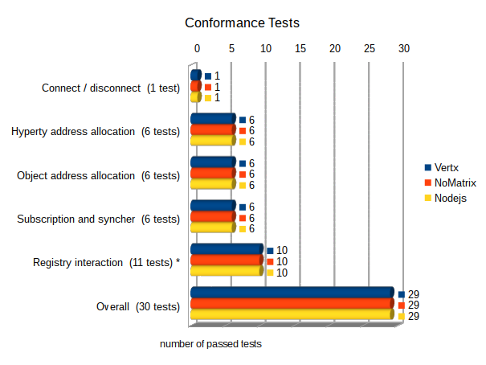

Figure : Overview of specification conformance test results

***Connection and status event emission test***

All 3 nodes pass the basic connect and disconnect test and emitted the correct sequence of status events during the deployment and connection phase.

***Address allocation / de-allocation tests:***

Also all tests for the allocation and de-allocation of hyperty and object addresses where passed successfully by all 3 message nodes.

***Subscription and publish:***

All 3 nodes have passed the test for subscription and publication of data object updates according to the latest specification

***Registry interactions:***

**Notes:**

For the interaction with the Domain Registry all 3 nodes make use of a RegistryConnector component that is available as a plug-in module. Therefore the pure message format and exchange between the MN and the domain registry is identical for all 3 MNs. Differences are only be caused by the way how messages are identified and assigned to the RegistryConnector plugin and how responses are parsed and routed back.

**Results:**

All MNs are failing to pass Test 5.10 (Test delivery and receiving of status update events). This test checks a quite recent addition of the spec. which allows any runtime to subscribe for status-changes of hyperties or objects in the domain registry. This functionality will require an architectural extension of the RegistryConnector, because it needs to implement a server interface as well in order to receive notification from the domain registry. So far it only acts in the client role, sending requests and to the domain registry and expecting responses. This extension is – at the time of test execution - not yet implemented in the RegistryConnector and therefore the corresponding test fails for all nodes using it.

The mentioned new feature is not yet part of the rethink core framework – therefore this failed test is not crucial for the use of the MNs.

All 3 Nodes are passing the remaining 10 tests successfully.

#### Performance test results

***Allocation and de-allocation of Hyperty addresses***

The following 2 figures provide a summary of the performance of the MNs in terms of allocation and de-allocation of hyperty addresses.

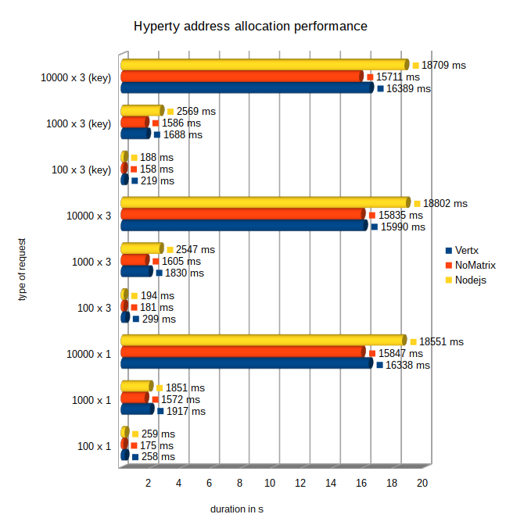

Figure : Performance of Hyperty address allocations

All 3 nodes successfully passed all hyperty address allocation tests. The performance of the hyperty allocations is on a comparable level for all nodes, while the NoMatrix MN performs slightly faster than the Vertx and Nodejs MNs. The NodeJS MN became a little bit slower especially for higher iteration numbers and for tests with several address allocations at once.

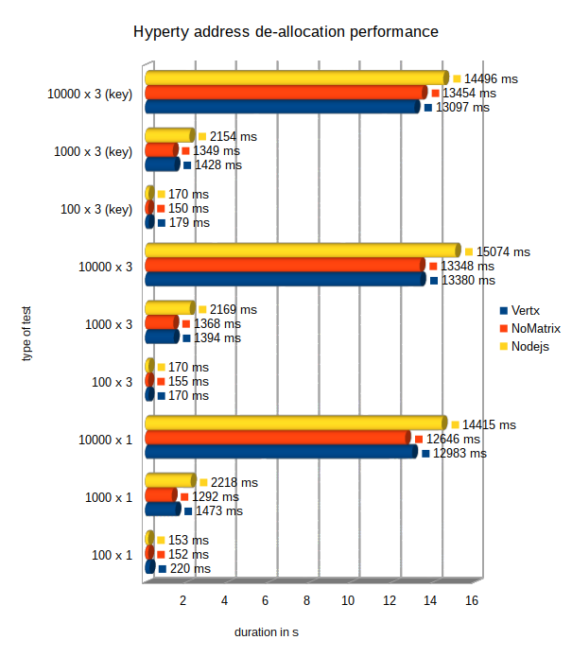

Figure : Performance of Hyperty address de-allocations

All 3 nodes passed successfully all hyperty address de-allocation tests. The performance of the de-allocations is in general up to 20% better than for the hyperty address allocations.

The NoMatrix MN performs slightly faster than the Vertx and Nodejs MNs. The NodeJS MN became a little bit slower especially for higher iteration numbers and for tests with several address de-allocations at once.

***Allocation and de-allocation of Object addresses***

The following 2 figures provide a summary of the performance of the MNs in terms of allocation and de-allocation of Object addresses.

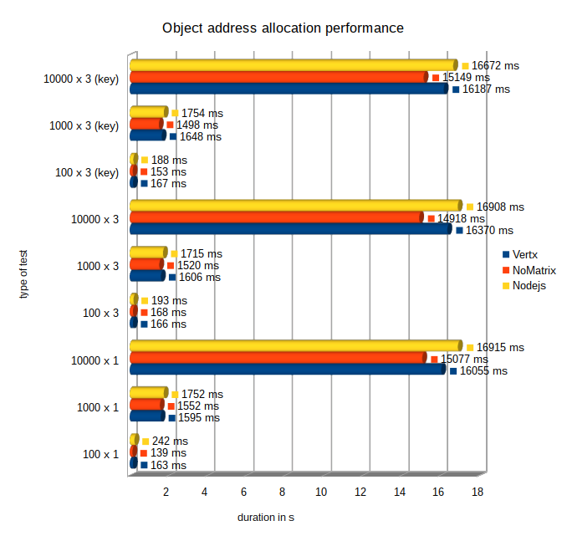

Figure : Performance of Object address allocations

All 3 nodes passed successfully all object address allocation tests. The NoMatrix MN performs slightly faster than the Vertx, which again is slightly faster than the Nodejs MNs. But in general the performance is on comparable level.

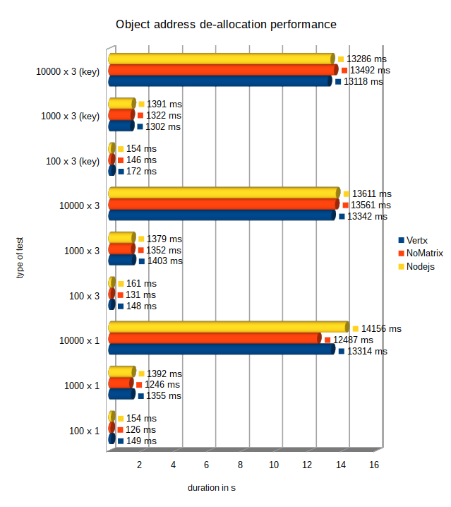

Figure : Performance of Object address de-allocations

All 3 nodes passed successfully all object address de-allocation tests. Also for the object addresses the performance of the de-allocations is in general up to 20% better than for the allocations.

The performance of the 3 nodes is on a comparable level, again with a small advantage for the NoMatrix MN in most of the tests.

***Hyperty messaging performance***

The following figure summarizes the results of the performance for the sending of message with different sizes from one Hyperty to another.

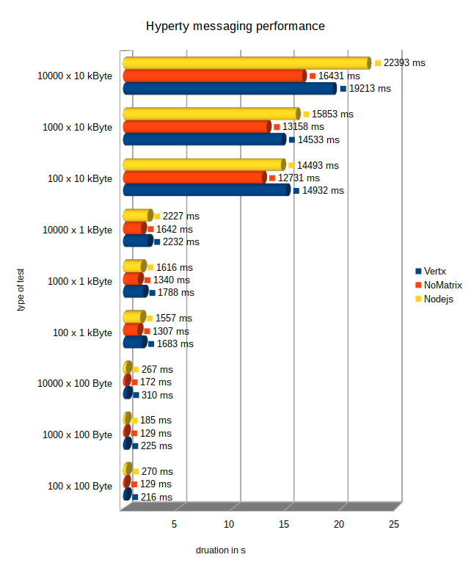

Figure : Performance of Hyperty messaging

All 3 nodes have passed successfully all hyperty messaging performance tests.

The NoMatrix MN shows the best performance in all different runs while the NodeJS and Vertx node are on nearly the same level.

***Object status update performance***

The next figure shows the results of the performance measurements for the delivery of object update messages to a variable number of subscribers.

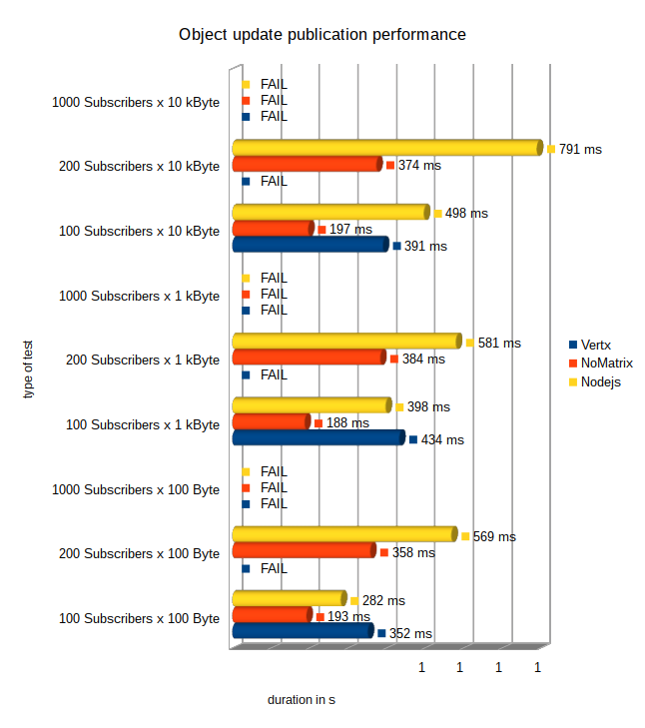

Figure : Performance for object update messages to N subscribers

**Note:**

All tests with 1000 subscribers for a event were expected to fail for all 3 nodes. The reason is that the tests were performed using the karma testscripts inside of a google-chrome browser. Since the common browsers have resource limitations regarding the parallel established of outgoing connections, the tests with 1000 subscribers were inhibited. The empirical limit for parallel connections was found around 250.

The NoMatrix and the NodeJS MNs have passed all tests with 100 and 200 subscribers and, as expected, failed for 1000 parallel subscribers due to the mentioned browser limitations. The NoMatrix node performed conspicuously faster than the NodeJS node.

The Vertx node has passed the tests with 100 but not with 200 subscribers. The reason for the failure was that not all subscribers received an event notification when an object update was performed. Variying numbers between 4 and 9 events got lost. Since the tests count only successful when all subscribers receive the update notifications, the test failed. The issue has been reported but the reason for these lost events was still under investigation by the component owner at the time of the test documentation.

#### MN Assessment conclusions and recommendations

The tests have shown that the NoMatrix MN can be recommended as the “all purpose” MN, passing all mandatory conformance- and performance- tests and providing the best performance in most of the cases.

The NodeJS MN is also passing all conformance tests and provides reliable and very good performance results. In tests with higher iteration numbers it appeared overall a bit slower than the NoMatrix node. This might be a consequence of the selected default logging settings of the MN which are relatively verbose and therefore time-consuming.

The Vertx MN is passing all conformance- and most of the performance- tests. It is the standard MN for most of the applied testbeds in reTHINK and has proven its reliability in the daily work. The lost events for very high numbers of subscribers for updates on a data object seem to have a rather low relevance in the real life operation, according to the practical experiences. Nevertheless they indicate a potential problem in the routing engine that must be investigated.

## Runtime evaluation

### Description of Component

The Hyperty Runtime supports the execution of Hyperties including: • Deployment of Hyperties • Deployment of Protocol Stubs • Communication between Hyperties • Management of Identities associated to Hyperties

### Metrics

Device side Hyperty Runtime (browser and standalone runtime) as well as Server side Runtime (NodeJS runtime) were implemented based on common runtime core platform.

#### Functional Metrics

More than 500 functional metrics are defined to evaluate the Hyperty Runtime including:

Hyperty is correctly deployed in the Runtime:

* Address Allocation
* Registration in the Domain Registry
* Associated with user Identity

Protostub is correctly deployed in the Runtime:

* Address Allocation
* Connected to the Message Node

Idp Proxy is correctly deployed in the Runtime:

* Address Allocation
* Connected to the IDP

Messages are correctly delivered by the Runtime:

* Among Hyperties in the same runtime (intra-runtime)
* Among Hyperties in different runtimes, from the same domain (intra-domain)
* Among Hyperties in different runtimes, from different domains (inter-domain)

Identity Management:

* User is able to select IDP to be used independently of the Hyperty
* User is able to login with selected IDP
* Identity Assertions are correctly generated and added to the body of outgoing Messages
* Identity Assertions contained in the body of incoming messages are correctly validated by the IDP
* Communication between two hyperties is encrypted with tokens generated from the IdP Proxies.

Data Synchronisation:

* Reporter creates a new object and invites one or more Observers
* Observer subscribes an existing object
* The object handled by the Observer is synchronised with the changes performed by the Reporter

Address reusage and data objects resume:

* Address allocated to hyperty is reused between sessions
* Address allocated to data objects are reused between sessions
* Data Objects created by Reporters are resumed between sessions
* Data Objects subscribed by Observers are resumed between sessions

#### Non-Functional Metrics

For the Core runtime, the execution time is the only non-functional metric used. For the NodeJS runtime, since it can be used in a server, additional non-functional metrics are defined:

**Deployment Performance**

1. Number of Hyperties deployed / sec
2. Number of Protostubs deployed / sec

**Reporte-Observer data synchronisation performance**

1. Number of Data Objects created / sec
2. Number of Data Objects created / sec with data object children
3. Number of Data Objects subscribed / sec
4. Number of Data Objects subscribed / sec with data object children
5. Number of Subscribers per Data Object
6. Number of Subscribers per Data Object with data object children
7. Number of Data Objects changed / sec with different number of subscribers and size of the change
8. Number of Data Objects Childs created / sec with different number of subscribers and size of the data
9. Number of Reporter data objects resumed / sec
10. Number of Reporter parent data objects resumed / sec with different numbers of data object childs
11. Number of Observer data objects resumed / sec
12. Number of Observer parent data objects resumed / sec with different numbers of data object childs

### Functional Runtime Tests

The evaluation of the Hyperty Runtime is performed with Karma Unit tests implemented [here](https://github.com/reTHINK-project/dev-runtime-core/tree/master/test), and for each one the execution time was measured as defined above. For quality control purposes, these tests are automatically executed every time a git push or git pull request is performed to develop and master branch and its status is depicted following best Continuous Delivery practices. The quality status is depicted in the Github repository *readme* page:

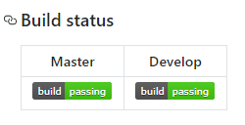

Runtime Quality Status

The most updated full detailed report of the tests execution are provided at https://travis-ci.org/reTHINK-project/dev-runtime-core where we can continuously monitor the runtime quality including:

* Hyperties are correctly deployed in the Runtime including the allocation of addresses, the registration in the Domain Registry and the association of User Identities;
* Protostubs are correctly deployed in the Runtime including Protocol Stub is successfully retrieved from the Catalogue server, an Hyperty Runtime URL is successfully allocated to the protocol stub, and the protocol stub is instantiated and connected to the Message Node.
* Idp Proxy is correctly deployed in the Runtime that is used to authenticate user with selected IdP e.g. Google IdP. The IDP Proxy is successfully retrieved from the Catalogue server, an Hyperty Runtime URL is successfully allocated to the IDP Proxy, and the IDP Proxy is instantiated and successfully connected to Google IDP.
* Messages are correctly delivered by the Runtime including:
* messages were successfully exchanged among Hyperties running in different runtimes, from the same domain (intra-domain).
* messages were successfully exchanged among two Hyperties running in different runtimes, from different domains (inter-domain).
* User is able to select IDP to be used independently of the Hyperty
* The user successfully authenticates with selected IdP.
* Identity Assertions are correctly generated and added to the body of outgoing Messages
* Identity Assertions contained in the body of incoming messages are correctly validated by the IDP

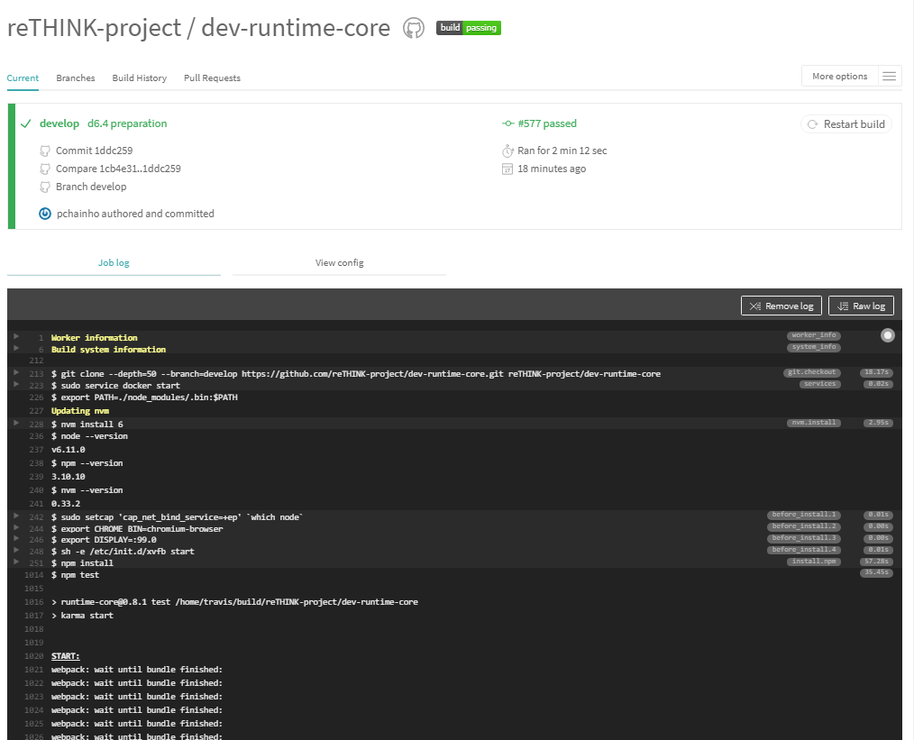

Travis Automated Tests Report Sample

### Non-Functional Runtime Tests

The following execution time measurements were taken:

|  |  |
| --- | --- |
| Test | Execution Time (ms) |
| Runtime installation | 36 |
| Protostub deployment | 10 |
| Idp Proxy deployment | 6 |
| New Hypert Address Allocation | 3 |
| Hypert Address Reusage | 2 |
| Intra-runtime Hyperty Message Delivery | 4 |
| Inter-runtime Hyperty Message Delivery | 5 |
| Inter-domain Hyperty Message Delivery | NA |
| New Data Object Address Allocation | 1 |
| Data Object Address Reusage | 1 |
| Data Object creation (new Reporter) | 27 |
| Data Object subscription (new Observer) | 42 |
| Data Object Observer Resume | 34 |
| Data Object Reporter Resume | 20 |
| Data Object Update synchronised with Observer | 13 |

Additional non-functional evaluations are provided for:

* Identity Module (see [here](identity-module/IdMEvaluation.md))
* Policy Engine (see [here](policy-engine/README.md))

### Evaluation analysis

*to be provided*

## Global Registry

### Description of Component

The Global Registry is a decentralized directory service, linking globally unique user identifiers (GUIDs) to a list of user accounts owned by a user. By resolving a GUID, services can retrieve information about the existence and location of all registeres user accounts for a specific user and connect to the respective account's Domain Registry. The Global Registry is built in Java using Spring Boot and relys on decentralized control by utinizing DHT technology.

### Methodology and setup

For the evaluation of the Global Registry, three separate nodes were set up and connected to each other as described in the [installation manual](https://github.com/reTHINK-project/dev-registry-global/blob/master/docs/install.md). Each node consisted of a virtual server managed by VMware with 1 CPU, 1 GB of RAM, and 10 GB of disk space. The used operating system was Debian Jessie with a 3.16.0 kernel, while the Global Registry daemon was dockerized using Docker 17.03.1-ce.

### Performance metrics

The conducted tests evaluate the performance of the Global Registry network unter high load. For this, JMeter was used to simulate multiple clients (100 threads) to access the service simultaneously. To keep the computational overhead of creating and signing datasets at a minimum, 4000 individual datasets were created in an offline-phase and saved to a database table. In the online phase, all datasets were read from the database and sent to the Global Registry and accessed again afterwards. Here, depending on the task, up to 340 (retrieving datasets via GET) and 120 (writing datasets via PUT) server hits per second were performed.

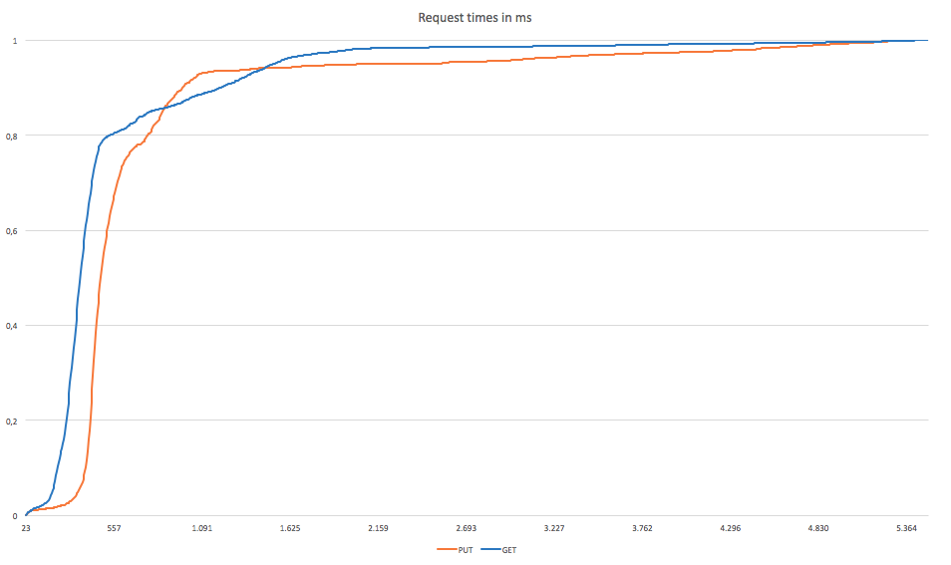 Figure 1: Elapsed times of GET and PUT requests in ms

When resolving a GUID, the service performed well with an average response time of 533ms with a median of 351ms. Anyhow, response times could be much higher, where a maximum value of more than 5492 ms was measured. The fastest response took only 23ms to complete. For writing datasets, an average response time of 1777ms was measured with a median value of 1174ms. The increased duration of PUT requests can be explained by the overhead required to write data to the DHT. Worst observed time for a PUT request was 13873ms, where the best was 25ms.

### Conclusions and recommendations

While the Global Registry is a central component of the ReThink architecture, write requests are assumed to occur rarely compared to resolving existing identifiers. With Kademlia as a basis for the underlying DHT architecture, GET requests are ansered quickly with a median value of 351ms. Writing performance was rather slow with a median value of 1174ms, but is thought to have no serious impact, as frequent updates to one's user accounts will only occur in the Domain Registy services, while the Global Registry will only be updated seldomly. To further increase performance and to stabalize the service, the service should be run on performant hardware. As the Global Registry was tested on virtual machines, limitations of processing power and RAM showed.

## Domain Registry

### Component Description

The Domain Registry is the component of reThink’s architecture that together with the Global Registry, forms the Registry Service. The Global Registry provides a mapping from a User’s Unique Id (GUID) to the several services it uses. Each Communication Service Provider (CSP) runs a Domain Registry service that resolves domain-dependent user identifiers to the actual information about this user’s Hyperty Instances (a Hyperty used by a user in one device).

A Domain Registry stores, for each user identifier, the list of Hyperty Instances the user runs on his devices. It also stores, for each Hyperty Instance, the data that enables other applications to contact it, by providing a mapping between the identifier for each Hyperty Instance and the data that characterizes it. It also enables a user's hyperties to be searched for using several parameters [reference to user manual](https://github.com/reTHINK-project/dev-registry-domain/blob/master/docs/DomainRegistryUserManual.md).

The Domain Registry is a critical service as it stands in the critical path for call establishment. As it will be used very often, it must provide a low access time, high availability and be capable of fast updates (e.g. for when a device changes IP address). It is based on the client-server model and handles high-speed and high-frequency data.

### Metrics

Given the Domain Registry requirements presented in the previous section, the following metrics must be evaluated in order to determine the suitability of an implementation: - Response time for read - As the Domain Registry is a critical component in the call establishment process, the time it takes to perform a read should be small, in the order of the tens of ms. We will test the evolution of this metric as the load on the server increases. - Number of concurrent requests - A large Service Provider is expected to have a large number of users, which will result in a high number of requests to the Domain Registry. Thus the domain registry should be able to scale to accommodate a large number of requests/s while providing a reasonable response time. - Response time for write - The device runtime will write to the Domain Registry whenever new hyperties are deployed, removed or updated. Although not as critical, the response time should also be within tens of ms. - Error rate - Measured in percentage of the requests that fail to be successfully replied to within the timeout period (defined as 5s). This value should be zero. - Recovery Time - Measured in second during which the service is not available, after a failure and until the backup server takes over.

### Performance tests

The Domain Registry was evaluated using an HTTP stress tool and a high-availability setup.

#### Evaluation scenario

This section describes the test setup.

##### Domain Registry deployment

The Domain Registry was deployed on [Google Cloud Plataform](https://cloud.google.com/compute/) [St. Ghislain, Belgium](https://cloud.google.com/about/locations/#locations) datacenter, using 8 VM with 1vCPU and 2GB RAM each. The VMs were assigned the roles described in Figure 1: 4 Cassandra DB nodes, 3 application servers and a single load balancer. Figure 1 presents 2 Load Balancers for redundancy purposes, but as a single one is active at any given time, only one was used for these performance tests. All request are sent to the load balancer, that distributes them in round-robin through the 3 application servers. Application servers query the 4 database servers also using round-robin.

The Operating System used as [Ubuntu 14.04 64bit](http://releases.ubuntu.com/14.04/) and the software was deployed using [Docker](https://www.docker.com/) 1.6.2. The load balancer uses [haproxy](http://www.haproxy.org/) 1.5. The [Cassandra DB](http://cassandra.apache.org/) was deployed using version 3.5 with a replication factor of 3. The application server was deployed using the [Spark micro framework](http://sparkjava.com/) 2.2. The Domain Registry version used was [R 0.2.0](https://github.com/reTHINK-project/dev-registry-domain/releases/tag/R0.2.0).

##### Client tool

The tests were performed using [AutoBench](http://www.xenoclast.org/autobench/) 2.1.1 as a wrapper around [HTTPPerf](http://www.labs.hpe.com/research/linux/httperf/) 0.9.0. These tools were run on a server with 2 Intel(R) Xeon(R) CPU E5-2640 v2 @ 2.00GHz CPUs (total of 32 cores), 128GB of RAM running Debian 8.2. This server was located at the University of Lisbon’s, Instituto Superior Técnico's Tagus Park campus, near Lisbon.

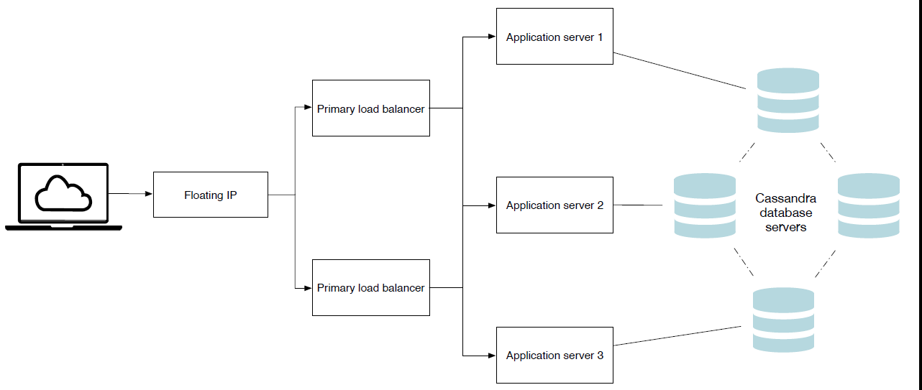

Figure 1 - Deployment architecture

#### Test methodology

Two types of tests were performed: performance and scalability tests, where the load is varied; failure recovery testes, where one of 3 servers is failed and then put back online.

The performance and scalability tests were conducted using 1, 2 and 3 application servers (as depicted in the left side of Figure 2). The number of database servers was always 4 in order to maintain the data availability. For each number of servers, 10 httpperf tests were conducted (using autobench) varying the rate from 200 requests/s up to 2.000 request/s with a step of 200 requests/s. Each HTTP connection was used to issue 10 requests (*num_call*) and 2.000 connection (*num_conn*) were used, totalling 20.000 HTTP requests per test point.

The option to have each HTTP connection issue 10 requests was due to the fact that the Domain Registry's client, the Connector running on the Message Node, uses connection pooling and reuse with HTTP persistent connections.

The following autobench command was used for these tests:

autobench --single_host --host1 my.server --port1 4567 --uri1 /hyperty/user/userid@inesc-id.pt --low_rate 20 --high_rate 200 --rate_step 20 --num_call 10 --num_conn 2000 --timeout 5

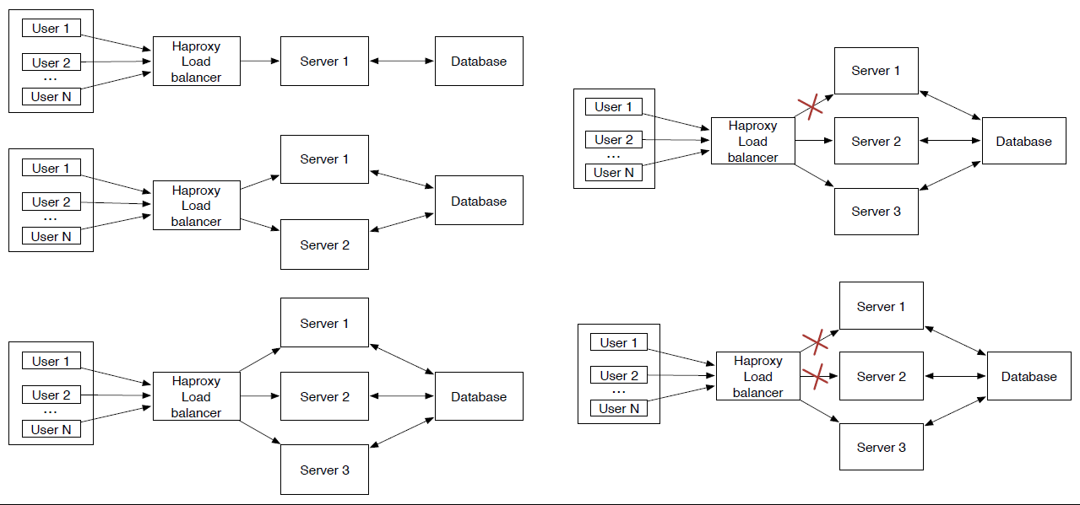

Figure 2 - Test scenarios

The application server failure test was conducted using a scenario with 3 application servers, where one of them was disabled (with a *docker rm -f*) and latter restarted. The goal was to measure the impact of the node leaving (including failure detection) and rejoining the set of nodes used by the haproxy load balancer. This test is depicted in the top right part of Figure 2.

Every test was repeated 50 times. Each data point is the average of all these runs. The tests are interleaved and were performed over the length of a few days to prevent eventual effects due to time of day network and VMs traffic.

#### Response time

Httperf presents some performance limitation that must be taken into account in order to understand the results obtained. In particular, httperf limits the number of concurrent connections (due to file descriptor limits). If the server is unable to keep up with the request rate, httperf will eventually run out of TCP connections and will be unable to sustain the request rate. Figure 3 presents the relation between the solicited request rate and the effective request rate. We can see that with 3 servers, httperf is capable of imposing a request rate close to the solicited rate up to 800 req/s. With higher rates, the effective rate falls behind the solicited rate. This effect is more pronounced when using 2 servers. With a single server, we can see that the effective rate lags behind the solicited rate from the very start.

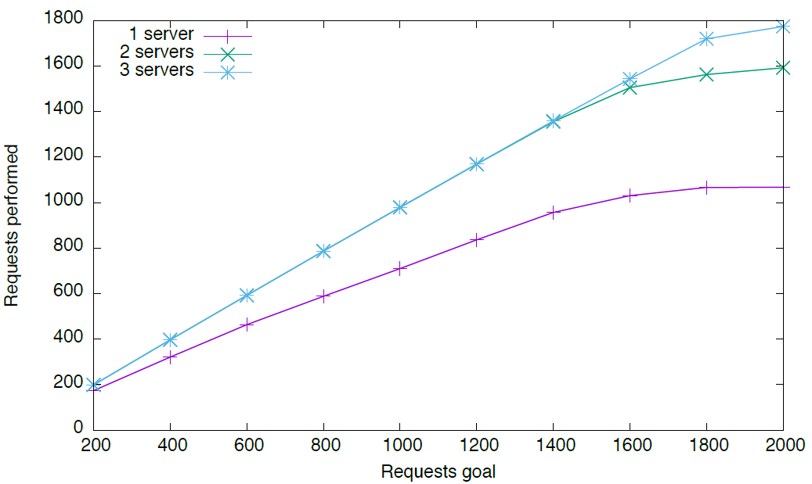

Figure 3 - Effective vs solicited request rate

In the following graphs we will use the effective request rate instead of the solicited request rate.

Figure 4 presents the average response rate for an increase request rate. Considering that the client and server are separated by the Internet, a value below 50 ms was considered acceptable. We can observe, that as single server can handle up to 700 req/s, while 2 are able to handle almost 1400 req/s and 3 servers are able to handle a little above 1700 req/s.

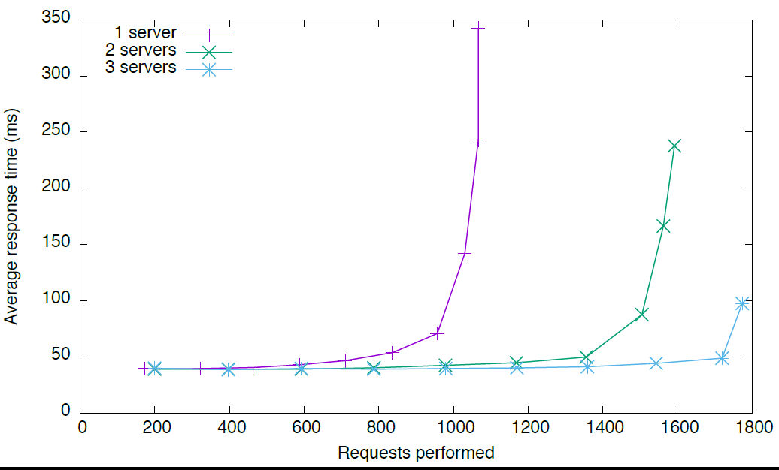

Figure 4 - Average response time

Going from 1 to 2 servers, we observe an almost linear increase in capacity. However, a third server does not provide the same increase in capacity. This is due to the increased load on the database servers, which will have to be analysed in the future.

#### Failure recovery test

Figure 5 presents the evolution of the response time and error count in the event of a application server failure. During this test, the effective request rate is constant, at 500 req/s. One of the 3 servers fails at instant 120s and is put back online one minute later. The events are marked in the figure by red vertical lines.

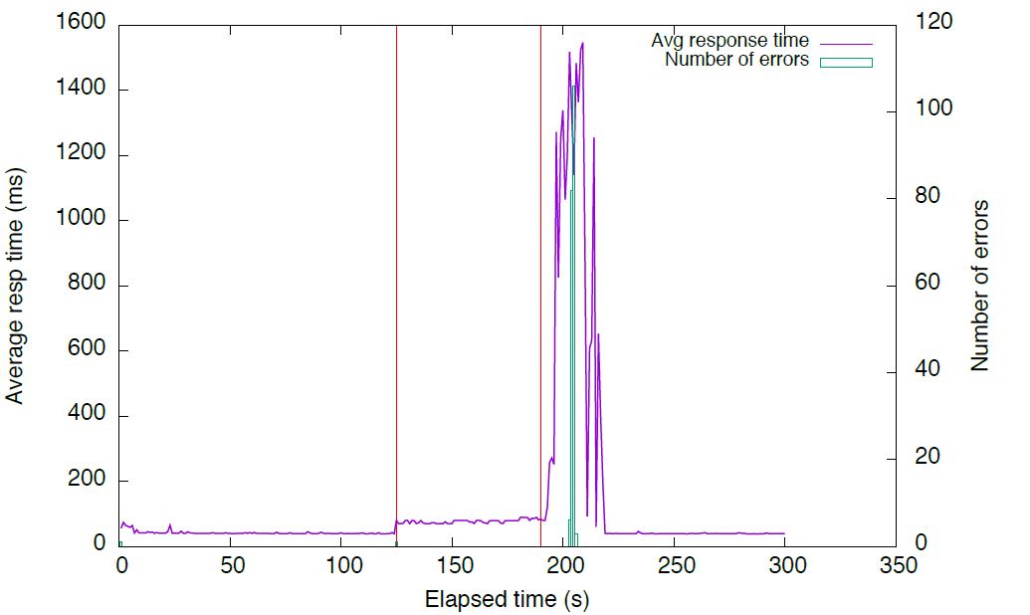

Figure 5 -

We can observe that the failure of the node results in an increased average response time, as only two servers are left to handle the workload. A small number of failed requests is observer when the server fails. These are the requests being handled by the failed server. Haproxy detects the failure and stops using that server.

When the server is put back online, following a *docker run*, haproxy detects the availability of the servers and adds it to the pool of available servers. However, the server is still booting up the Spark framework. As such, the JVM takes time to do the JIT compilation, load the required classes and open the database connections, leading to a high response time for the first few requests. This impacts the response time and even causes some requests to timeout. After a while, the newly added server recovers and the response time drops to the initial value.

### Fail-over tests

The tests described in the previous Section demonstrate the ability of the Domain Registry implementation to scale in order to handle a large number of clients. The scalability is provided by the deployment architecture, where the number of nodes processing the requests as well as the number of nodes that make up the database can be dynamically adjusted according to the expected load. In this Section, we complement the previous scalability evaluation with an evaluation of the high availability performance.

#### Evaluation scenario

These tests were conducted at a later date. As such the scenario is not identical. The deployment architecture is still the same, as ilustrated in Figure 1, but the used testbed was different. The Domain Registry was deployed on a datacenter at the University of Lisbon’s, Instituto Superior Técnico's Tagus Park campus, using 9 VM with 1vCPU and 2GB RAM each. The VMs were assigned the roles described in Figure 1: 4 Cassandra DB nodes, 3 application servers and a 2 load balancers in active/passive configuration. All requests are sent to the load balancer, that distributes them in round-robin through the 3 application servers. The Operating System used was Ubuntu 14.04 64bit and all software was deployed using Docker 1.6.2. The load balancers uses haproxy 1.5. The Cassandra DB was deployed using version 3.5 with a replication factor of 3. The application server was deployed using the Spark Java framework 2.2. The Domain Registry version used was R 0.2.0.

The load testing tools were run on a server with 2 Intel(R) Xeon(R) CPU E5-2640 v2 @ 2.00GHz CPUs (total of 32 cores), 128GB of RAM running Debian 8.2, located in the same datacenter. After reviewing and testing several open source load testing applications, we ended up choosing [httperf 2](http://www.labs.hpe.com/research/linux/httperf/) to simulate the client load.

#### Test methodology

There are two load balancers. The master node handles all the requests and the backup node is in standby mode. When the backup node detects a failure of the master, it assumes its role. This is accomplished by using the Virtual Router Redundancy Protocol (VRRP) running between the two nodes. A single IP address is shared by both nodes, but only the master announces it. Under normal conditions, all the requests are sent to the Master. When the Backup stops receiving VRRP announcements from the Master, it assumes that the Master is down and takes over the shared IP address and operation. When the Master is back online, the Slave relinquishes control of the shared IP address. [Keepalived](http://www.keepalived.org/) was used to implement VRRP and the fail-over behaviour.

We simulated two types of Master node failure: failure of the service provided by the node (haproxy) and failure of the fail-over mechanism itself (keepalived). The latter simulates a complete node failure.

#### Recovery Time

Figure 6 illustrates the failure of the service provided by the node. In this case, after about 20s, we stop the haproxy service on the Master node. There is a service failure that lasts about 5s. After 5s, the service is resumed by the Backup node. We set keepalived to monitor Haproxy every 5 seconds. That is why there is a 5 second gap until the Backup node takes over. However, this value was used just for testing, to actually see the transition. In production this value will be decreased to 2 seconds. That was the only value that was manually set by us. At arround 40s, we restart the haproxy service on the Master node. While assuming the server role, if the Backup node ever starts receiving VRRP advertisements again, it elects the first node as master (because the Master was set up with a higher priority level) and transits back to being the backup node, in a always listening, passive configuration. The transition back to the Master node is faster. The brief failure in the service is due to the fact that as the IP address changes, ongoing TCP connections are dropped, as these were started with the Backup node but the Master server does not know them, thus rejecting those packets. All new connections will proceed normally.

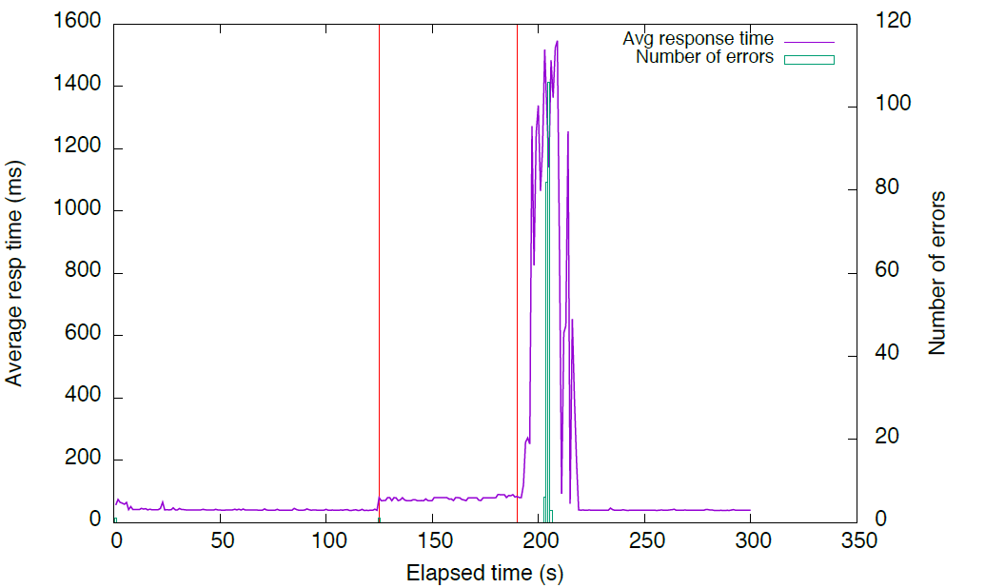

Figure 6 - Load balancing service failure

Figure 7 shows a similar test, but this time we stop the failover service (keepalived) on the Master node. Now the service interruption is shorter, as the Backup node stops receiving the VRRP announcements as soon as the keepalived service is stopped. The return of the control to the Master node is similar to the previous case: when the keepalived service is resumed, it starts sending the VRRP announcements and regains control.

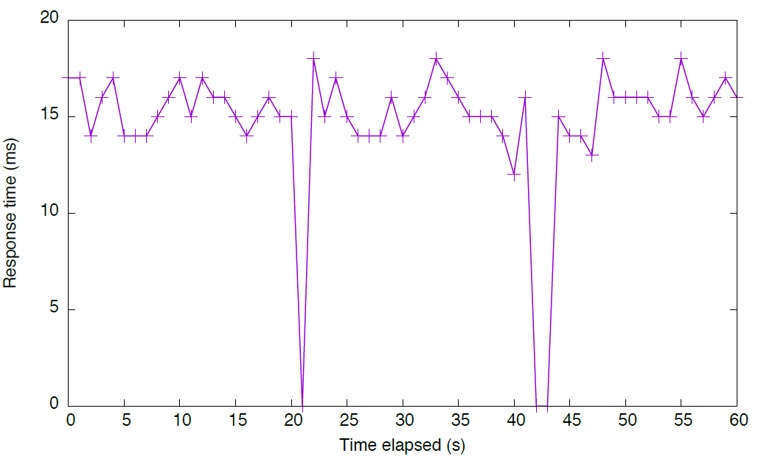

Figure 7

In both situations, the down-time is only a few seconds. This is a reasonable amount of time, particularly when we take into consideration that this is a rare event. The more common failure of an application node is handled by the load balancer (haproxy), as examined in deliverable 6.3.

## Catalogue Performance Assessment

### Description of Component

The Catalogue provides the service to store descriptors of Hyperties available for use. It also provides the means for the runtime to obtain (download) the implementation of a Hyperty and ProtocolStubs required for ProtOfly after learning about an Hyperty from the Registry Service.

As such, the Catalogue Service merely stores information and in particular does not need to manipulate any of the stored records. For a detailed description of the internals of the catalogue as well as installation and set-up guides, please refer to [D4.1], [D4.2], and [D6.1].

### Methodology and setup

Deliverable [D6.3] provides a detailed performance evaluation of the Catalogue using dummy test hyperties and ProtoStubs. As such, the evaluation of the catalogue in this deliverable repeats the methodology as described in [D6.3] but uses actual, larger components served by the catalogue, i.e., actual hypeties and ProtoStubs as developed over the coarse of the the prject are retrieved to evalute the catalogue’s performance. The tests mimic a real world situation in which a client requests its runtime from the Catalogue Server.

#### System under Test

The system under test (SUT) comprises set-up of the catalogue as found in the reTHINK testbed deployment. The set-up resembles a deployment found at a commercial service provider. In fact, the set-up in the figure below is the testbed setup at Fraunhofer Fokus, which is as a virtulized platform (as a service) run on commercial equipment and network components guarged by a commercial firewall. The used hardware is unchanged with regard to the tests run for the initial assesments documented in [D6.3] and hence not described in detail herein. As in the former assessment of the catalogue, autobench and httperf are used to probe the SUT.

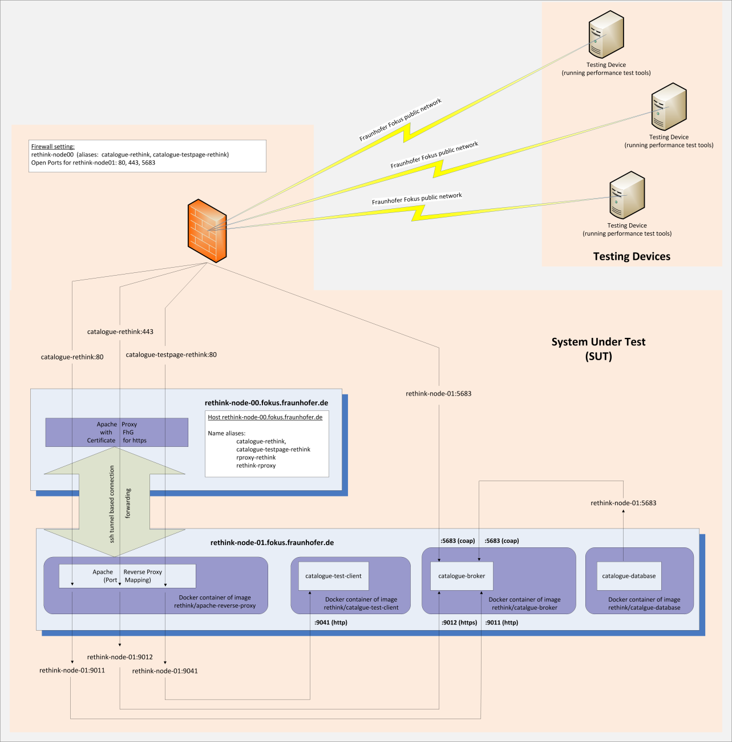

Figure -- System under test (SUT) for the Catalogue performance assessment

#### Retrieved Catalogue objects

Performance tests were conducted for retrieving all information for a Hyperty Runtime stored in the catalogue. In a first experiment, the Catalogue Object Descriptor is retrieved from the Catalgoue Server. The descriptor contains all information about the stored object in order to decide at the client if a full retrieval of the object’s source code is necessary. The actual executalbe code of the Hyperty Runtime is retrieved in a second experiment.

As such, the experiments mimic the real world behavior of the reTHINK system in which clients may retireve a catalogue object descriptor first in order to decide if a locally stored copy of a prefious fetch is still up to date, and in case a newer version of the source is available, perform a full fetch of the catalogue object including the executalbe source code. The Catalogue Object Descriptor for the Runtime is hown below.

{  
 "cguid": "2e810e3c0623102ee7d92056dd12032e",  
 "runtimeType": "browser",  
 "version": 18.699999999999996,  
 "objectName": "Runtime",  
 "description": "Description of Runtime",  
 "sourcePackageURL": "hyperty-catalogue://catalogue.fokus.fraunhofer.de/.well-known/sourcepackage/Runtime",  
 "language": "javascript",  
 "hypertyCapabilities": {  
 "mic": true,  
 "camera": true,  
 "sensor": false,  
 "webrtc": true,  
 "ortc": true  
 },  
 "protocolCapabilities": {  
 "http": true,  
 "https": true,  
 "ws": true,  
 "wss": true,  
 "coap": false,  
 "datachannel": false  
 }  
}

The sourcpackage object returned by the Catalogue is shown below. Note that the content of the sourceCode field is not shown below; the size of the Runtime’s source, which is retrieved in the second set of experiments, is approx. 153 kB.

{  
 "encoding": "base64",  
 "sourceCodeClassname": "Runtime",  
 "sourceCode": “NOT_SHOWN_HERE”,  
 "md5": "6ee1b00925aea3365303f6112b62d281"  
}

### Metrics and Experiment Blueprint

#### Metrics

Deliverable [D4.1] identifies two functional requirements for the catalogue: * "The catalogue service shall allow discovering the information it stores." * "The catalogue service should provide fast response times. As querying the Catalogue occurs before an end-to-end communication is established, response times have no immediate impact on an established end-to-end communication."

They transfer into the relevant KPIs, i.e.: average request (vs. response) rate and average response time, as well as numbers of errors encountered when retrieving information nfrom the catalogue. In addition, the number of erros are recorded for each experiment in order to verify that reported measurements are not biased by any irregularities in the SUT, the testing device, or the communication between the latter two. Deliverable [D6.3] provided a detailed discussion of those KPIs in the context of the performance evaluation of the catalogue.

As the interface towards the catalogue is http-based, separate metrics for testing conformance are not defined. The catalogue behavior is conformant if it successfully returns (an existing) http-request for a catalogue element (i.e. hyperty, ProtoStub, etc).

#### Experiment Blueprint

The basic experiment which is used to impose load on the SUT consist of a "testing device" that runs httperf [httperf] to send http-requests to the Catalouge. The following parameters of httperf as considered in the experiment influcence the load imposed on the SUT: * rate -- the rate at which (persistent) http connections are invoked; * number of connections -- the number of connections to invoke per experiment; and * number of calls -- the number of http requests send for each connection.

The following figure illustrates a single connection issues by httperf. For that connection, httperf issues N calls, i.e., http-requests. Calls are issued sequentially, i.e., httperf waits for the response corresponding to REQ_0_x before it issues the following request, i.e., REQ_0_x+1. The time at the testing device between issuing a request and receiving the corresponding response is denoted as Response Time. The figure accounts as well for a potential processing time between receiving a response (e.g.: RES_0_x) and issuing the following request (e.g.: REQ_0_x+1); this time is refered to rho_0. Accordingly, the Inter-Request Time is given by rho_0 + Response Time; and the Call Duration is given by N * Inter-Request Time where Nrefers to the number of calls (i.e., issued http-requests) per connection. As the number of calls per connection is given as a parameter.

For this example, the resulting (average) request and response rate should be equal, i.e.: N / Call Duration.

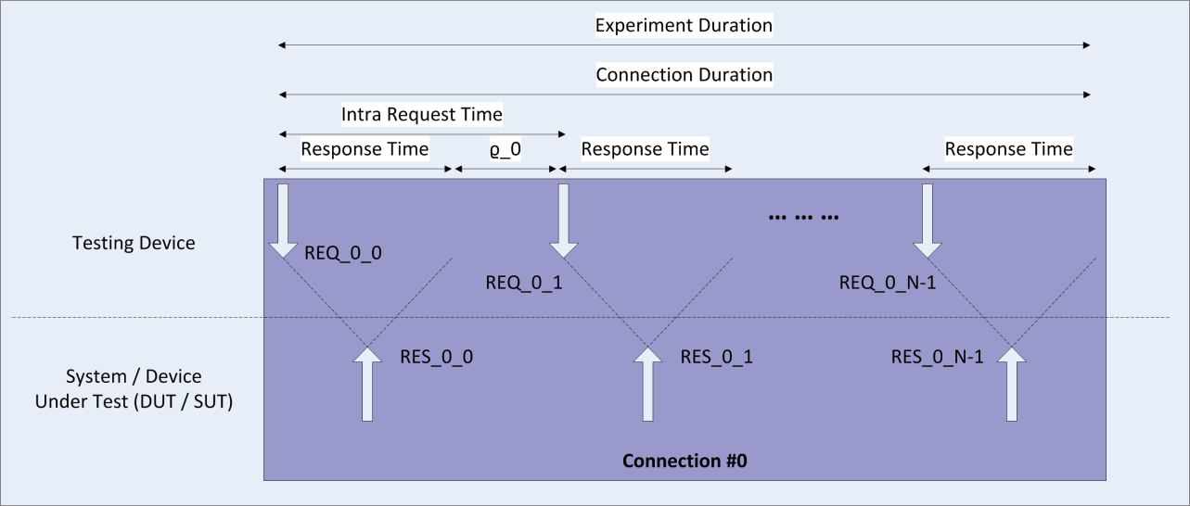

Figure -- Illustration of a single httperf connection

The following figure illustrates the situation for multiple connections issued by httperf per experiment. The top part of the figure shows the case in which the Connection Duration is shorter than the Inter-Connection Time, the latter being configured via the connection rate (Inter-Connection Time = 1 / rate). Assuming M refers to the number of connections per experiment (which can be configured upon invokation of httperf), and M beeing sufficiently large, the average request rate for the depicted experiment can be approximated by N / Inter-Connection Time or alternatively by N * M / Experiment Duration. (Note that in the figure, M = 2.)

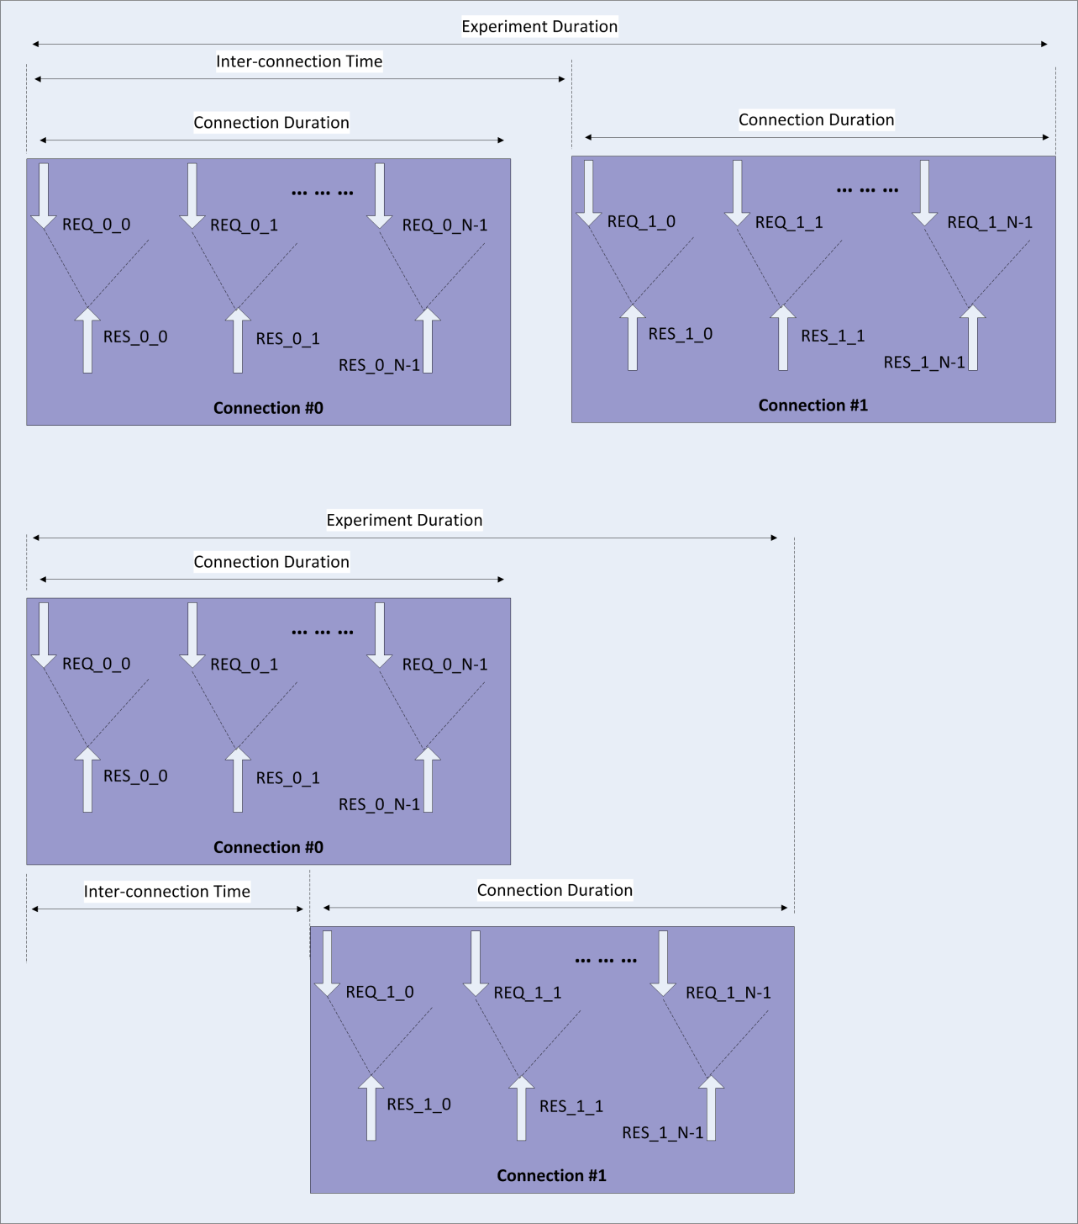

Figure -- Illustration of a multiple httperf connections

The bottom part of the figure above shows the case in which the Response Time is so long that the resulting Connection Duration is longer than the Inter-Connection Time, i.e., due to the configured rate, a new connection is started before the previous connection finishes. Due to the overlapping connections, we see periods in which http-requests are issued simultaneously from several connections; the experiment duration as shorter as compared to the situation illustrated in the upper part of the figure. Hence, the average request (and response) rate reported for the experiment shown in the bottom part of the figure is higher.

In conclusion, for assing the performance of the Catalogue, one has to set the connection rate to a rather high number in order to enforce the parallization of conections, which in turn steers the number of calls (i.e. requests) per second. Therein, the request rate can be controlled via the number of connections M.

Besides, it should be noted that httperf is not run immediately but is invoced by autobench [autobench], which allows to run several httperf-based experiments in a row where each experiment is invoked with a different connection rate.

Each experiment is repeated 200 times to calculate statistic significance of the results, i.e., to obtain confidence values for the reported averages. Repetitions of measurements are automatically invoked using [autobench], which in turn calls the corresponding httperf command. The corresponding autobench command is:

autobench --single_host --host1 ${CATALOGUE_URL} --uri1 ${URI} --low_rate 1 --high_rate 4000 --rate_step 5 --num_call 1 --num_conn 20 --timeout 5 --output_fmt tsv --port1 $PORT --file response_time_numcalls_1_$i.tab 2>&1 | tee response_time_numcalls_1_$i.outputLog

### Test Results

#### Catalogue Response Time for Retrieving the Hyperty Runtime Catalogue Descriptor Object

The first assessment aims at determining the Catalogue's response time to a single request to obtain the Catalouge Descriptor (object) for the default Runtime. A single testing device is used to impose load on the SUT. The load in terms of demanded requests per second is constantly increased by enlarging the (connection) rate; each connection consists of one call. Hence, each request is sent via a newly established TCP connection.

The following figure shows the average response time as a function of the demanded request rate for having one call per connection. For loads up to 500 requests per second, the system stablely response on average within 1.38 ms, whereas the lower bound for the respnse time is at 1.15 ms. Analyzing the CDF shows that for requests rates below 500 Hz, the system responds on average in 95% of the time within 1.6 ms.

Starting at 500 reqquests per second, the average response time as well as its variation increases. The average response time saturates at around 7.41 ms (while experiencing large variations in the measurements) for an imposed load larger than 2000 requests per second.

Considering all response times for an imposed load below the system’s saturation rate (i.e. at 2000 Hz), the system responds for 95% within 5.90 ms.

Note that the round trip time measured via ping between the testing device and the Catalogue for these measurements is 0.56 ms on average; and that this RTT is included in all of the reported response times.

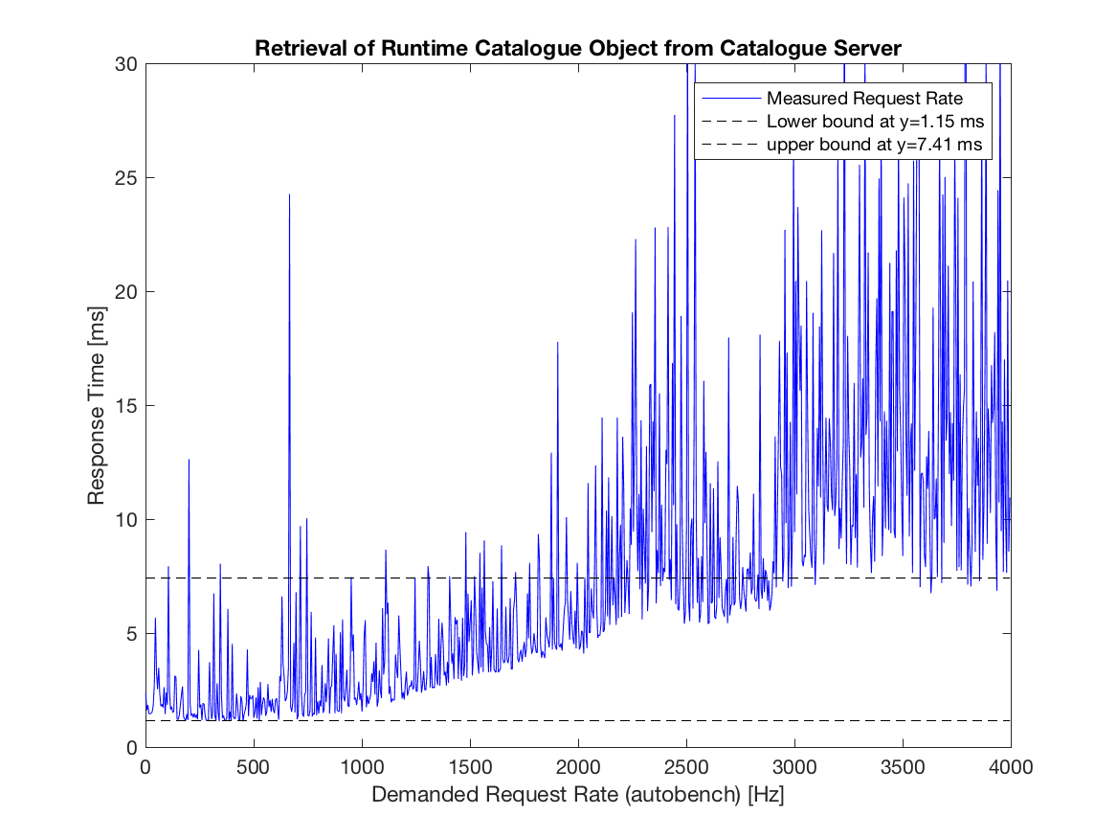

Figure -- Catalogue Assessment: Response Time for Retrieving the Default Hyperty Runtime Descriptor as a function of Demanded Request Rate

The next figure plots for lower rates the average response time as well as the corresponging 95-percent confidence levels. We encounter high variations in the expected mean response time as a function of the imposed load. It seems that imposed request rates in multiples of 50 Hz cause high variations in the response time and increase the expected mean for that load as well. Though the actual reason for that behavior is hard to analyze, measurements show that even for the worst case (here at an imposed load of 200 requests per second), the expected mean response time is with 95% confidence below 30 ms, which can be assumed as a rare, worst case expected performance. Even accounting all of the observed variations to the catalogue (and not to any other component of the SUT or the used measurement tools), we can deduct with at least 95% confidence that the mean response time of the Catalogue is below 30ms.

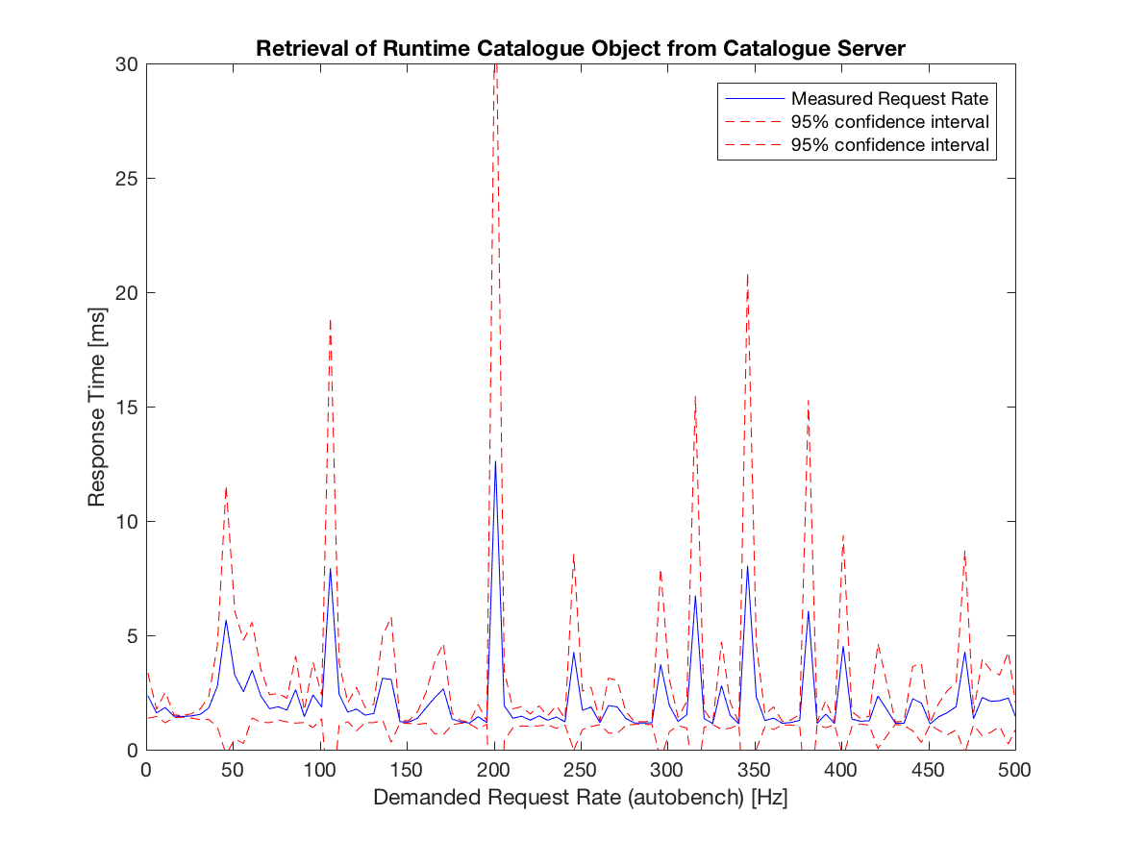

Figure -- Catalogue Assessment: Response Time for Retrieving the Default Hyperty Runtime Descriptor as a function of Demanded Request Rate (unsaturated system, showing 95% confidence values)

The obersavations regarding the stable state of the system (i.e. below 500 requests per second) and its satuation phase (in between 500 and 2000 requests per second) are also shown in plotting the actual measured request rate over the demanded (i.e. imposed) request rate. Both rates are in linear relation for the stable state, and go into saturation, which is reated at around 2000 imposed requests per second, which result in actual response rates of 1350 Hz.

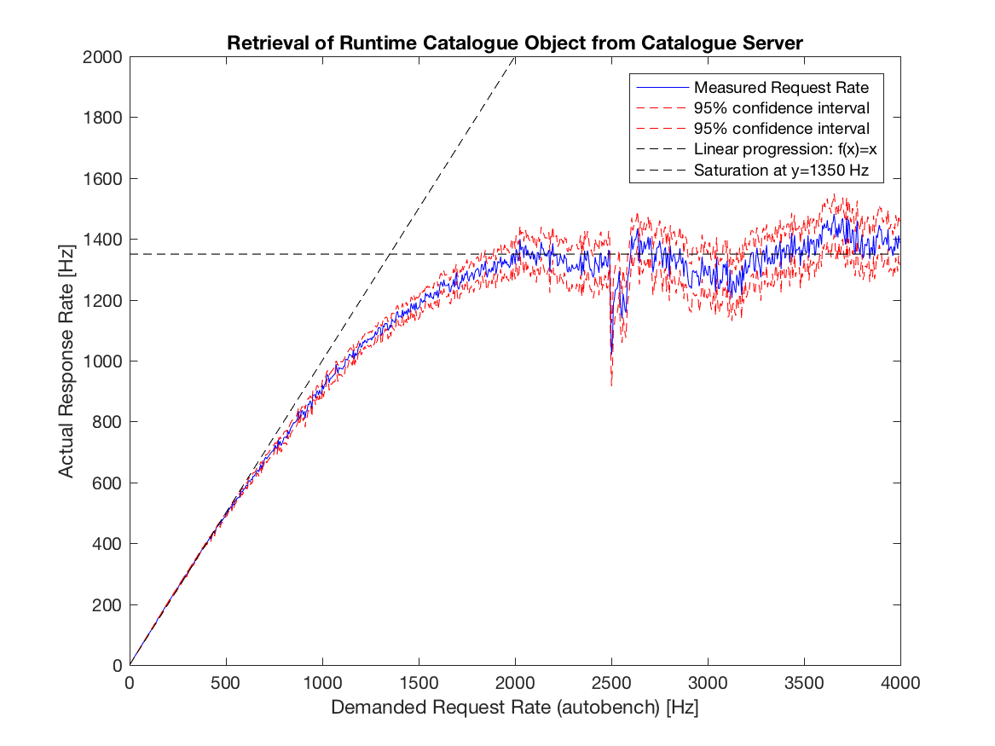

Figure -- Catalogue Assessment: Illustates the the actual (i.e., measured) request rate over the demanded request rate

Finally, looking at reported errors during the experiment (see next figure), all experiments have an imposed rate of less than 410 requests per second run without any reported error. All reported errors are time-out errors; a time-out is triggered by httperf if either a TCP connection could not be established for 5 seconds, or if a response is not received within that timeframe.

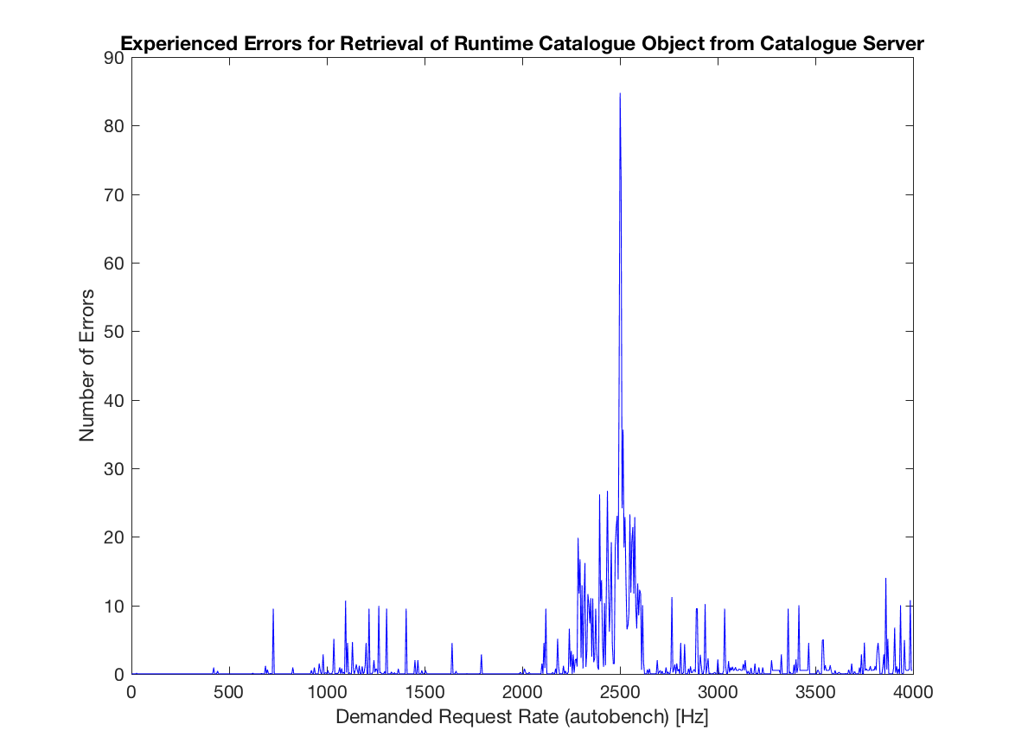

Figure -- Catalogue Assessment: Reported errors

As the main intend of the catalogue implementation is to provide a proof-of-concept suitable to evaluate the reTHINK concept at a hackathon, testbed, or pre-commercial trials, in summary, one can assess that such an evaluation is well possible as in either case, it is unlikely that more than 410 devices contact the catalogue simultaneously within one second in order to retrieve a catalogue object descriptor.

#### Catalogue Response Time for retrieving the full Hyperty Runtime Catalogue Object including the executable source code.

Qualitatively, retrieving the full sources of the Hyperty Runtime provides the same results as just retrieving the catalogue object descriptor of the Hyperty Runtime. Measurement results show a steady state phase for request rates below 600 requests per second; the average response time here is 1.35 ms. The latter is 15% higher than for just retrieving the catalogue descriptor object, which accounts for the additional 150 kB of source code contained in the response. The response time saturates at roughly 8.54 ms for a demanded request rate of 3500 demanded requests per second. The circumstances that this demanded request rate is larger as for requesting the significantly smaller catalogue object descriptor seems to be caused by seeing less variations in response times as compared to the previous set of experiments. Having responses larger in size seems to stableize the process of generating the responses as copying message in memory becomes more significant. The behavior is consistent with expectations as the actual measured rate of received responses per time interval decreases for larger responses as shown later.

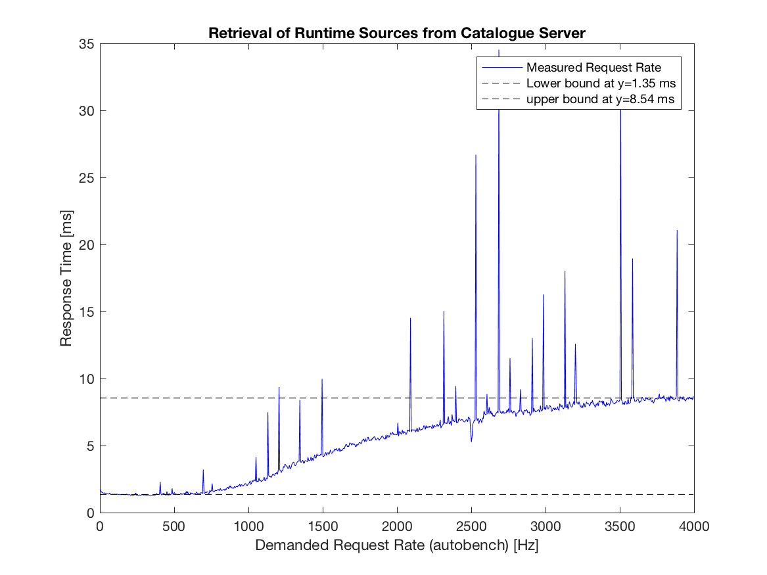

Figure -- Catalogue Assessment: Response Time for Retrieving the Source Code of the Default Hyperty Runtime Descriptor as a function of Demanded Request Rate

Looking at the following figuer, which plots for lower rates the average response time as well as the corresponging 95-percent confidence levels, we see that for rates lower than 400 requests per second, confidence levels do not overlap with conficendence levels at higher rates for which the SUT is saturated; hence we may deduct at 95% certainity that for rates lower than 400 requests per second, the expected mean response time is 1.35 ms and is constant with respect to the imposed load.

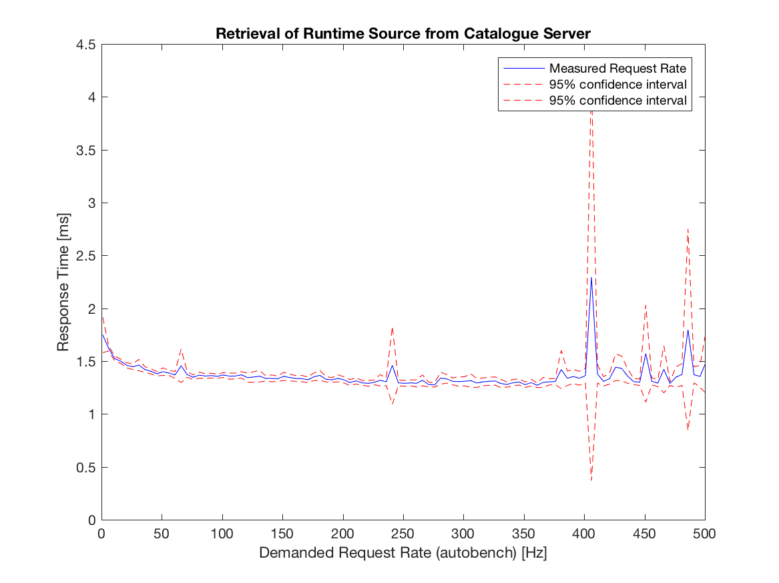

Figure -- Catalogue Assessment: Response Time for Retrieving the Source Code of the Default Hyperty Runtime Descriptor as a function of Demanded Request Rate (unsaturated system, showing 95% confidence values)

The measured actual response rate for retrieving the "mere" catalgogue descriptor object or the full source code of the default hyperty saturate at approx 2500 demanded requests per second. Whereas in the former case, we measure an actual response rate of 1350 Hz, the reate decreased for a full retrieval of the hyperty runtime's source code to 1180 Hz.

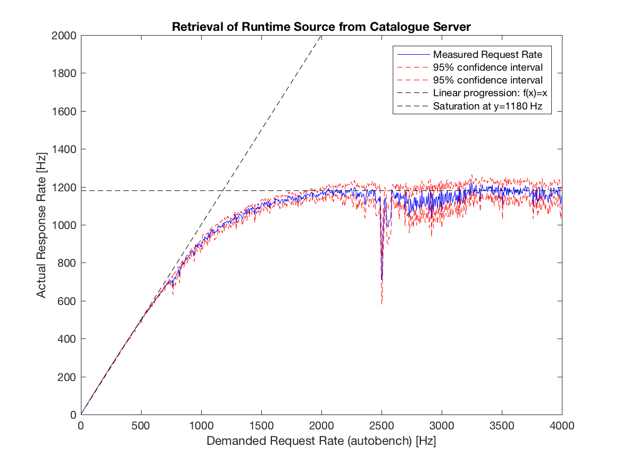

Figure -- Catalogue Assessment: Illustates the the actual (i.e., measured) request rate over the demanded request rate for retrieving the Default Hyperty's Source Code

Finally, evaluating the number of errors encountered while requesting the full hyperty runtime source code, the Catalogue implementations performs nearly without any error in the steady phase (only 2 errors encountered for a total of 20000 experiments within the systems steady phase).

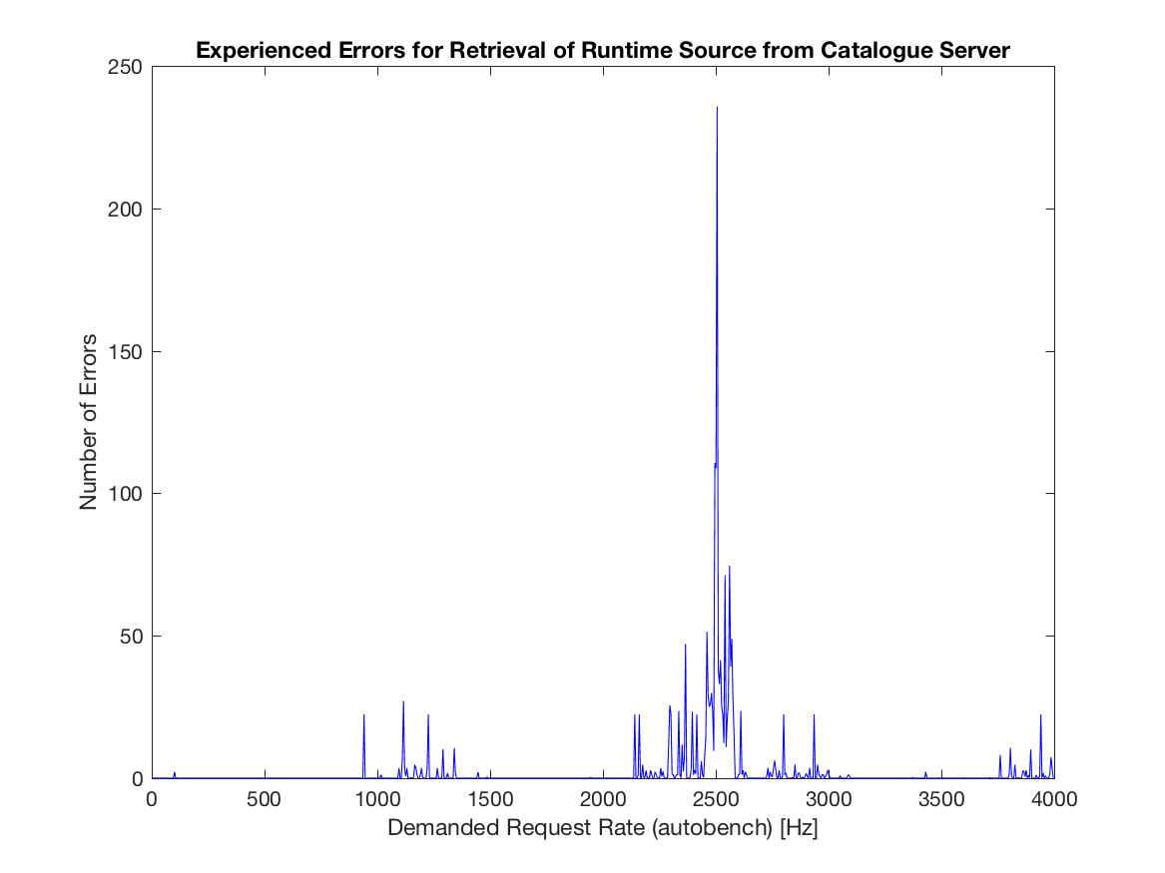

Figure -- Catalogue Assessment: Reported errors while retrieving the Source Code of the Defaul Hyperty

### Conclusions and recommendations

The goal of the Catalogue service is to store and provide descriptors of Hyperties, Runtimes, ProtoStubs, etc. available for use and to allow downloading their source code. The implementation of the Cataologue service assures response times in the order of a few milli-seconds. As seen in the following figure, downloading a the full source code of an Hyperty, Runtime, or ProtoStub only marginily effects the Catalogue's response time (here in the sub-one-millisecond order).

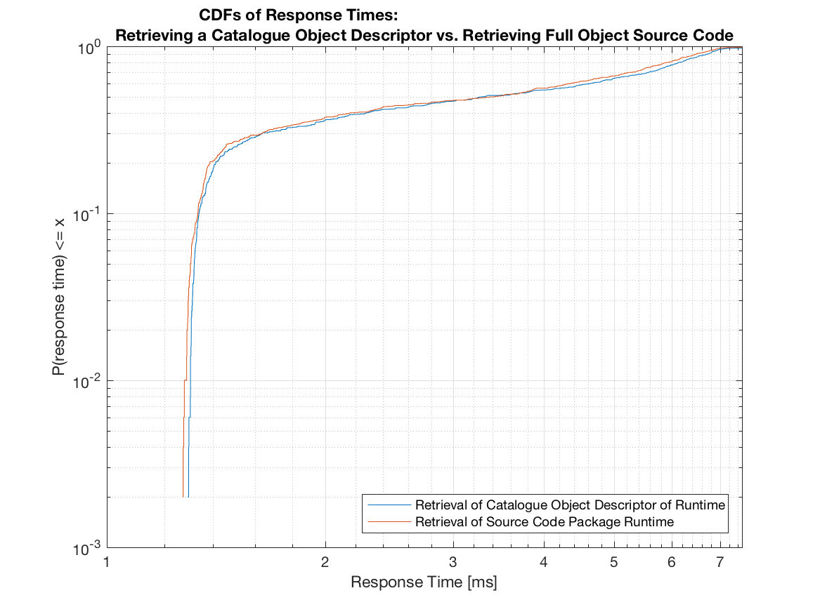

Figure -- Comparison of Response Times for Retrieving a Catalogue Descriptor Object vs. the Full Object's Source Package

As such, the implementation of the Catlogue is responsinve enough not to noticeable effect the establishment of end-to-end communication.

The implementation of the Catalogue service provides stable response times that are invariant against request rates below 500 Hz. Response times linearly increase from around 1.15 ms to around 8.54 ms for response rates up to 3000 Hz. As such, the implementation of the catalogue suits large scale proof-of-concept (pre-commercial) set-ups. It should be noted that this performance limitations is with regard to the number of simultaneous requests within a second and not with regard to the number of devices supported in a test bed. Statistically, a test bed may support a far larger number of devices as not all of them are likely to contact the Catalogue server simultaneously. In case a given deployment needs to server more than 500 (respectively 3000) requests within a one-second time frame, a deployment may evaluate "load distribution mechanisms" as, for example, natively offered by apache servers, which may forward incoming http-requests on a round-robin base to several servers (here catalogues) in the backend.

## Identity Provider

### Description of Component

The Identity Provider (IdP) provides a service that autenticates users, provides proofs of past authentication process (called identity assertions), and checks the validity of such assertions. It also provides IdP-Proxy to the IdModule deployed on the runtime so that this IdModule may interact with the IdP whatever protocol it may use.

Two OpenID Connect-compliant Identity Providers have been customised and deployed for demonstration purpose: 1. the first one is an OAuth2/OIDC server with added support for IdP-Proxy, adapted from agmoyano/OpenIDConnect [1]; 2. the second one is adapted from Nat Sakumura phpOIDC implementation [2].

### Metrics

Since IdP is a purely request-based service, the most relevant KPIs would characterize response time, for instance average response time and 9th decile: - for authentication requests, - for assertion generation, - for assertion verification.

However, IdP requests per user should be scarce compared to communication-related exchanges, especially on our testbeds which constitute more of a prototype environment. Moreover, the goal of reTHINK is to let the user choose his/her identity provider, which could thus be Google or Facebook. Therefore, tests limites tho the two provided IdP would not be relevant. Finally, it is not the responsibility of reTHINK to test reference implementation of identity protocols such as OpenID Connect. Indeed, IdPs are peripheral support services and will not be critical in evaluating overall environment performance. As a matter of fact, they are pre-existing (almost 'legacy') platforms whose functionalities are needed within reTHINK project but not results of reTHINK.

### Performance tests

No server performance tests are planned, as IdP servers are Open source project that have been modified to add the IdPProxy feature. This IdP proxy is executed on client side.

The application IdP-Proxy test is installed with the IdP Server and processes 3 actions: it loads the IdP-Proxy if implemented, generates and validates an Identity assertion if the user is logged on this IdP. An example of the application is accessible et https://auth.rethink2.orange-labs.fr/IdPProxy_test.html. Test application for the IdP Proxy:  


Tests conduced on IdP-Proxy have been conducted using a Firefox platform, and have provided the following results: - Javascript IdP-Proxy loading: - min time : 4ms - max time : 13ms - av time : 8.9ms - Javascript generate assertion - min time : 327ms - max time : 1235ms - av time : 553ms - Javascript validate assertion - min time : 147ms - max time : 296ms - av time : 214ms

It should be noted that the results are highly related to the client machine. Also, the length of the salt has a very low influence on the processing time.

### Identity parameters negotiation tests.

Conformance tests have been conducted to enable the use of IdP-Proxy according to the IETF specifications of the WebRTC Security architecture [3].  
As described in [Corre et al. paper](https://link.springer.com/chapter/10.1007%2F978-3-319-60131-1_27) We evaluated the possibility to deploy negotiation over ACR and IdP's origin with current WebRTC specications. Our conclusion shows that it is not possible to request ACR to IdP Proxy when calling the generateAssertion function. As a result, the specication would need to be updated to support ACR negotiation. In particular: the generateAssertion function could be extended to accept additional parameters, and the IdentityValidationResult could be left open to extensions.  
We implemented our identity parameters negotiation solution on the CS side as it was the simplest solution. As identity negotiation is most useful in scenarios of inter-operable communication services, such services could be acting as the identity recommendation source. This may seems to contradict theWebRTC trust model with untrusted CS. However, in the interoperable scenario, we may want to relax the trust model and consider that a CS may be trusted by its own user. In this situation a CS could be well-suited to provide recommendation and evaluation of the other-peer's authentication.  
This has been inplemented in a simple WebRTC application that uses our IdPProxy.  
Step one:  
Bob is connecting to his WebRTC Application (https://acor-webrtc.rethink2.orange-labs.fr/) using his identity, and opens a room.  
Step two:  
Alice connects to the same application ans join bob's room. At this stage, they can communicate, but no identity proof have been exchanged.  
Step three:  
Alice claims to Bob an Identity assertion, with a trust level to 2, and a hint to get a subset of accepted IdPs domains.  
Stet four:  
Bob is receiving the claim and sends his identity assertion.

# Development Evaluations

## Hyperty development evaluation survey

### Survey purpose.

The purpose of this sruvey was to evaluate the evolution of the feedback perceived from developers when developing hyperties to check the evolution of the project and compare with the results obtained from phase 1.

### List of questions included in the survey

1. Is the documentation clear and easy to find and understand?
2. Which parts of the reTHINK did you need to understand better to develop the hyperty?
3. Do you identify any part which would require a better documentation?
4. Do you understand how the syncher API works?
5. Do you find the reporter-observer pattern used for data exchange between hyperties helpful?
6. Do you understand the role of the Message Node?
7. Do you understand the role of the Registry domain? 8.Do you understand the role of the Catalogue node?
8. Is the provision of the Catalogue node easy?
9. Do you find the hyperty developer toolkit useful?
10. Is the documentation of the developer toolkit complete and easy to follow?
11. Is there any unclear or missing point the hyperty developer toolkit documentation?
12. Did you manage to implement all the features of your application for phase 2?
13. If you answered "No" to the previous question, please let us know what features you tried to implement and was not possible.
14. Did you manage to debug your application easily during the development?
15. Is clearly defined the border between Application and hyperty code?
16. Did you find any limitation of the Identity Management features provided by the Runtime?

### Is the documentation clear and easy to find and understand?

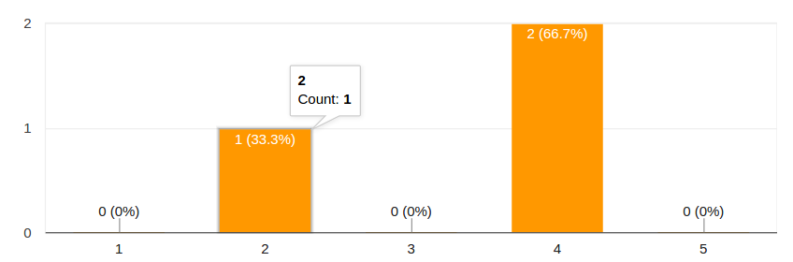

Answers for question 1

A light improvements has been registered from phase1 survey.

### Which parts of the reTHINK did you need to understand better to develop the hyperty?

The syncher was mentioned by all the participants in the survey. Other aspects mentioned are Message Bus, Discovery and Identity Management.

### Do you identify any part which would require a better documentation?

Syncher is also identied as the topic that would require more detailed and interactive documentation. Also the dataObjectReporter and Observer were mentioned.

### Do you understand how the syncher API works?

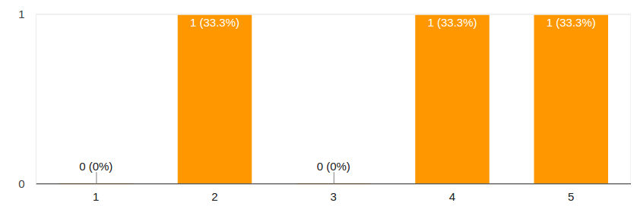

Answers for question 4

### Do you find the reporter-observer pattern used for data exchange between hyperties helpful?

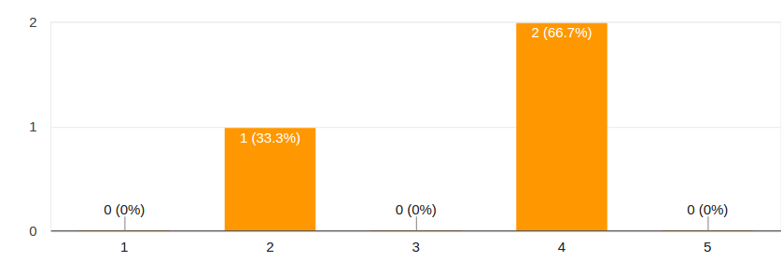

Answers for question 5

### Do you understand the role of the Message Node?

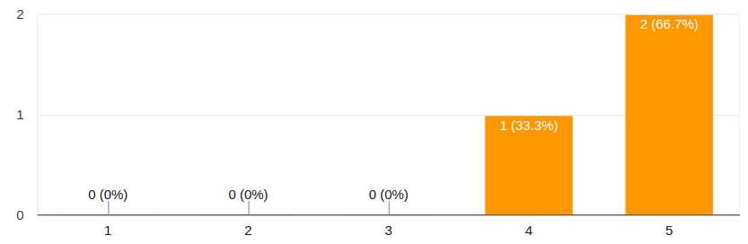

Answers for question 6

### Do you understand the role of the Registry domain?

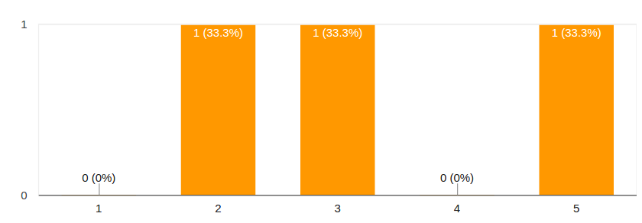

Answers for question 7

### Do you understand the role of the Catalogue node?

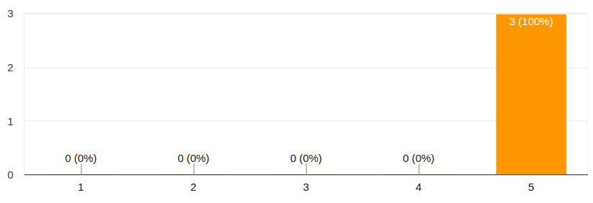

Answers for question 8

### Is the provision of the Catalogue node easy?

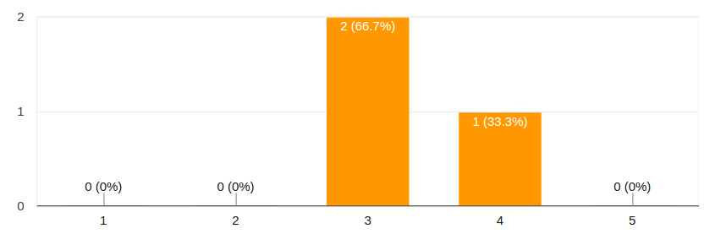

Answers for question 9

The provison of the Catalogue is found easier now by participants in the survey.

### Do you find the hyperty developer toolkit useful?

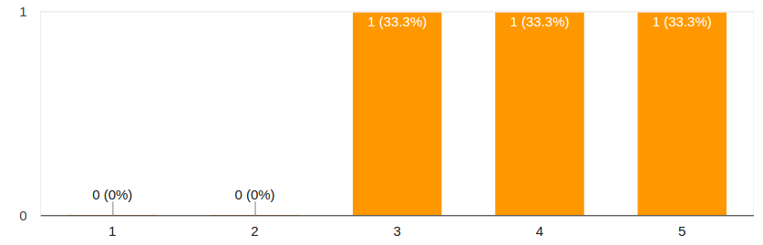

Answers for question 10

### Is the documentation of the developer toolkit complete and easy to follow?

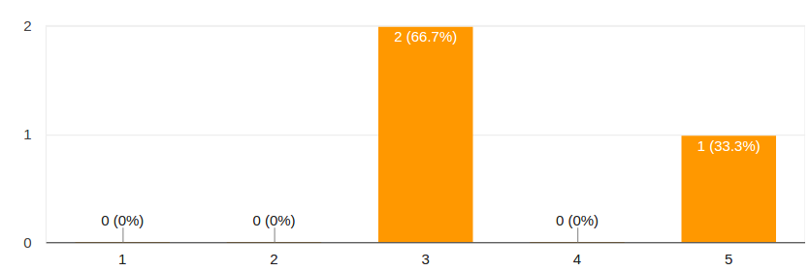

Answers for question 11

### Is there any unclear or missing point the hyperty developer toolkit documentation?

It was answered that the development of ProtoStubs and IdProxies was not correctly documented.

### Did you manage to implement all the features of your application for phase 2?

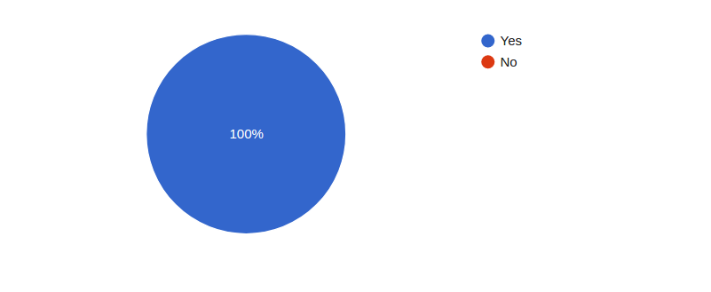

Answers for question 13

### If you answered "No" to the previous question, please let us know what features you tried to implement and was not possible.

No answers received for this point.

### Did you manage to debug your application easily during the development?

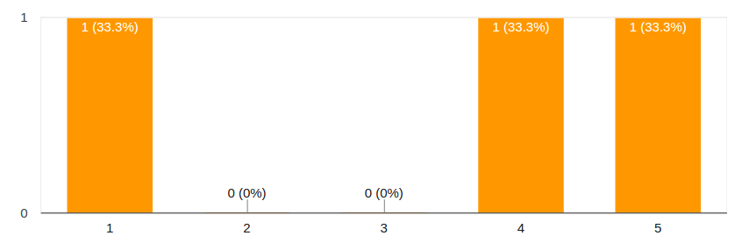

Answers for question 15

The results are better than the obtained for phase 1. However this is a point which should be addressed in the future to make development easier.

### Is clearly defined the border between Application and hyperty code?

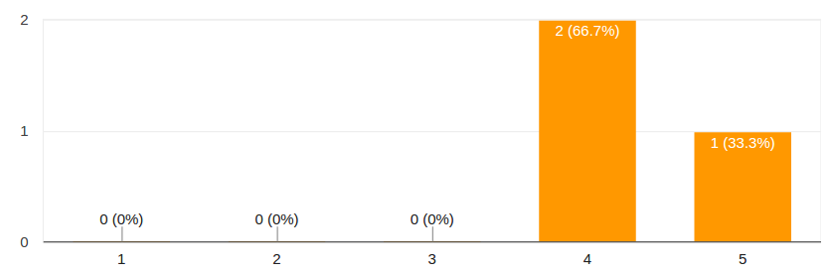

Answers for question 16

### Did you find any limitation of the Identity Management features provided by the Runtime?



Answers for question 17

The limitation found was a more complete information about the registered user

## Application development evaluation survey

### Survey purpose.

The purpose of this survey was to evaluate the evolution of the feedback perceived from application developers using the ReTHINK framework to check the evolution of the project and compare with the results obtained from phase 1.

### List of questions included in the survey

1. Do you now understand the reTHINK overall concept?
2. What feature/s of reTHINK framework does looks more promising to you?
3. Is the documentation clear and easy to understand?
4. Did you deploy your own reTHINK development environment or you use an existing one?
5. If you deployed your own development environment, how easy was it?
6. What hyperties does your application use?
7. Were the used hyperties well documented?
8. Did you manage to implement all the features of your application for phase 2?
9. If you answered "No" to the previous question, please let us know what features you tried to implement and was not possible.
10. Did you manage to debug your application easily during the development?
11. What would you like to improve/add in order to be able to debug ReTHINKs apps more easily?
12. Does the identity meet the requirements of your application?
13. Is clearly defined the border between Application and hyperty code?

### Do you now understand the reTHINK overall concept?

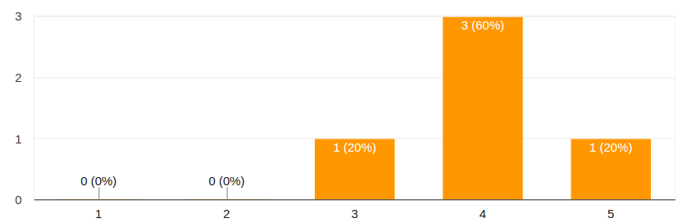

Answers for question 1

### What feature/s of reTHINK framework does looks more promising to you?

### Is the documentation clear and easy to understand?

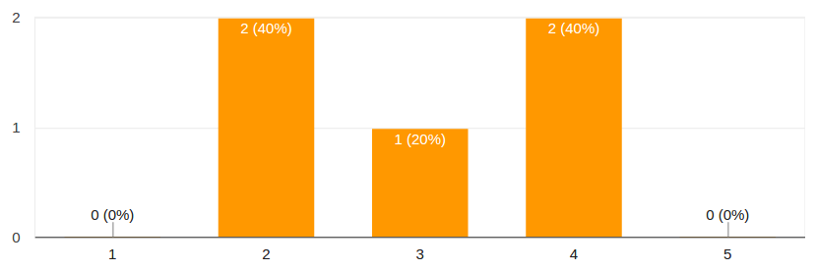

Answers for question 3

### Did you deploy your own reTHINK development environment or you use an existing one?

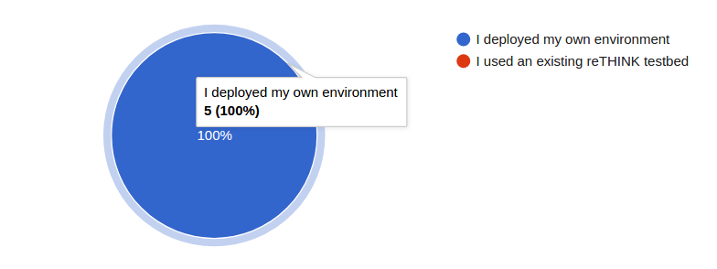

Answers for question 4

### If you deployed your own development environment, how easy was it?

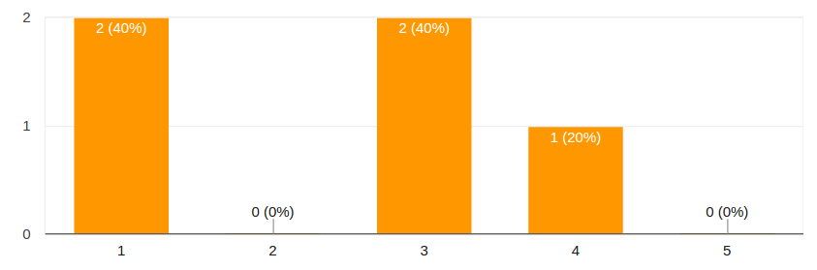

Answers for question 5

### What hyperties does your application use?

### Were the used hyperties well documented?

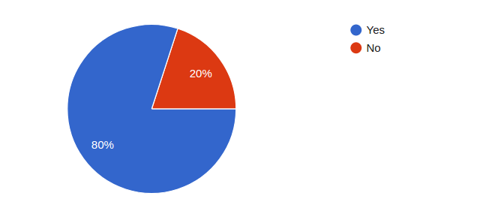

Answers for question 7

### Did you manage to implement all the features of your application for phase 2?

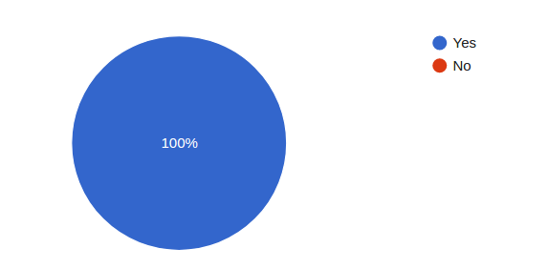

Answers for question 8

### If you answered "No" to the previous question, please let us know what features you tried to implement and was not possible.

### Did you manage to debug your application easily during the development?

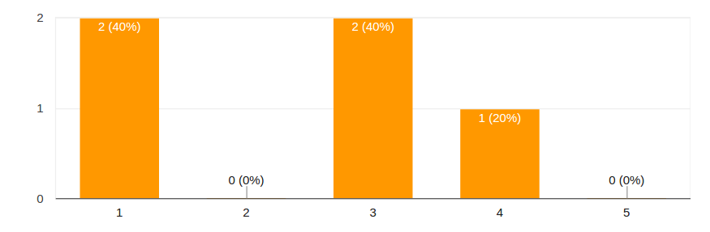

Answers for question 10

### What would you like to improve/add in order to be able to debug ReTHINKs apps more easily?

### Does the identity meet the requirements of your application?

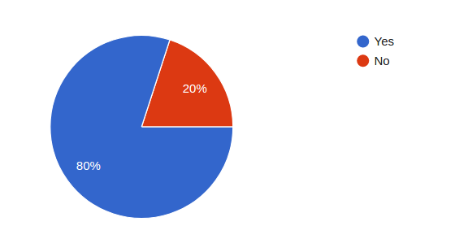

Answers for question 12

### Is clearly defined the border between Application and hyperty code?

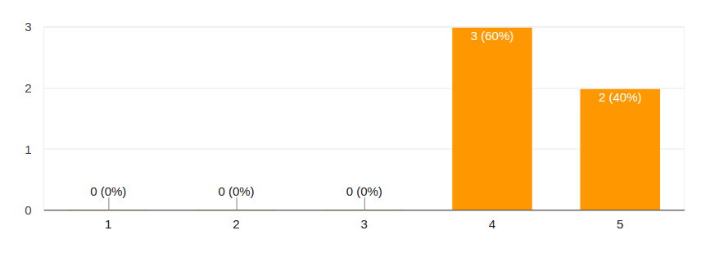

Answers for question 13

## Developer Competition Evaluations

INESC-ID and AlticeLabs organized a developer competition in Lisbon, which took place on Saturday, May 27th, 2017. The event was promoted via [Meetup](https://www.meetup.com/Decentralised-Comms-LX/events/239818330/). It started at 9:30 and lasted until 19:00, taking place at the Techtris House, a startup incubator and home to the WebSummit offices in Lisbon. The goals of the competition were to promote the ReThink platform and gather developer feedback. The competition had developers, who were completely unfamiliar with the ReThink platform, complete a set of 5 challenges. Challenges started with creating a simple application that made use of a Hyperty, progressing through combining multiple hyperties, creating a new hyperty and concluding with the development of a video-conferencing web application making use of available hyperties. At the end of each challenge, developers were asked to fill a questionnaire about the task they had just completed. The competition had 12 participants, grouped into 8 teams of at most two elements. Most participants were male, but a female attended. Participants’ ages ranged from 20 to 70 years. Two groups made significant progress into the fourth challenge. A jury made up of two INESC-ID and two Altice Labs representatives awarded the first prize (worth 500€) to Diogo Pereira. Participation awards were given to all participants. Overall, participants recognized value to the ReThink platform, saying they would recommend its use. Some of the suggestions included: * Offer built-in integration with front-end frameworks for UI creation * Having a larger offer of hyperties for developers to integrate into their apps

The most valuable features were found to be: * Ease of integrating hyperties for complex tasks into new applications * Ease of use * The ability to interoperate with applications from other developers by reusing their hyperties

These conclusion were reached though the use of the questionnaire presented in this section, that was used to evaluate different aspects of the reTHINK system and its development framework. The main goal of this questionnaire was to collect feedback on the reTHINK Beta Tester Event, organized on May 27th for a limited number of outside developers. This questionnaire was divided into seven sections. One section for team caracterization and background, five sections corresponding to each of the challenges and a last section for overall evaluation.

The collected feedback from this survey will be used to identify and improve on the weaker parts of the framework, making the system more usable. It will also allow us to evaluate how well understood are the most important concepts, so that we may improve the documentation and training material.

This event was a success, allowing us to collect very useful feedback. The following preliminary conclusions are highlighted:

* Participants found Hyperties are easily integrated into Apps. However, more examples are required
* All participants considered reTHINK easy to use
* The reTHINK library logging is too verbose
* Documentation needs to be improvement
* All participants expressed the intention to use the reTHINK framework again in future projects
* It would be great if reTHINK was supported in more browsers
* The authentication GUI needs improvements in terms of user interface
* The Hyperty toolkit was appreciated by participants
* It would be great if reTHINK had built-in integration with front-end frameworks and examples

### Survey - Teams presentation and background

This section of the survey was used to collect information about the participants. Participants could enter the competition alone or in teams of two elements. In total, this event had twelve participants divided into eight teams. Not all of them answered all the questions.

1. How old are you?

* 20-25 (8)
* 25-30 (1)
* >70 (1)

1. What is your genre?

* Male (11) - 92%
* Female (1) - 8%

1. What is your academic background?

* Electronics and Electrical Engineering (2) - 18%
* Computer Science Engineer (7) - 64%
* Telecommunications Engineer - 9%
* ENGINEER ( X67 + ENPC72 ) - 9%

1. How much knowledge do you have about web application development?

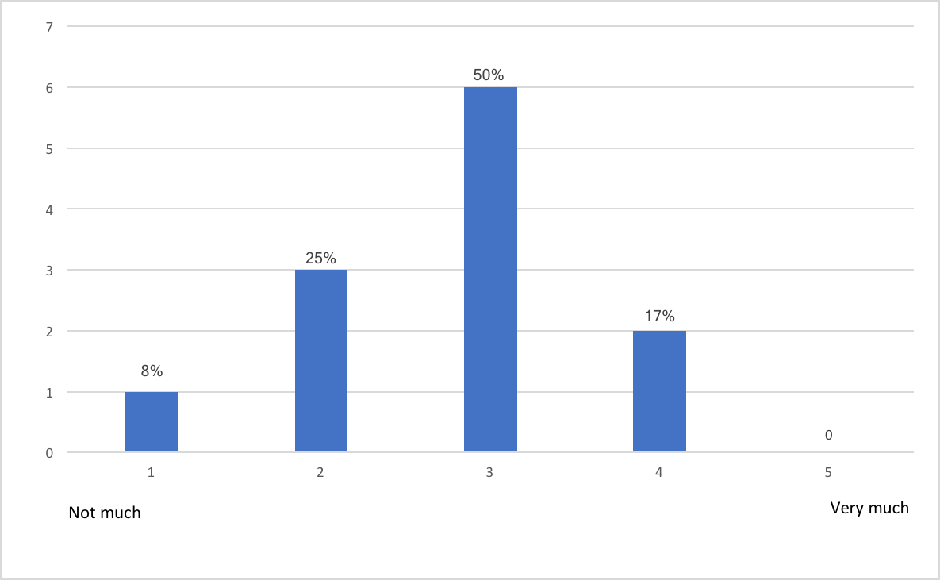

1-5

1. Do you have any experience with frameworks for web application development?

* Yes (5) - 58%
* No (7) - 42%

1. Select all the programming languages that you already work with.

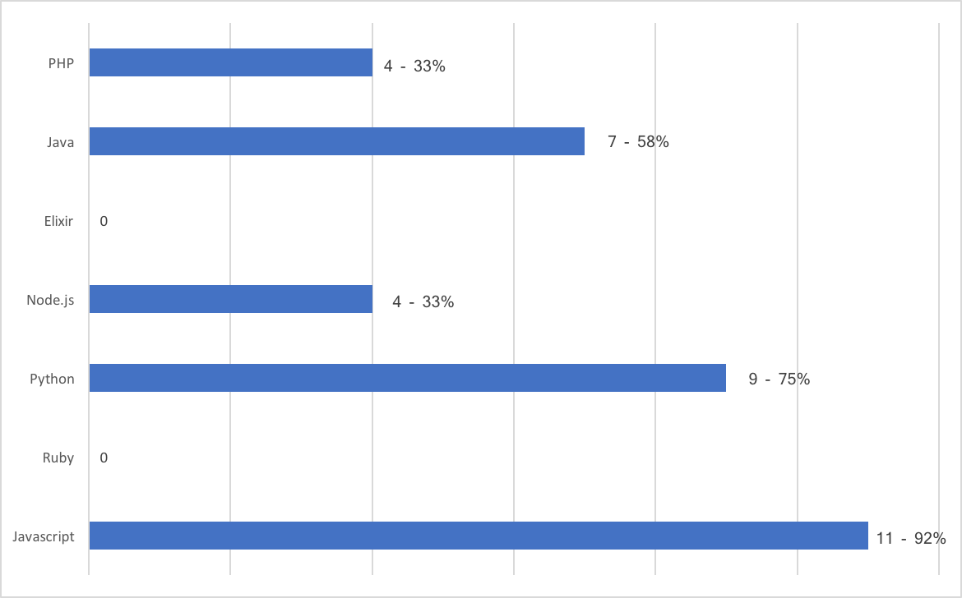

1-7

1. Select all the frameworks for web application development that you already work with.

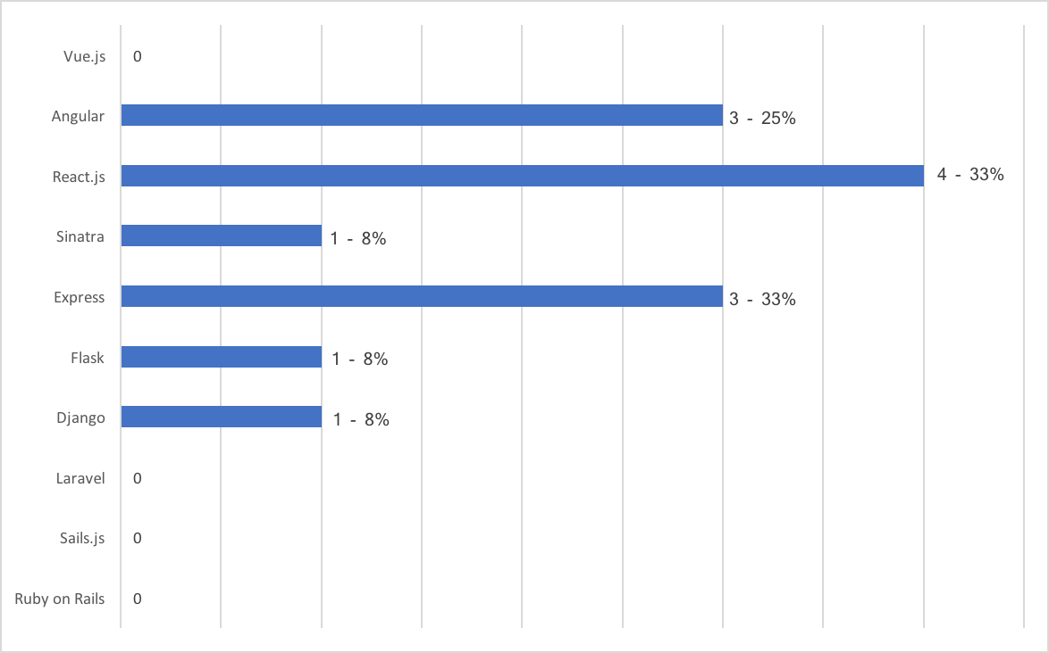

1-8

### Survey - First challenge

This section corresponds to the first challenge of the event that each team had to complete. The main goal of this first challenge was to provide a first contact with the reTHINK framework. Each team had to developed a simple web application that uses an hyperty called CodeGeneratorReporter, taking advantage of its features. This hyperty provides a numerical code depending of the team's name, that should be passed as input. This challenge was divided into two tasks. The first task was to install the reTHINK framework and to load the CodeGeneratorReporter hyperty. The second task was to use the features of the loaded hyperty.

1. How easy was to include Hyperties in your application?

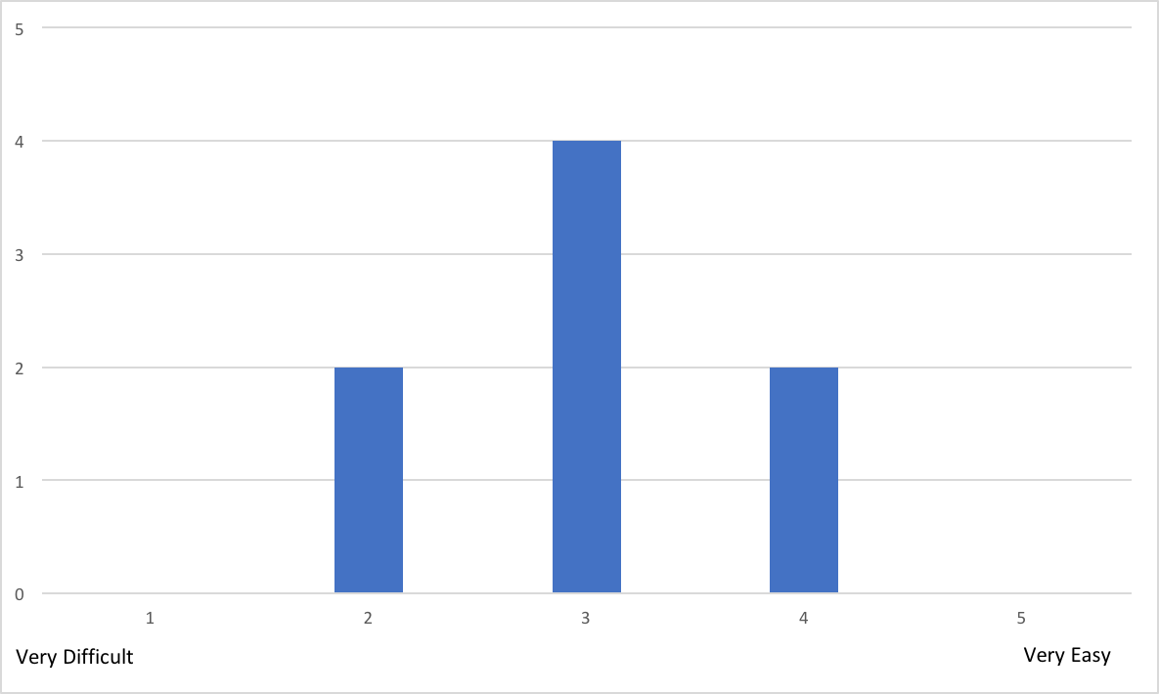

2-1

Most relevant comments to the previous question:

* Without the tutorial and further instructions, we would have taken a lot more time.
* After launching and installing, it was difficult to understand that authentication was needed and where to find a button to authenticate using Google

1. How much knowledge about reTHINK do you think is required to use it?



2-2

Most relevant comments to the previous question:

* You have to have minimal understanding of the framework (conceptually) to be able to understand how to use it.
* It's needed a good knowledge because is lacking some documentation

1. How much time did you spent reading the documentation? (estimate)

* 10min
* 15min (2)
* 20min (2)
* 30min
* 1h
* 2h

1. Did you manage to easily test and debug your application?

* Yes - 100%
* No - 0%

Most relevant comments to the previous question:

* The application itself was simple enough that testing and debugging were not a big problem. However, the rethink library logging is maybe a little too verbose.

1. How much time did you spent in the 1st task? (estimate)

* 10min
* 15min (2)
* 20min
* 30min
* 50min
* 1h
* 3h

**Note: Our estimate for this task was 45 minutes. The average time of the participants was 48 minutes.**

1. How much time did you spent in the 2nd task? (estimate)

* 5min
* 10min
* 20min
* 35min
* 1h
* 1h45min
* 2h (2)

**Note: Our estimate for this task was 30 minutes. The average time of the participants was 44 minutes.**

1. Which task gave you the most trouble? And why?

* No problem (4)
* Task 1, due to misunderstanding of the script (2)
* The second task was harder because of some misunderstandings (2)

1. Did you manage to use the Identity Management features?

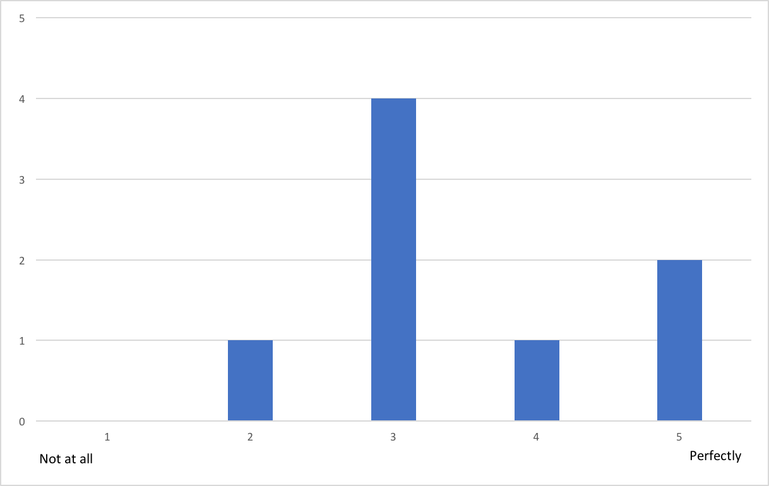

2-8

Most relevant comments to the previous question:

* Unfortunately only google appeared to work.
* It was difficult to understand that authentication was needed and where to find to google button to authenticate
* It did not seem to work very well. For example, I tried to login using Slack, but it would always open a Google authentication page, even though the page clearly displayed Slack as the IDP. It was also not possible to add a second Google account.

1. Let us know what limitations you found and how you would improve it.

* It would be useful (at least for developers) to be able to use anonymous identities.
* Excessive Logging
* When a user can authenticate with the Google Services, a dedicated button should be displayed, instead of being inside a dropdown menu
* Better documentation and some good tutorials to get people started
* The main limitation I identified was with the identity management feature

1. Classify your experience with reTHINK in this first challenge.

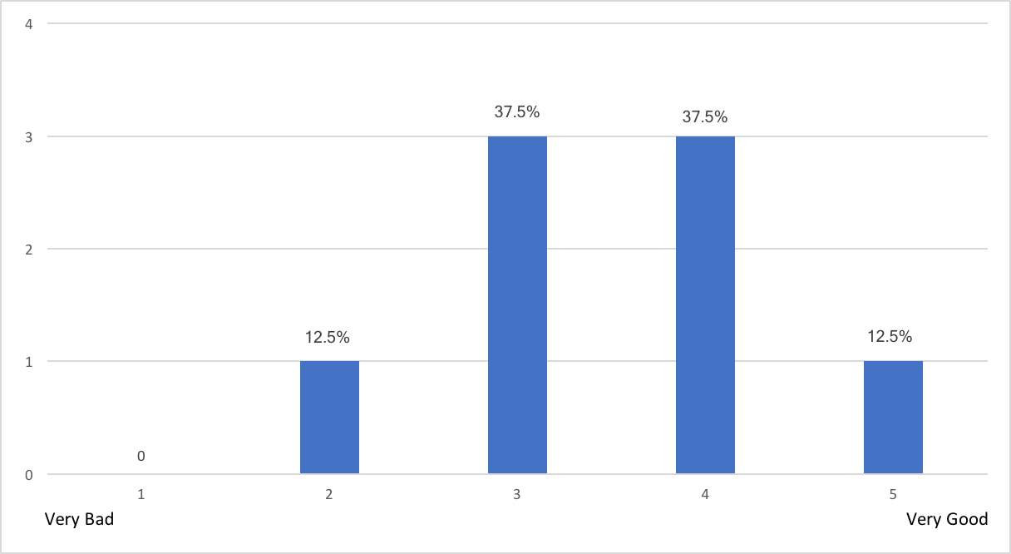

2-10

#### Conclusion:

Each team completed with success this first challenge and we were able to collect very useful feedback about reTHINK and its features. There were positive aspects, such as:

* Even with minimal knowledge about web application development, all participants were able to use reTHINK and complete this challenge;
* All participants considered reTHINK easy to use;
* All participants considered it easy to load Hyperties into their web applications.

However, we also collected some negative feedback that should be addressed, such as:

* The authentication GUI, in terms of user interface, was difficult to understand for some participants;
* Without the tutorials and instructions available during the event, the participants recognized that it would have taken them much longer to complete all the tasks;
* Lack of documentation;
* The reTHINK library logging is maybe a little too verbose.

### Survey - Second challenge

This section corresponds to the second challenge of the event that each team had to complete. The main goal of this second challenge was to combine multiple hyperties into a web application. Each team had to developed a more complex web application, in terms of user interface, that uses the CodeGeneratorReporter and GroupChatManager hyperties. This challenge was divided into three tasks. The first task was to load two hyperties. The second task was to develop all the user interface to deal with all the features of the GroupChatManager hyperty e.g. creation of chat rooms, sending messages (chat capabilities). And finally, the third task was to combine the two loaded hyperties.

1. How easy was it to include more than one Hyperty in your application?

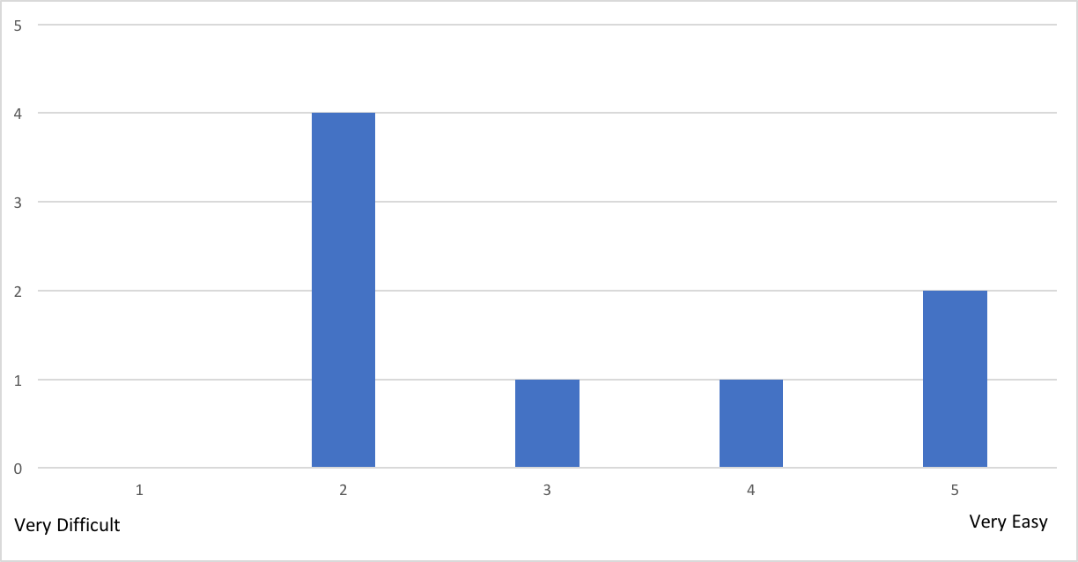

3-1

1. Were the used Hyperties well documented?

* Yes - 62,5%
* No - 37,5%

Most relevant comments to the previous question:

* The documentation is OK, but sometimes not entirely clear.

1. How much knowledge about reTHINK do you think is required to use it?

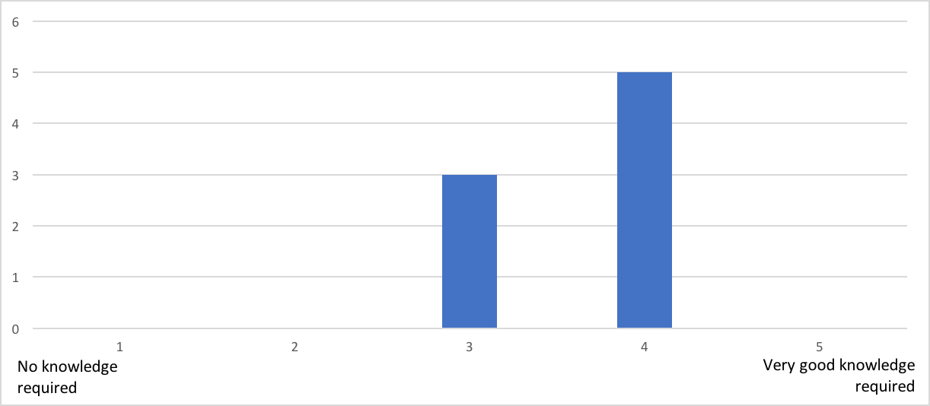

3-3

Most relevant comments to the previous question:

* You can get it working with only basic knowledge, but then you may find some things a bit confusing (for example, the domain when inviting users).

1. How much time did you spend reading the documentation? (estimate)

* 5min (2)
* 15min
* 20min
* 30min
* 1h
* 2h
* 3h

1. How much time did you spent in the 1st task? (estimate)

* 5min (2)
* 10min (2)
* 20min (2)
* 30min
* 1h

**Note: Our estimate for this task was 15 minutes. The average time of the participants was 19 minutes.**

1. How much time did you spent in the 2nd task? (estimate)

* 30min
* 1h
* 1h40min
* 2h
* 2h15min
* 3h (2)

**Note: Our estimate for this task was 150 minutes. The average time of the participants was 115 minutes.**

1. How much time did you spent in the 3rd task? (estimate)

* 5min (2)
* 30min (2)
* 40min
* 45min

**Note: Our estimate for this task was 15 minutes. The average time of the participants was 26 minutes.**

1. Which task gave you the most trouble? And why?

* The second task, especially the user join (2)
* In the third task there was a small problem when trying to authenticate with an anonymous mozilla tab were the menu would not normally appear, giving an error on the console, in chrome it worked as normal (2)

1. If you had to implement another chat application would you choose the reTHINK framework again?

* Yes - 100%
* No - 0%

1. Justify your answer to the previous question.

* With the experience we have now, it is quite easy and intuitive to implement this functionality using reTHINK.
* Ease of use
* Even though it was hard to start, with some practice from myself the framework would be great to make new projects in the future
* After realizing the operation is relatively simple and simplifying the use compared to the traditional method
* It is relatively simple to use but needs better documentation
* The yes is actually a maybe. I think there are some good things in reTHINK. It was very easy to create a chat room, invite other users and send messages. However, I am concerned about the stability of the platform. I often experienced timeouts and strange errors that would only go away after clearing the cache.

1. If your answer was "No" to question 9, which framework/libraries would you choose then? And why?

* I'm not sure. I'm not very familiar with the options out there. I might take a look at XMPP, but I would probably not want to use it for a simple chat application on the web.

1. Let us know what limitations you found and how you would improve it.

* Async system not fully functional
* The only problem I had with the framework was when trying to authenticate with the anonymous firework page
* It's mostly lack of documentation and having to use ".instance" to access methods is unintuitive
* Frequent errors/timeouts.

1. Classify your experience with reTHINK in this second challenge.

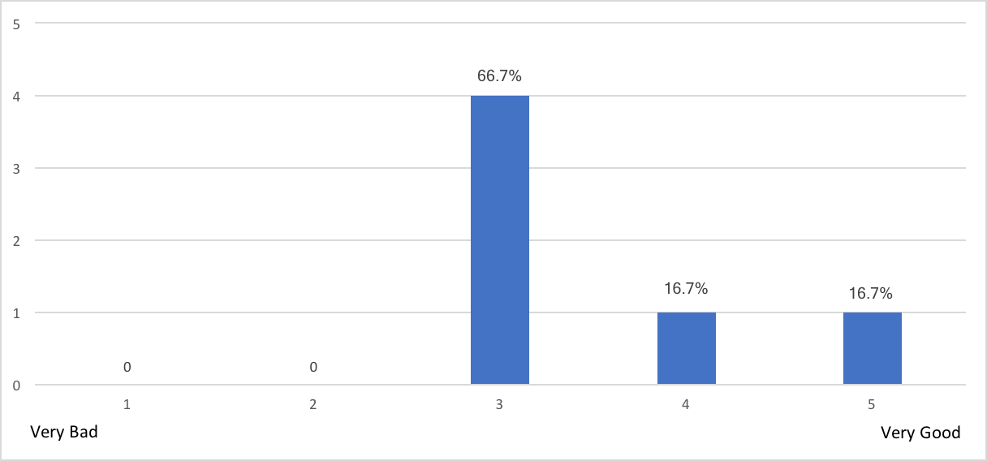

3-13

#### Conclusion:

Only four teams were able to complete this second challenge with success. In spite of this, it was still possible to collect some useful feedback about reTHINK and its features. There were positive aspects, such as:

* The participants recognized that if they had a bit more practice with the framework, they would use it in future projects;
* All participants would use reTHINK framework again to develop new chat applications;
* It is quite easy and intuitive to implement chat functionality using reTHINK.

However, we collect also some negative aspects that should be considered, such as:

* Lack of documentation and sometimes the existing documentation is not entirely clear;
* Problems arise if the used browser is not Chrome;
* Some timeout errors and no explanation for them;
* The fact that it is necessary to clean the cache constantly is a bit dull.

### Survey - Third challenge

This section corresponds to the third challenge of the event that each team had to complete. The main goal of this third challenge was to change the CodeGeneratorReporter hyperty functionality, reusing the previous developed application. Now, this hyperty should generate a code and a timestamp according to the team's name, that should be passed as input. This challenge was divided into two tasks. The first task was to configure the hyperty toolkit, following the available documentation on the reTHINK repository. The second task was to change the hyperty functionality and to use it in the developed application.

1. How easy was it to setup the reTHINK environment in your local machine?

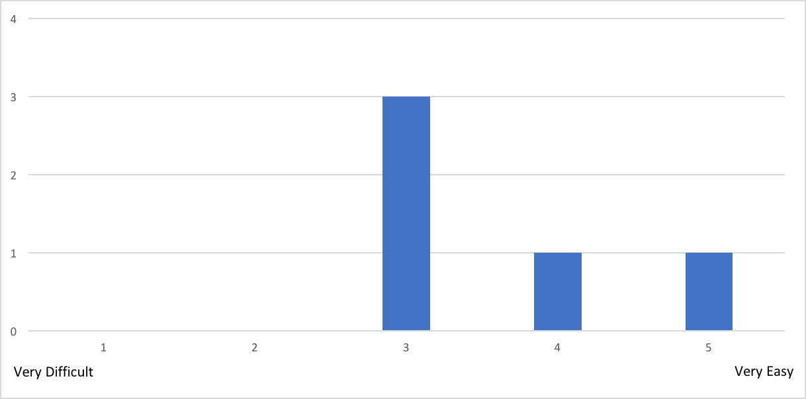

4-1

Most relevant comments to the previous question:

* We had problems installing the correct branch (so, our fault), but the branch had a mistake.

1. How much knowledge about reTHINK did you think is required?

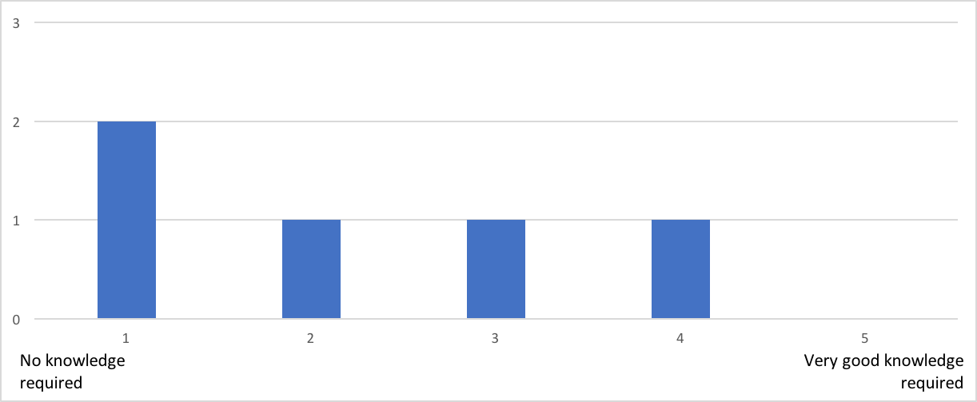

4-2

1. How much time did you spent reading the documentation? (estimate)

* 10min (2)
* 30min
* 3h

1. Did you have problems with the reTHINK environment configuration? Justify.

* No (2)
* No, most problems were small mistakes on the developer's end.
* My Ubuntu 17.04 did not have a "node" binary, instead it is called "nodejs". I had to apt install nodejs-legacy for the build to work. I also had a problem when running it because it was trying to bind to a low port (<1024). I figured it out pretty quickly, but the error message is not very descriptive. I also eventually found a note about this in the Wiki, but by that time I had already Googled the problem and solved it. It would be better to mention it in the README, because everyone who uses Linux is going to have the same problem.

1. How much time did you spent in the 1st task? (estimation)

* 25min
* 30min
* 1h
* 1h30min

**Note: Our estimate for this task was 35 minutes. The average time of the participants was 51 minutes.**

1. How much time did you spent in the 2nd task? (estimation)

* 0min
* 5min
* 20min
* 3h

**Note: Our estimate for this task was 40 minutes. The average time of the participants was 51 minutes.**

1. How easy was it to change the Hyperty functionality?

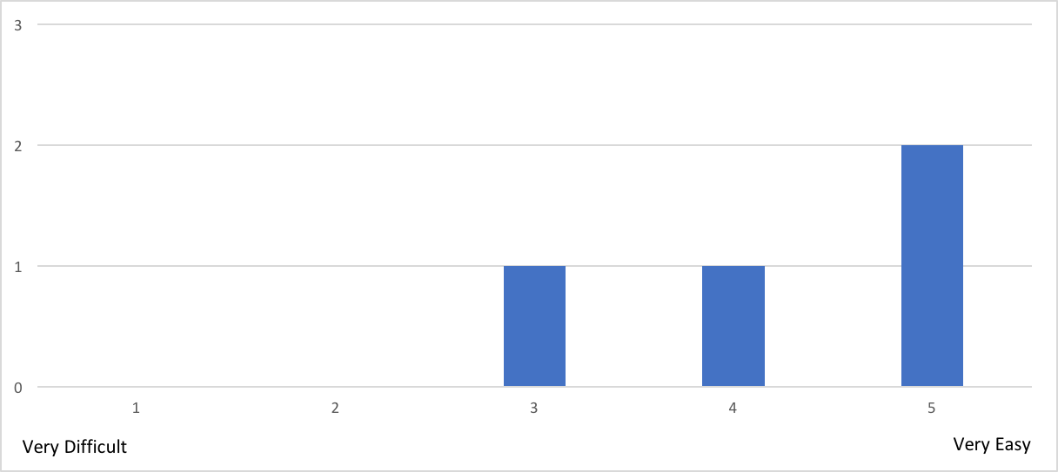

4-7

1. Let us know what limitations you found and how you would improve it.

* Only being able to have 1 tab open loading a certain hyperty lost us a bit of time.

1. Classify your experience with reTHINK in this third challenge.

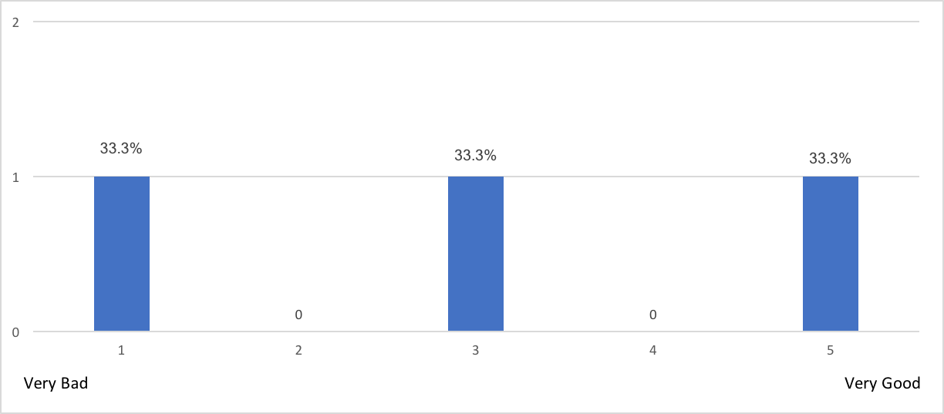

4-9

#### Conclusion:

Only two teams were able to complete this third challenge with success. In spite of this, it was still possible to collect some useful feedback about the development of hyperties. There were positive aspects, such as:

* Most of the participants considered it easy to setup the reTHINK development environment (hyperty toolkit);
* Most of the participants considered it easy to change the hyperty functionality.

However, we collect also some negative aspects that should be considered, such as:

* Lack of documentation;
* Only being able to have 1 tab open loading a certain hyperty.

### Survey - Fourth challenge

This section corresponds to the fourth challenge of the event that each team had to complete. The main goal of this fourth challenge was to develop a video conference application. This application should cover some functional requirements, such as the creation of chat rooms with the possibility of inviting users to join in, A/V calls between users and the possibility to make A/V calls at the same time that a chat room is available (exchanging messages). This was an open challenge in which the participants could choose hyperties already available or develop their own hyperties.

Unfortunately, neither of the teams that made it to this challenged, managed to finish this challenge in time. Below are listed all the questions and some of the collected answers.

1. Did you choose to develop new Hyperties? If yes, describe them briefly. If not, pass to the sixth question.
2. How easy was to develop new Hyperties?
3. How much knowledge about reTHINK did you think is required?
4. How much time did you spent reading the documentation? (estimate)
5. Which features did you tried to implement that gave you the most trouble? After answer to this question, pass to the tenth question.
6. Which Hyperties did you use?
   * CodeGeneratorReporter, GroupChatManager and Connector
   * GroupChatManager
7. In your opinion, how hard would it be to develop new hyperties?

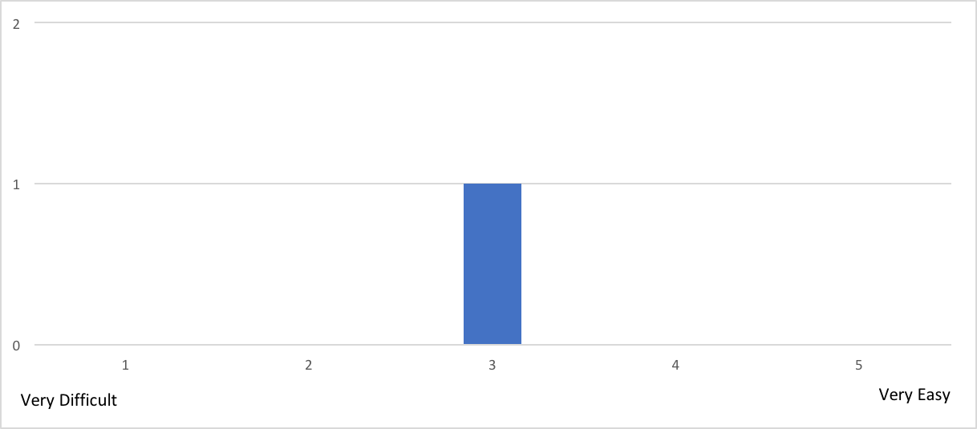

5-7

Most relevant comments to the previous question:

* We didn't have time to attempt to create a hyperty from scratch, so we cannot infer the difficulty. Based on changes made in challenge 3, it seems manageable
* It's hard to tell. Modifying the hyperty in challenge 3 was very easy, but I did not have the chance to build a new one from scratch. Still, looking at the code of the existing hyperties, it does not seem too difficult.

1. Did you try to change or add new functionalities to the used Hyperties?

* No (2)
* Yes (0)

1. If your answer to the previous question was "yes", what did you try to implement?
2. Let us know what limitations you found and how you would improve it.
3. Classify your experience with reTHINK in this fourth challenge.

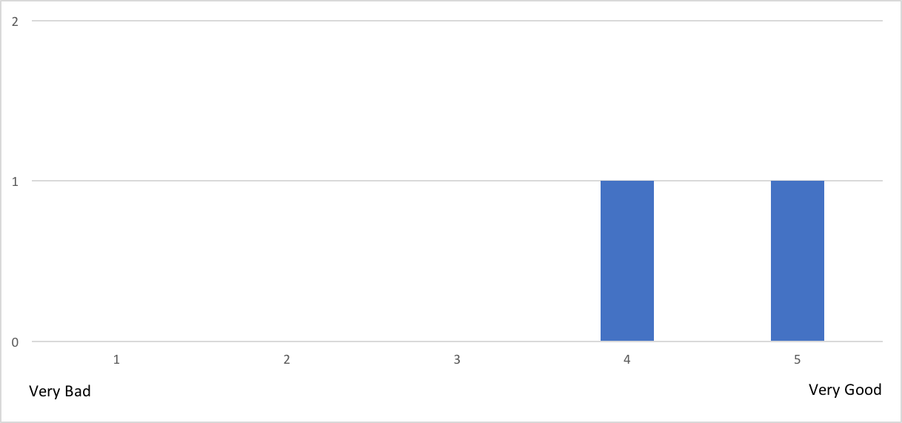

5-11

### Survey - Fifth challenge

This section corresponds to the fifth challenge of the event that each team had to complete. The main goal of this fifth challenge was to develop a new hyperty from scratch. Each team was free to design the hyperty, as well as the web application that uses it.

Unfortunately, no team reached this challenge, so we could not collected answers. Below are listed all the questions.

1. Describe briefly the developed web application.
2. Describe briefly the developed hyperties.
3. How easy was to develop new Hyperties?
4. How much knowledge about reTHINK did you think is required?
5. How much time did you spent reading the documentation? (estimate)
6. How useful and complete is the available documentation to support the development of Hyperties?
7. Please provide your suggestions to improve the documentation.
8. Which features did you tried to implement that gave you the most trouble?
9. Classify your experience with reTHINK in this fifth challenge.

### Survey - reTHINK Overall Evaluation

This section of the survey was used to make an overall evaluation about reTHINK.

1. Which framework for web application development would you recommend? And why?

* reTHINK
* Never used frameworks to develop web applications
* We haven't used other web frameworks
* ReactJs, as it has a healthy community, it is well supported, large heaps of documentation and the developer experience in general is very pleasant.
* I don't have enough experience with web frameworks to make a recommendation

1. Taking into account your experience in web application development, how do you compare reTHINK framework with other web frameworks?

* I liked reTHINK but hadn't much experience with others
* We haven't used other web frameworks
* All the challenges we did were easy to implement with reTHINK. Unfortunately, we couldn't experience how it would work when used with a real-life application, but we consider it would be manageable. It needs more extensive documentation, especially on the demos.
* Again, not enough experience to compare.

1. How easy was it to understand the reTHINK documentation?

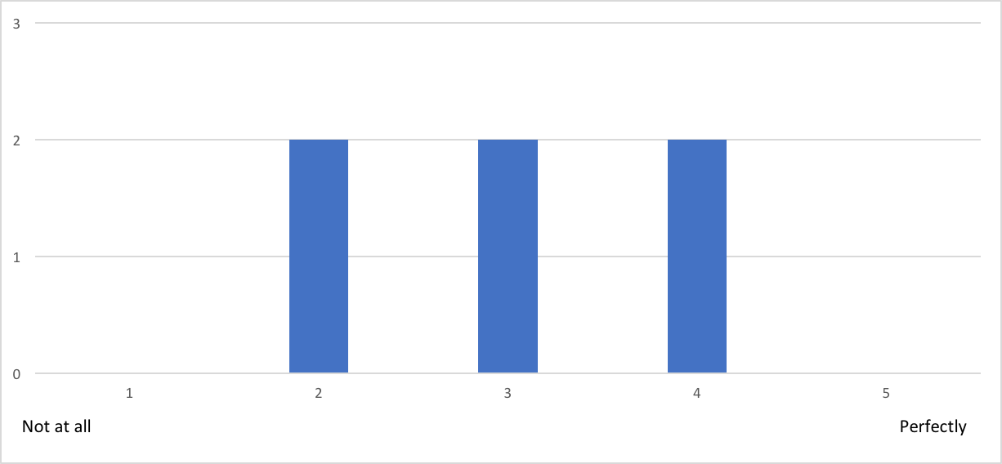

6-3

1. What features of the reTHINK framework look more promising to you?

* The fast chatrooms creations
* It's ease to use in projects. Doesn't require much to run in a script
* We think the most important feature (killer-app) of the reTHINK framework is the possibility of completely different and independent developers developing compatible applications without needing to standardize protocols
* The best thing about reTHINK is how simple it is to take the "plug-and-play" hyperties and build an application out of them

1. In your opinion, what are the main benefits of using Hyperties?

* The mainly benefits is maybe the with some training you could achieves good results fast
* It's easy to use Hyperties in an application
* Hyperties shine when developing complex applications that need to interact with different domains. It simplifies the process of managing connections, domains, etc, which greatly improves the developer experience
* Easy discovery. Things seem to "just work" (at least when they don't timeout)

1. What features would you like to see in reTHINK framework?

* For now none, but we still have to explore the framework better
* Built-in integration with front-end frameworks and examples
* More hyperties! I think the best way to popularize it would be to have the basic building blocks ready, so you can quickly build an application out of them

1. Would you recommend the reTHINK framework?

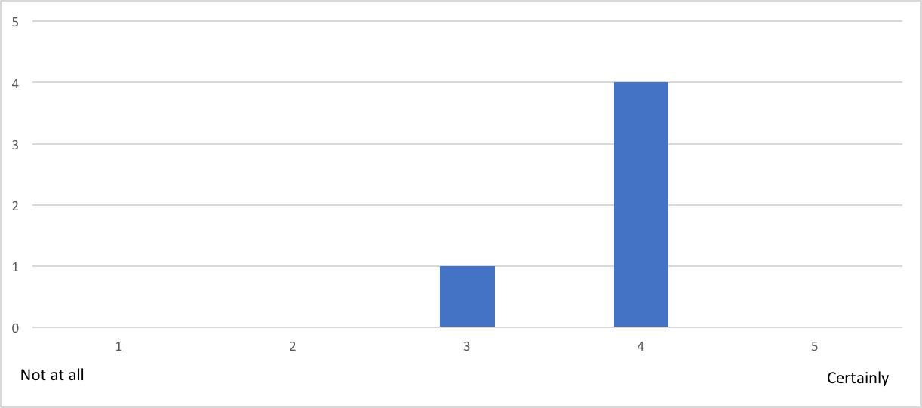

6-7

#### Conclusion:

Taking into account all the feedback, the overall evaluation of reTHINK seems promising. There were positive aspects, such as:

* Most of the participants were very enthusiastic about the framework;
* Most of the participants suggested new features.

However, we collect also some negative aspects that should be considered, such as:

* The documentation needs a few improvements in order to be more understandable;
* Participants would like to see more hyperties in reTHINK.

## Overall Evaluation

# Trials Evaluations

This section provides an evaluation of conducted trials with a special focus on the main challenges addressed by the reTHINK framework:

* Interoperability with mush less standardisation effort thanks to some novel concepts like the protocol on-the.fly
* Identity management decoupled from service provider giving back the power to user to decide who to trust
* Cross domain discovery

## Interoperability Tests

This documents provides guidelines to perform interoperability tests with reTHINK framework. Before you go ahead with these tests it is recommended to be familiar with main reTHINK concepts enabling full interoperability among services without having to standardize protocols or service APIs, as described *here (link to startup concepts wiki page)*.

The following tests allow to verify the usage of these concepts to support adhoc interoperability (i.e. interoperability between endpoints without previous knowledge) at different levels:

* Interoperability between two reTHINK different domains using different Messaging Nodes implementations including Protostubs but using the same Hyperty implementations.
* Interoperability between two reTHINK different domains using different Messaging Nodes implementations including Protostubs and different Hyperty implementations.
* Interoperability with legacy services, i.e., between one Hyperty and some non-reTHINK service.

For each of these tests, the latency will be measured for two scenarios:

1. when communication occurs for the first time between the two peers. In this situation, the protocol stub and the Idp Proxy has to be downloaded from the catalogue and deployed in the runtime.
2. it is not the first time the communication occurs between the two peers. In this situation, the protocol stub and the Idp Proxy is cached locally and does not have to be downloaded from the catalogue.

### Tests Setup

Interoperability tests can be performed partially locally or fully using back-end services like the ones provided by reTHINK testbeds. In both options two Google accounts are required.

#### Interoperability Tests Setup with remote domains

This is the simplest setup environment where no service has to be installed locally. Only standard Browsers are required. The usage of Chrome or Firefox *(which versions?)* are recommended. The *hysmart* testbed from Altice Labs using the [vertx](https://github.com/reTHINK-project/dev-msg-node-vertx) Messaging Node implementation and the *Tlabs* using the [Matrix based Messaging Node](https://github.com/reTHINK-project/dev-msg-node-matrix), are used in these guidelines but any reTHINK compliant testbed can be used. Just follow the [Quick Installation Guide for reTHINK Framework](https://github.com/reTHINK-project/specs/blob/master/deployment/readme.md) to deploy your own reTHINK domain or testbed.

#### Interoperability Tests Setup with one localhost domain and one remote domain

In this setup environment, one of the domains is installed as localhost. This kind of setup environment is useful to test locally some developments before deploying in testbeds. It also gives you more freedom to decide on the implementation to be used including your own implementation, if that is the case.

**Localhost installation:**

1. Toolkit installation: follow the quick toolkit installation guide as provided [here]((https://github.com/reTHINK-project/dev-hyperty-toolkit#quick-start).
2. Domain Registry installation: follow the installation guide [here](https://github.com/reTHINK-project/dev-domain-registry/readme.md)
3. Messaging Node installation: select one of the following Messaging Nodes implementation and perform the provided installation procedures:

* [VertX](https://github.com/reTHINK-project/dev-msg-node-vertx)
* [Matrix](https://github.com/reTHINK-project/dev-msg-node-matrix)
* [NodeJS](https://github.com/reTHINK-project/dev-msg-node-nodejs)
* [no Matrix](https://github.com/reTHINK-project/dev-msg-node-nomatrix)

### Cross-domain with different protocols

The cross-domain interoperability test with different protocols allows to test how two domains using different messaging communication protocols, i.e. using two different Messaging Nodes implementations can interoperate without having to agree in advance on the protocol to be used.

#### Group Chat interoperability test

Step 1: Open one browser window at https://rethink-project.github.io/dev-smart-contextual-assistance-app/ and select "Connector Hyperty". A window will be opened asking you to select the Identity Provider to be used.

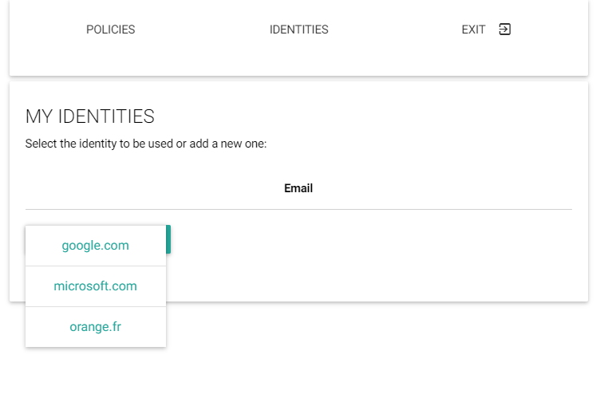

Select your Identity Provider

Select Google and request to login,

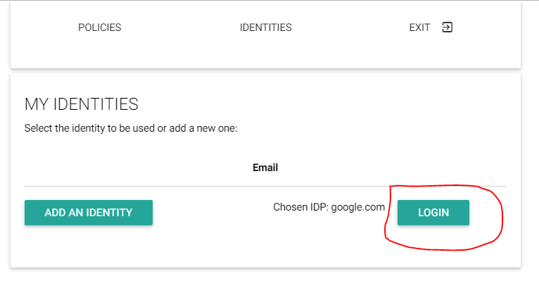

Ask to Login with Google

and authenticate with your first Google account:



Login with Google Account

Give some time to load the runtime and Hyperties used by the Smart Contextual Application. When loaded you should see the following window:

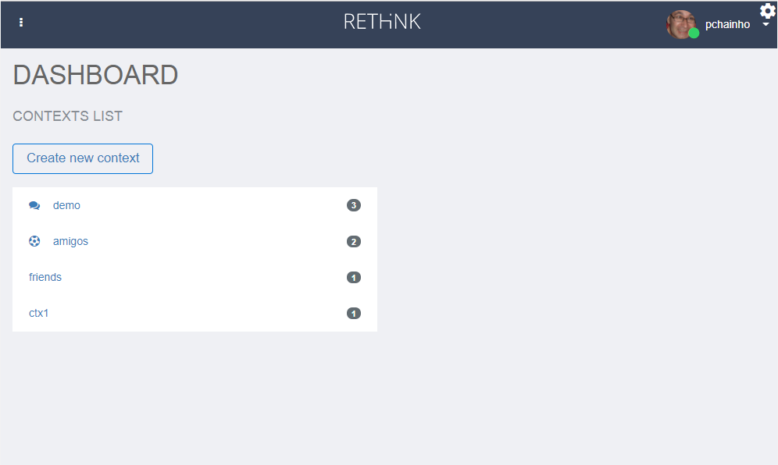

Smart Contextual Home

Step 3: Open a second browser window in anonymous mode at https://rethink-dev.tlabscloud.com/. The procedure to select an IdP and login with your second Google account, should be performed. Again, give some time to load the runtime and Hyperties used by the Call Center Application. When loaded you should see the following window:

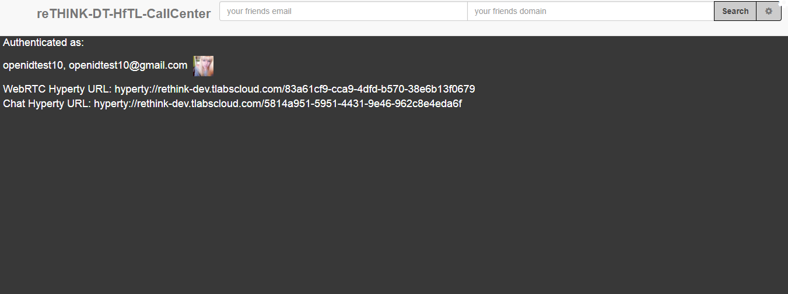

Call Center Home

Step 4: Go back to the SCA App home opened window and click to create a new context:

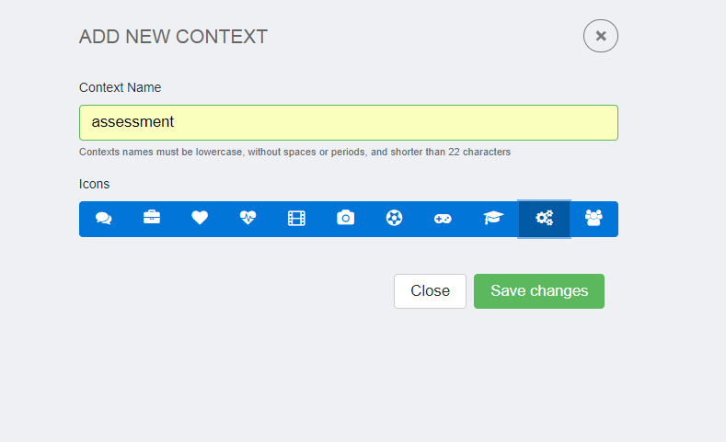

SCA Context Creation

Step 5: Click in the new created context and you will get into the new, but empty context environment. Click into "Add Contact" to start the party:

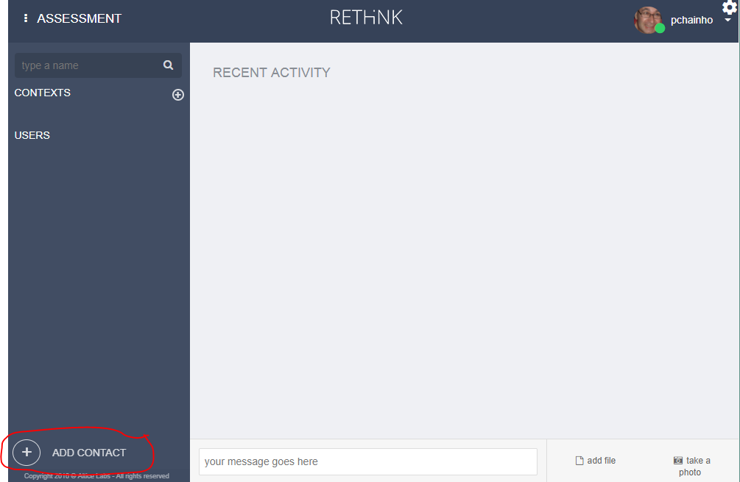

SCA Add Contact

A new user interface will show up where you should provide information about the user you want to invite, in this case the one using the Call Center App. Insert the email address you have used for your second Google account and the https://rethink.tlabscloud.com/ domain. Click invite.

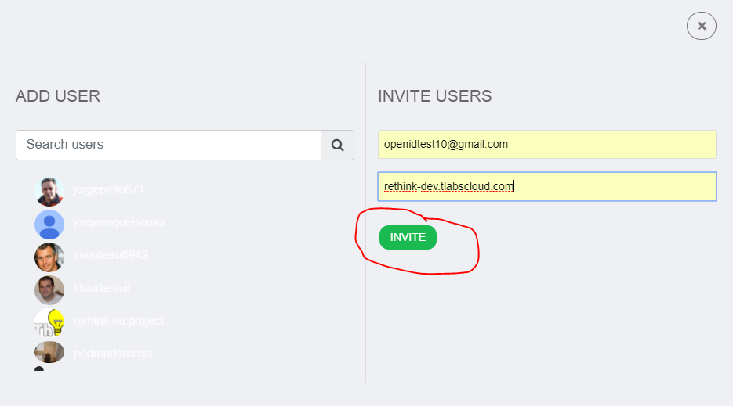

SCA Invite User

Step 6: The new user should join the SCA new context and in the second window a chat window will be opened.

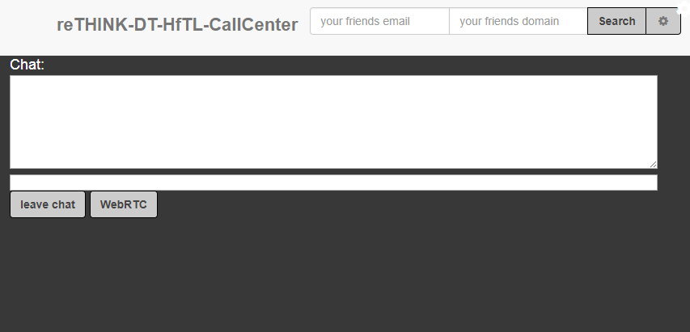

Call Center user joined the SCA new context

Step 7: Both users can exchange messages:

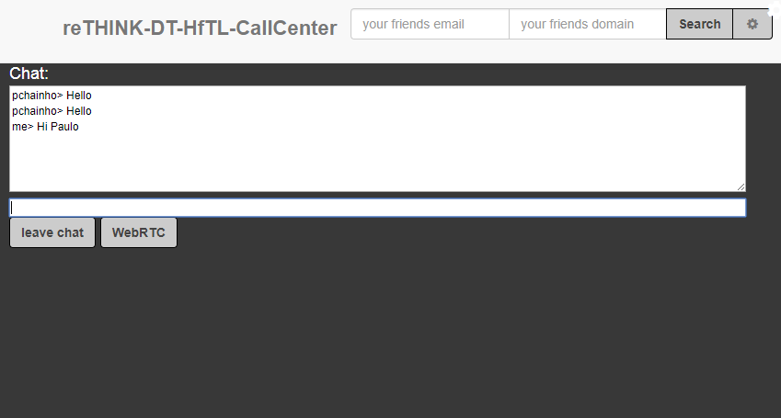

Call Center user chat with SCA user

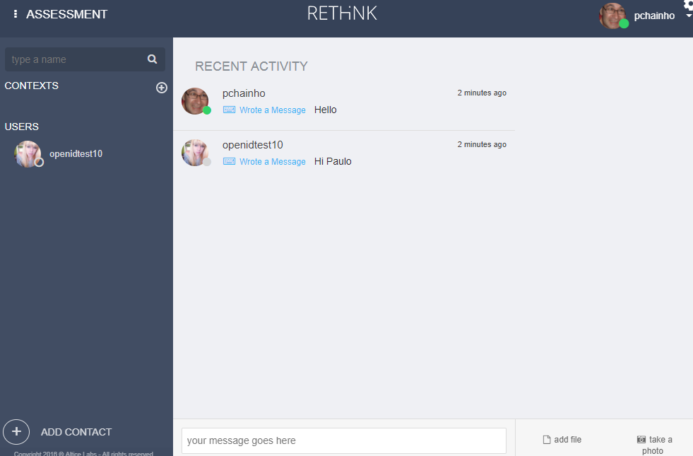

SCA user chat with Call Center user

#### Group Chat interoperability with Slack legacy service

This test will require having two Slack accounts in some team (https://slack.com/). It is assumed the SCA Context and the Call Center Group Chat created in the previous test, is still open.

Step 1: Open a third Browser window in some Slack team with your first Slack account.

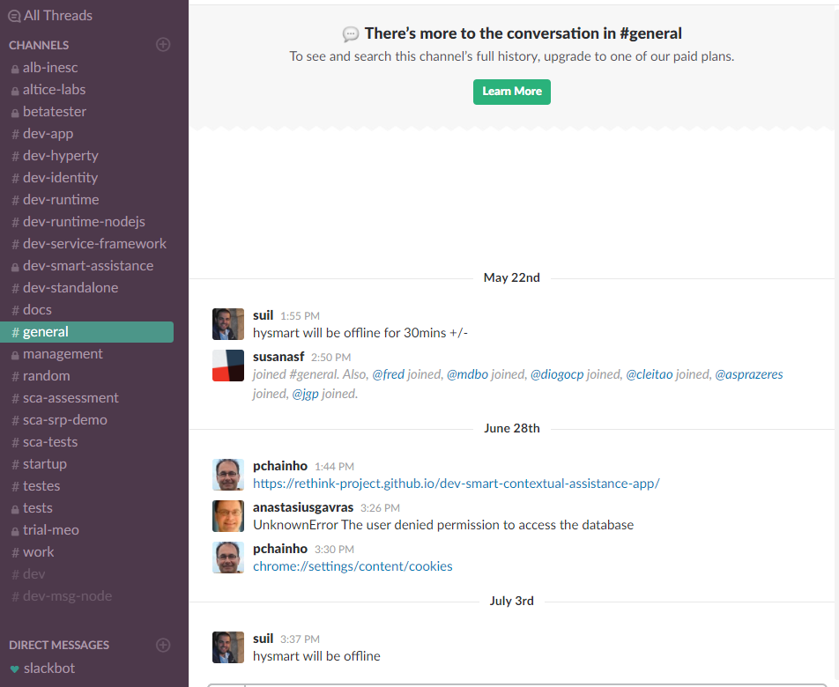

Slack Home

Step 2: In your previously SCA Context window click to add a new participant. Insert the slack user account used in the previous step and its slack domain and click to invite.

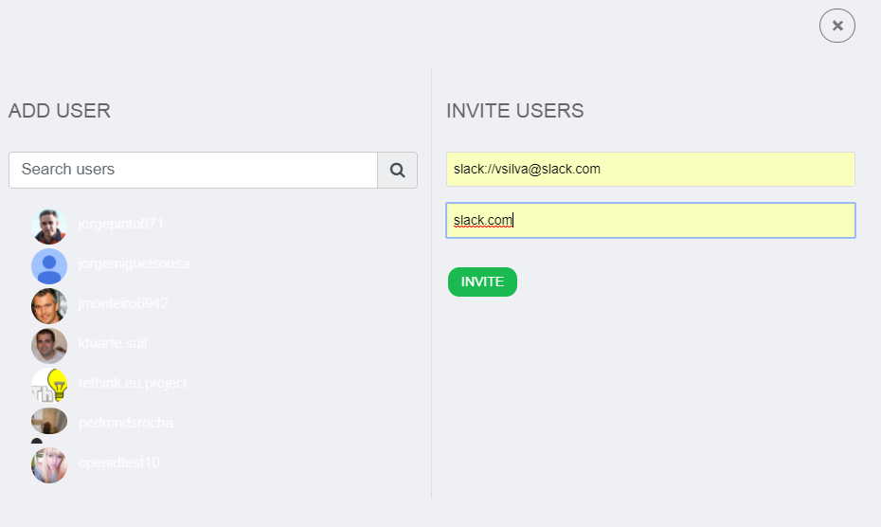

Slack Home

Step 3: A window will be opened asking you to select the Slack team where the invited user is, your Slack identifier as well as asking you authorisation to use it.

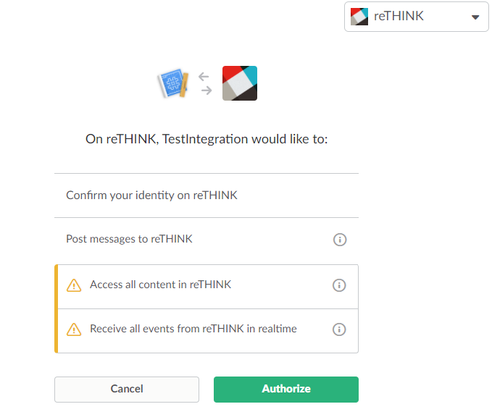

Slack Authorisation

Step 4: The Slack user should be added as the third participant to the Context. Now the three users can exchange messages among them. The user from the reTHINK SCA Application, chat with users from the reTHINK Call Center App and legacy Slack application:

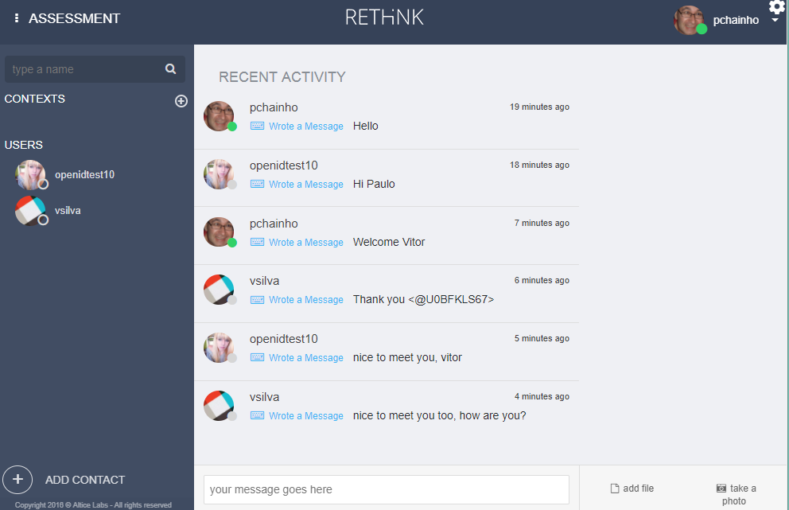

SCA user chat with Call Center user and Slack user

The user from the reTHINK Call Center App, chat with users from reTHINK SCA Application and legacy Slack application:

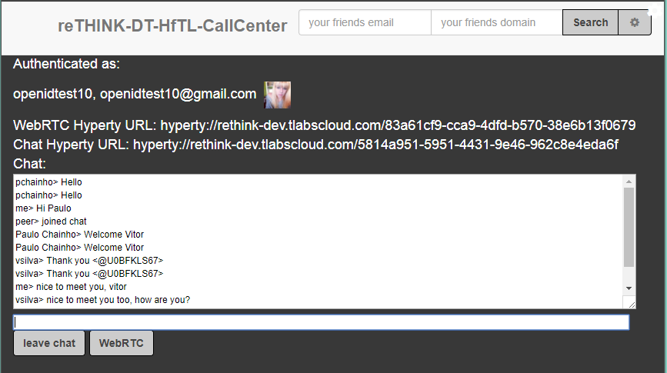

Call Center user, chat with SCA user and Slack user

The user from the legacy Slack application, chat with the reTHINK Call Center App user and with the reTHINK SCA Application user:

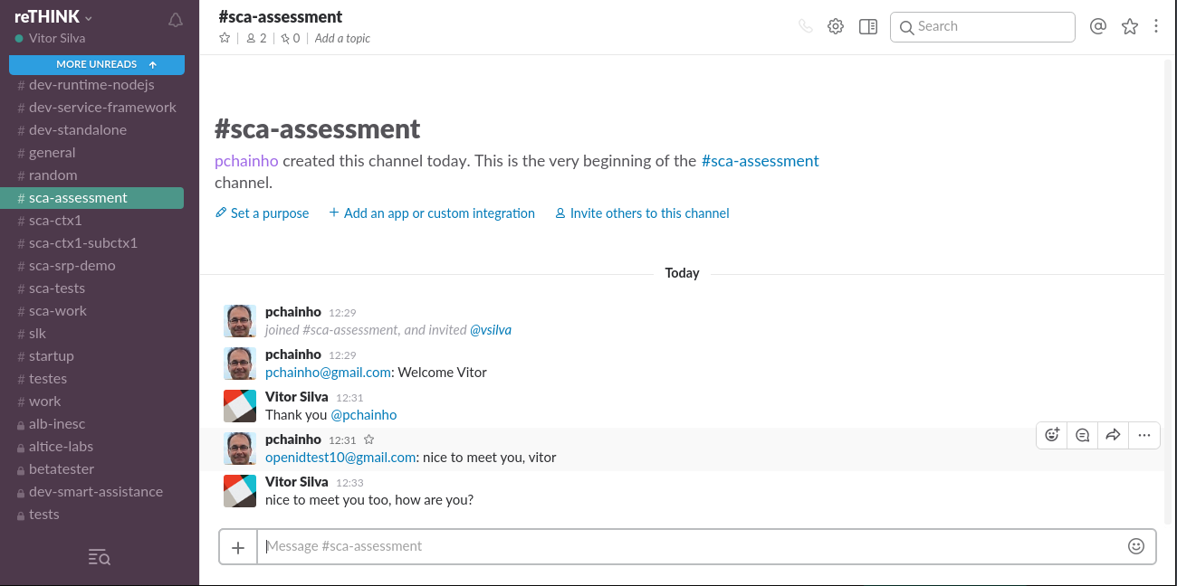

Slack user chat with SCA user and Call Center user

#### WebRTC Audio and Video interoperability test

This test will show how two users using different Applications, different Hyperties from different domains, each one using different protocols, are able to call each other. It is assumed the SCA Context and the Call Center Group Chat created in the previous test, is still open.

Step 1: In your previously SCA Context window, select the contact using the Call Center Application. Click to call the Call Center user with video:

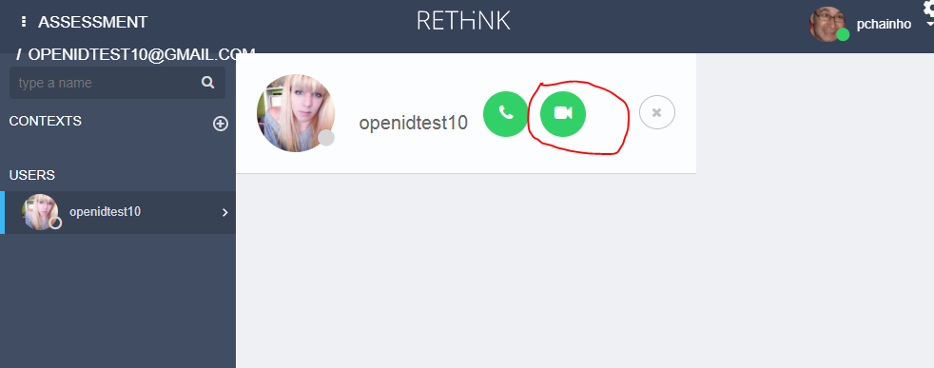

SCA user calls the Call Center user

On the Call Center side an incoming call notification shows up with information about the SCA calling user:

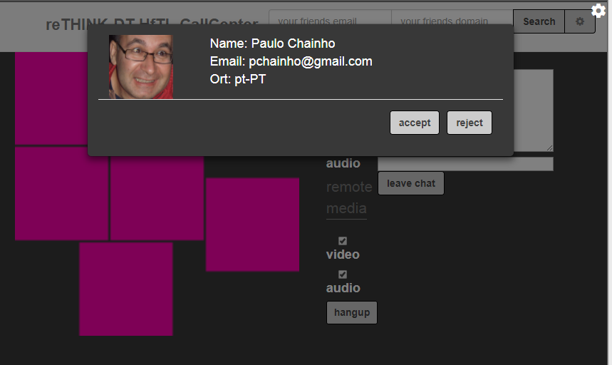

Incoming Call to Call Center user

Step 2: The Call Center user accepts the incoming call and a Video communication is established between the Call Center user:

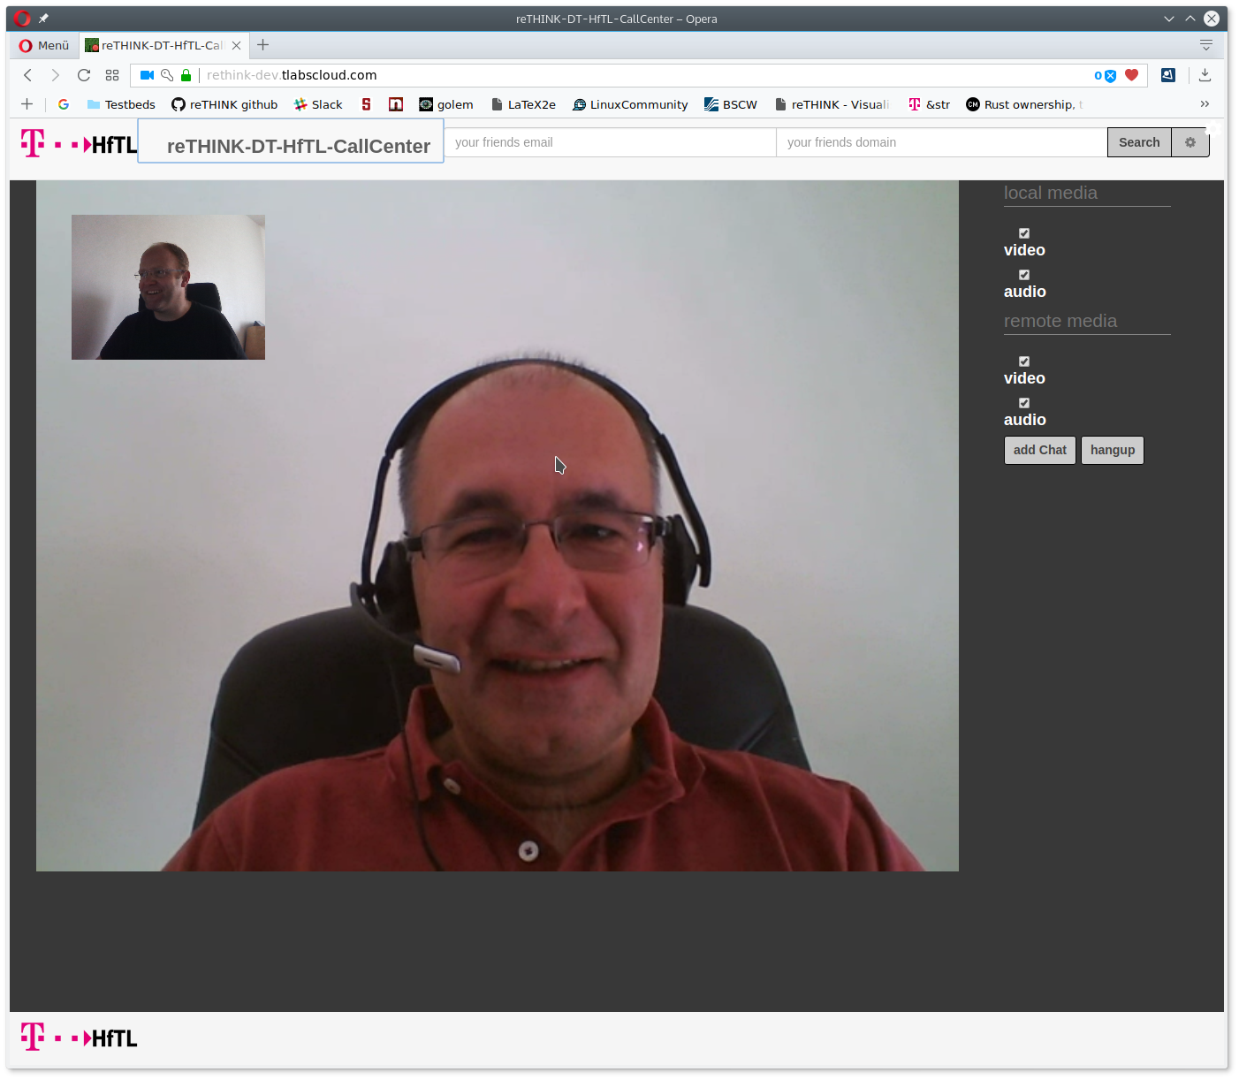

Call Center Video Communication with SCA user

and the SCA user:

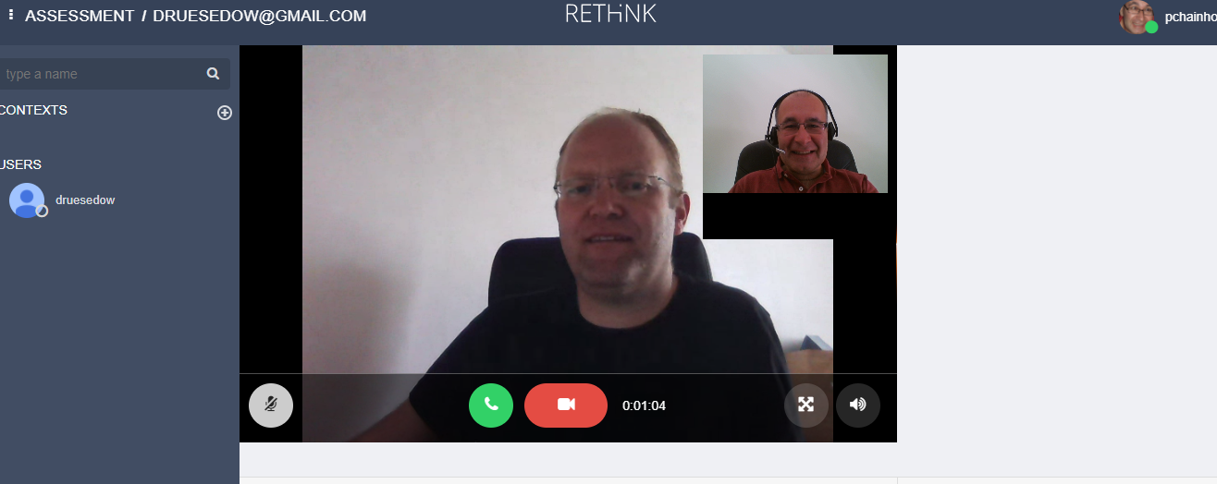

SCA Video Communication with Call Center user

##### Call Setup latency

The Call Setup latency was measured for the call established between the DT Call Center Application hosted in Berlin, Germany, and the SCA Application hosted in Aveiro (Portugal):

**Incoming Call Notification Time**

Min: 501 milliseconds Max: 599 milliseconds Average: 536 milliseconds

**Call Setup Time**

Min: 940 milliseconds Max: 1140 milliseconds Average: 1062 milliseconds

Taking into account the two services were hosted at different countries with using different protocol stubs, which means during these procedures it was required to load and instantiate different protostubs into the runtime, we consider these results as very encouraging.

## Identity Management Evaluation

### Description of Component

ReThink identity management is based on several components that are working together: * The Identity Module (Id Module) is a component of the runtime. It is the component responsible for handling the user identity and the association of this identity with the Hyperty instances, in order to make Hyperty instances identifiable. The identity in the reTHINK project is not fixed to a unique Identity Service Provider, but obtained through several different Identity sources. With this approach, the Id Module provides to the user the option to choose the preferred source and also method for authentication. This module has to support multiple Identity acquisition methods, e.g. OpenID Connect 1.0, Kerberos System, or authentication through smart cards. For example, a user with a Google account can use Google as an Identity Provider to provide Identity Tokens, which can be used by the Identity Module to associate him with a Hyperty instance. * The Identity providers are key in the identity management as they are used for authentication delegation. * The IdP-Proxy is the software module that is provided by the Identity provider in order to give a secure way to generate an identity assertion and assert it to a third party. The IdP-Proxy is based on W3C and IETF specifications of WebRTC and have been generalized in the reTHINK framework.

#### Principle

The identity management is based on the paradigm of a multi-IdP multi-service architecture, stating that we have interoperability between services. In legacy communication services (i.e. Telco), trust is considered as a basis because the service provider is also identity provider, and interconnection between networks are presumed secure. Here, the game is different because a user should trust his browser (as trusted computing base), the IdP he has chosen, and probably his service provider. But there is no way to ensure that the user you want to reach uses a trustful service. For example, if Bob is using service A, he wants to reach Alice on service B, if there is an interconnection between A and B, how can bob be sure that Alice is the right person to reach? To solve this issue, the W3C and IETF specify the IdP-Proxy mechanism. It allows Bob to deliver an identity assertion, which can be verifiable by the other party. Within the context of the reTHINK project these actions and services are performed by Hyperties running on the Runtime Core. The Hyperties are identified by long and complex strings derived from Hyperty instances URLs, further needing to have a user identity associated to it. With this association becoming publicly registered, it is possible to discover the user Hyperty instance by searching for a known user identity. For example, if Alice install a Hyperty and uses her identity obtained from an IdP, for example the Google email address ”alice@gmail.com” to associate with the Hyperty, Bob, when searching for this email, receives the Hyperty instance of Alice, which allows him to initiate a conversation with Alice. Because Bob also needs to register his Hyperty with an identity, when Alice receives the call, she can identify who is calling her. Note that, the user identity can be obtained from a service provider other than the CSP and because of that, IdPs are a separate service from CSPs. The identity is verified by validating the Public key contained within the Identity Token (obtained using the validate assertion service from the corresponding IdP) and them challenging the clamming party (e.g Bob) to prove the possession of the associated Private key. This validation operation is performed by the IdM not by the Hyperty itself. Thus, this procedure does not the behavior of the Hyperty, nor thus this need to know how to manage the identities. The connection between the IdM and the IdP is performed using a DTLS handshake during the WebRTC connection setup, ensuring that authenticated person is the one that has opened the peer connection. This prevent man in the middle attack from the service provider.

#### Use cases

The main use case the establishment of a secure communication channel between peers and assuring the identity of each one. Of course this can be generalized in the communication with objects, with some trustful authentication services. When an Hyperty connects to a service, the runtime authenticates itself towards the destination runtime using the Identity Token obtained from the selected IdP, based on the identity selected by the user. Upon a successful mutual authentication session keys are also established, which are used to establish the secure communication channel between the connecting peers. This identity selection and ID Token usage is supported by two main mechanisms. One embedded in the reThink core runtime, called IdModule and a second one called Browser extension.

### Implementation

The following describes the two implemented mechanisms for identity management, the one embedded in the reThink core runtime (IdModule) and Browser extension.

#### IdModule

The embedded identity management mechanism is the core component responsible for the identity management and the establishment of secure channels between runtimes in reTHINK. For the interaction with the IdP an IdP-Proxy is required, providing the particular interface methods for each particular IdP. As defined by W3C and IETF this IdP-Proxy should be provided by the IdP itself. However, since this is a novel approach and the most commonly IdP do not provide IdP for JS, the IdP-Proxies can be retrieved either from the IdP (when available) or from the reTHIK catalog.

For component isolation, the user does not directly interface directly with the IdModule. The user selection and management within the embedded identity management is performed via the Identity Management GUI, described below. Additioanlly, and to improve the user experience, the IdModule allows for the identity to be selected by the application by providing a dedicated API. The application is able to call for the creation of an Hyperty with or without selection the user to be associated. If no ID is defined, the GUI is called automatically to request the ID selection from the user, as illustrated bellow in the Identity Management GUI description.

In order to support the use of identities managed by the browser itself, the IdModule also supports a browser extension in order for the Identity Token to be obtained via the browser.

#### Browser extension

A second implementation of the Identity Module is based on the browser extension. It supposes that the browser is responsible to manage user identity, and uses the IdP-Proxy as a proof of authentication for the browser. Here again, as no actual IdP provides the IdP-Proxy, we have developped two implementations of the IdP-Proxy with OpenID Connect protocol. The difference of this implementation is decoupled from the core framework, and thus can be used by the application, regardless of the use of the framework or not, stating that even if no hyperty is loaded, the user is usually authenticated in the service.  
This extension is callable by a single "Connect" button replacing the numerous current "XXX" Connect (Facebook, Google, twitter...).

### Functional Testing Procedures

#### IdModule Functional Testing Procedures

The following describes Functional Testing Procedures to test the usage of the Id Module. This is accomplished using the functionalities provided by the GUI to perform the identity management inside the reTHINK runtime. This GUI enables the user to: 1. Select the Identity Provider from which to login; 2. Login, using the specified Identity Provider (IdP), via an IdP controlled Window that will pop-up to the user, and 3. Remove an identity from the list of authenticated identities.

##### Landing Page

When a user first interacts with reTHINK, the landing page (shown bellow) allows for two distinct interactions. The first is selecting the small wheel icon at the right upper corner. The second is selecting an Hyperty from the List of Hyperties. The former allows the user to select between the Policies GUI and Identity Management GUI, while the last automatically shows the Identity Management GUI to the user for identity selection.

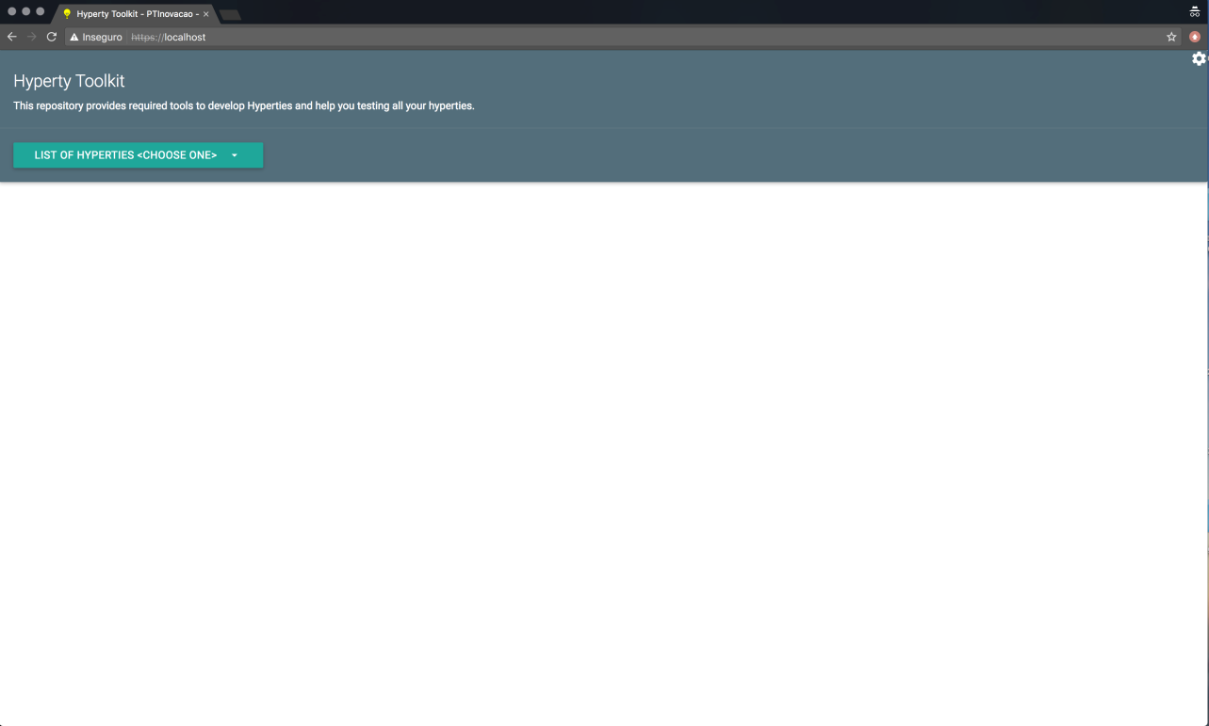

Example of reTHINK Landing Page

Whether the user was automatically promped to the Identity Management GUI, or the user manually selected the Identity GUI via the small wheel icon, both interactions will show the Identities Page to the user (shown bellow). This page consists of a single "Add an Identity" button, which allows the user to start the identity selection and authentication process used in reTHINK.

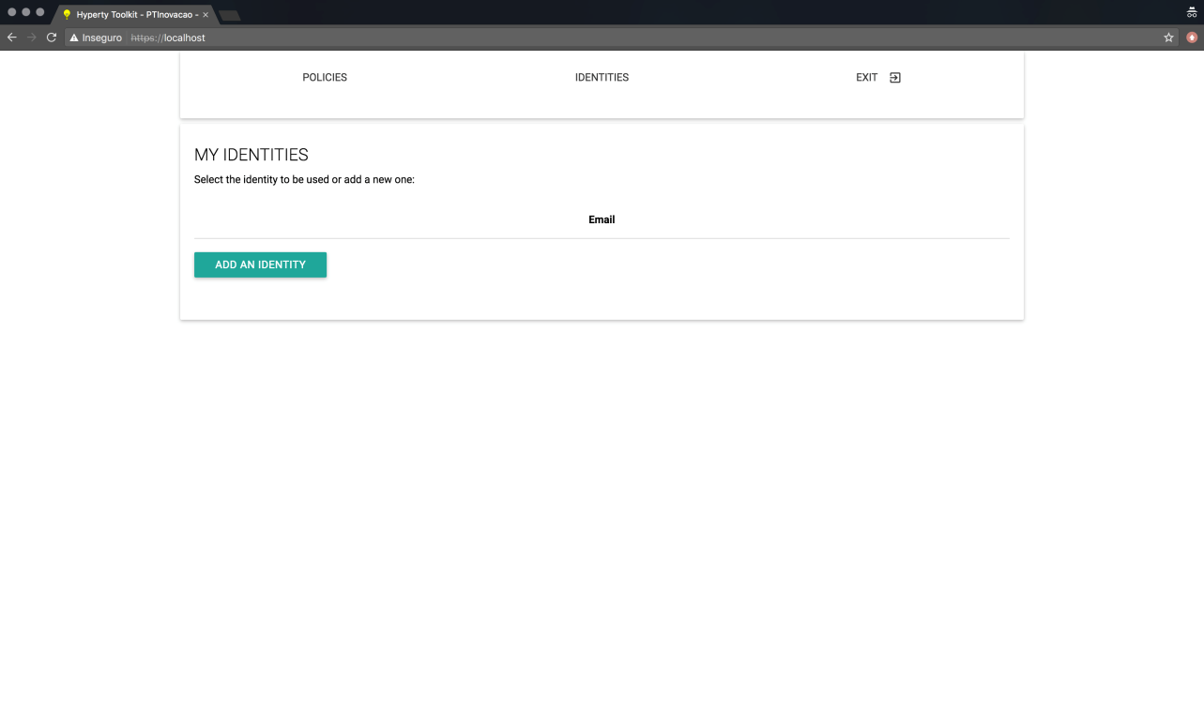

Identities GUI Page

##### Login in

When the user clicks the "Add an Identity" button shown in the previous section, a list of available Identity Providers in shown (see bellow). The user then proceeds by selecting the IdP from which he whishes to login.

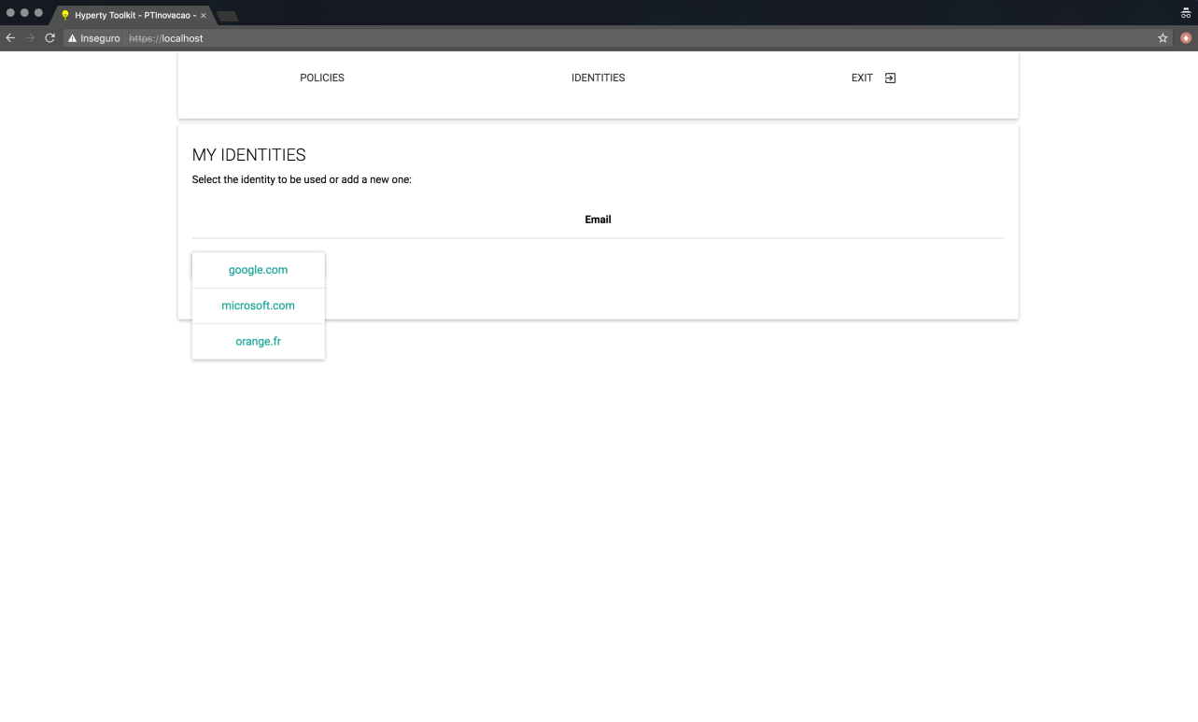

IdP Selection Page

After the IdP selection is finished, the Login page is presented (see bellow). On this page, the user can select a different IdP via the "Add an Identity" button, thus overwriting the Identity Provider selected before, and the user can also proceed with the authentication process by clicking the "Login" button.

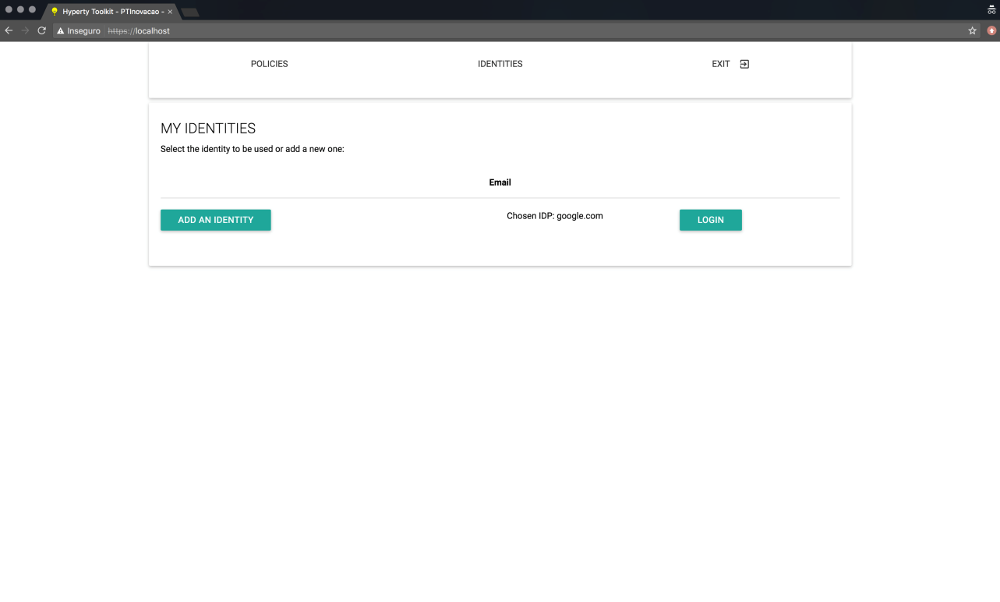

Login Page

When the "Login" button is pressed, a new window, controlled by the Identity Provider (i.e. reTHINK does not control the content displayed inside this window), is shown to the user (see bellow). On this Pop-up window, the user authenticates against the selected Identity Provider using the provided login form.

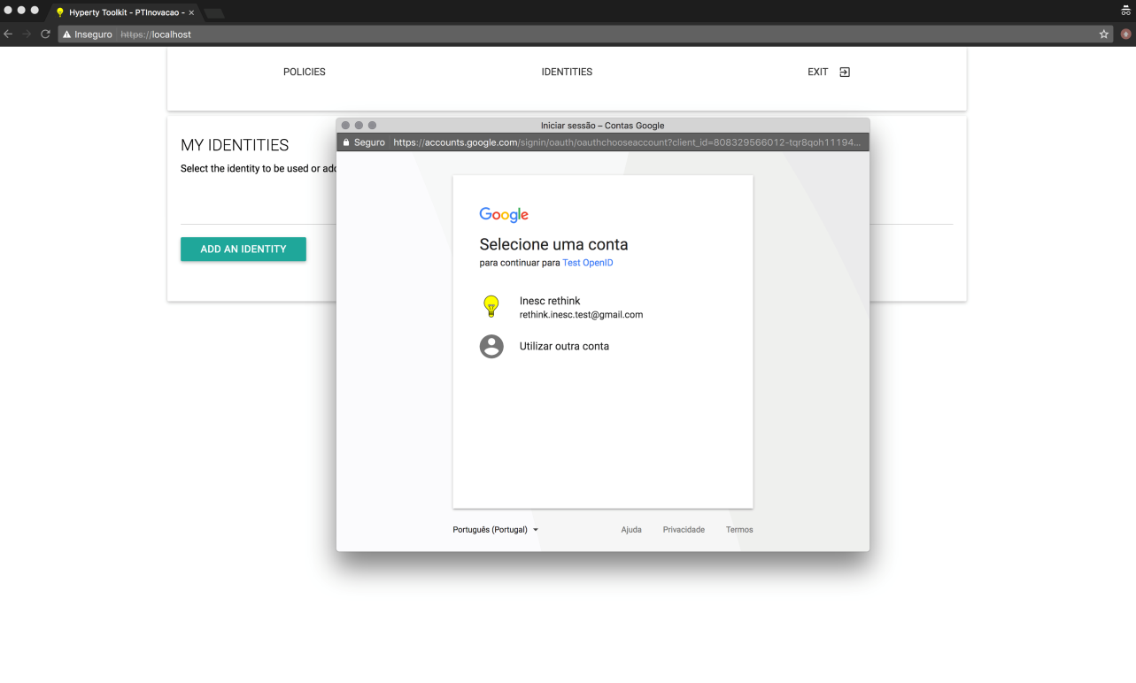

Login Pop-up

##### After Authentication

After the authentication process in concluded, the user may be presented with one of the following pages: * A page correponding to the selected Hyperty (seen here). This page is shown if the user was automatically redirected to the Identity Management GUI after selecting an Hyperty in step 1 (Landing Page). * A page containing a list of all the authentiated identities in the runtime (seen here). This page is shown if the user manually selected the Identity Management GUI in step 1 (Landing Page);

###### Authenticated Identity in Hyperty

If the user was automatically redirected to the Identity Management GUI after selecting an Hyperty, then this user will be redirected back to the Hyperty page (shown bellow) after the authentication process is over. This allows for the authentication process to be integrated seamlessly in the Hyperty selection flow.

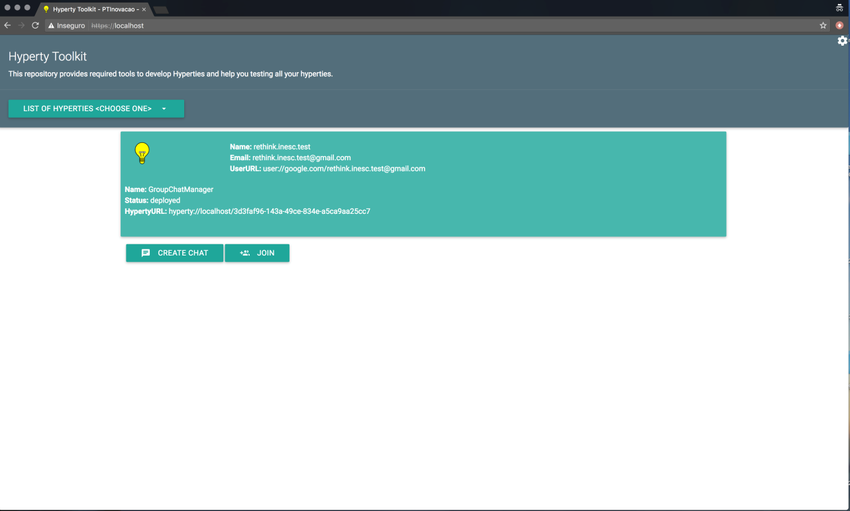

Authenticated User Page

###### Listing and Removing Authenticated Identities

If the user manually selected the Identity Management GUI, then this user will be presented with a list of al authenticated identities in the runtime. Furthermore, this list also allows users to remove authenticated identities from the runtime. To remove an authenticated identity the user must select the "Remove" button associated with the identity he wishes to remove.

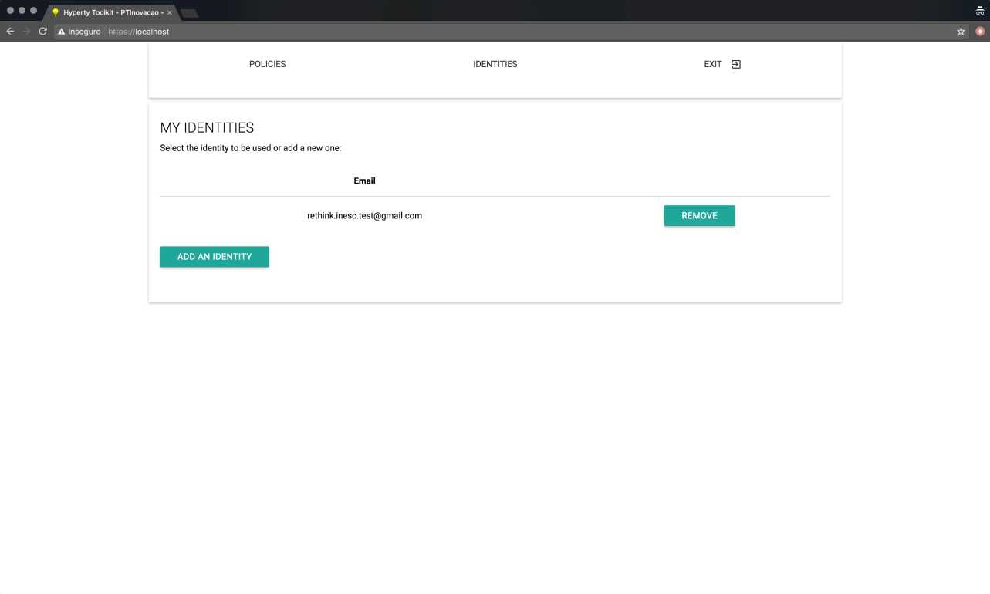

Remove User Page

This page, containing the list of authenticated identities, also becomes accessible by selecting the Identity GUI, as is described in the Landing Page section, after adding at least one identity.

#### Browser Extension Functional Testing Procedures

*Step one*: go to the application home page and click the "Connect" button.  
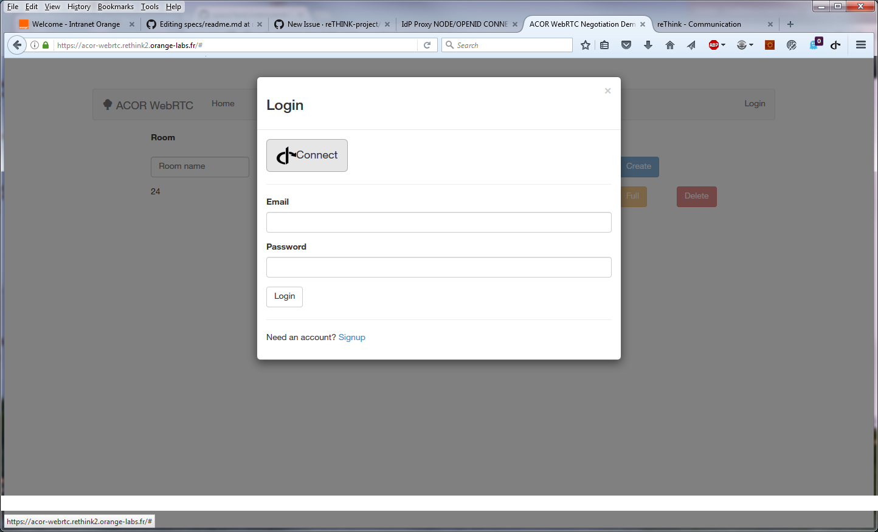

*Step two*: The Firefox extension that is managing ID Cards in the browser appears and proposes the identities formerly registered:

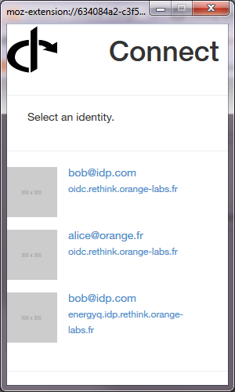  
*Step 3*: If the user clicks on the identity and he is not yet authenticated, it is redirected on the IdPProvier:

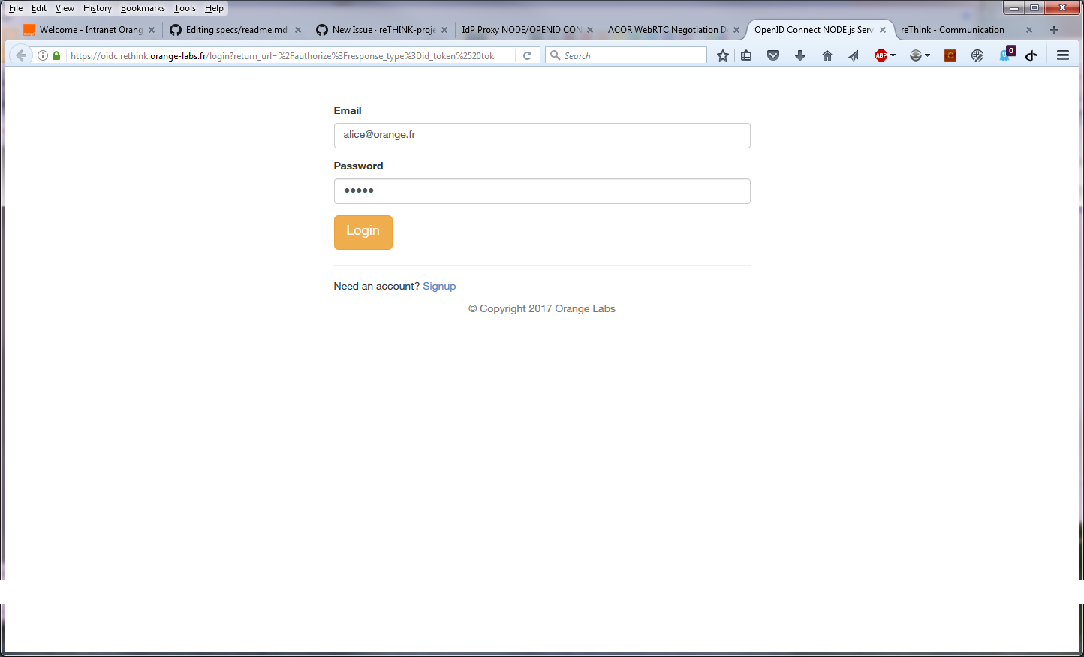  
*Step 4*: The user is automatically logged in the service. Note that if he as already authenticated, the Step 3 is skipped.

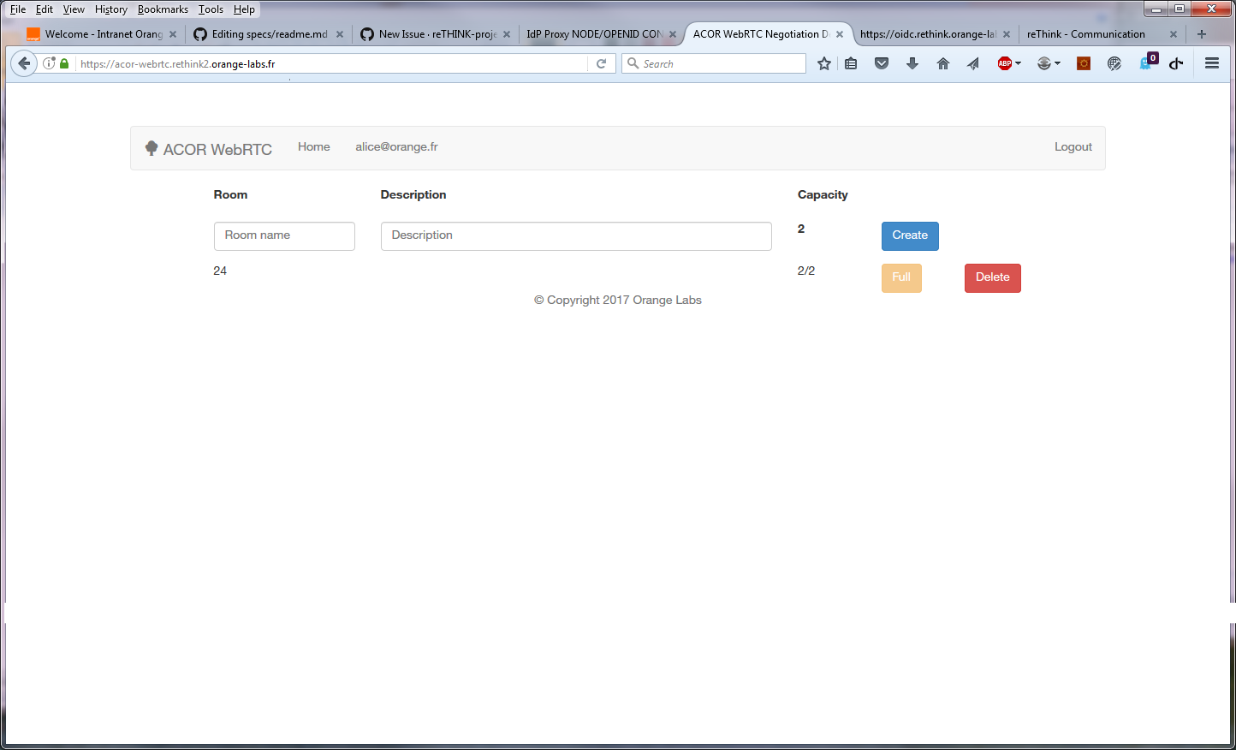

logged

### Non functional Evaluation

The non-functional evaluation of the IdModule is presented in [IDModule Evaluation](IdMEvaluation.md).

### IDModule non-functional Evaluation

In order to evaluate the performance of the developed ID Module, several tests were performed to evaluate the performance cost within the reTHINK framework. This evaluation covers the following features: identity acquisition from a user, the mutual authentication protocol and the secure communication using messages. Tests that required two users in different web browsers are demonstrated using the fictional users Alice and Bob, which are represented with the letter ‘A’ and ‘B’, respectively.

#### Methodology

For this evaluation, 1000 samples were taken for each test and averages of these samples were considered. The tests were performed on a computer with the following characteristics: CPU with an intel core i5-3210M running at 2.5 Ghz, 8GB of memory RAM and the Ubuntu 14.04 LTS operating system. The tests were performed on the components developed and integrated in the reTHINK framework. To test the ID Module integrated in the reTHINK framework, scripts were made in JavaScript language to allow them to run in the web browser and to allow data to be retrieved. Since some scenarios requires two users to evaluate the component, for example the mutual authentication protocol, two web browsers were used, namely Chromium and Chrome. Each browser represents a single user running an instance of the reTHINK application. The decision to separate the users in different browsers comes from the need to ensure that each instance of the reTHINK application running in the browser has its own resources and is running isolated from each other. The Chromium and the Chrome web browsers were chosen given their structure similarity. To measure the times of each method or sub parts of the methods, the performance tool (https://www.w3.org/TR/hr-time-2/) which offers an API to obtain the current time in sub-millisecond resolution was used. To calculate the time each part takes, the 'performance.now()' function was called at the beginning of the method under test and called again at the end of the method to be tested. The measured time is the difference from the time obtained in the end minus the time obtained at the beginning.

#### User Authentication

The process of authenticating a user and obtaining his identity comprises several steps. Starting by the generation of a public/private key pair for the RSA protocol, followed by the call to the IdP to generate the assertion. In the first call a URL to authenticate is obtained. A second call for the generate assertion method to actually obtain the identity assertion followed by the storage of this identity. The times for these steps were measured to find the performance cost added to the reTHINK framework by using the developed solution which is based on the WebRTC standard. For those tests, Google IdP proxy, developed in this Thesis was used to obtain the identity. This test ignores the time the user takes to select the identity via the GUI and the time the user takes to insert his credentials.

Figure 1 illustrates the time each component takes for the whole process of identity acquisition, showing an average of 1000 measures. These results suggest that, the methods with more impact on performance are the generation of the public/private key pair, the opening of a new window and the second call of the generate assertion method. The key generation time, taking about 200 ms, is relevant. However the main impact is in the opening of a new window, followed by the second call to the generate assertion. This second call includes the time the IdP takes to generate the assertion itself.

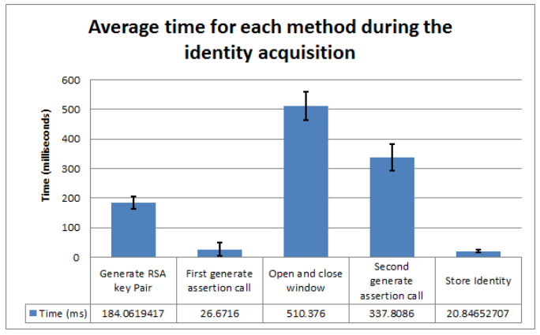

Figure 1 - Time for the user authentication process

The developed mutual authentication requires the Identity Module to generate a public key to be asserted by the identity module. Taking into account that the average time needed for the identity acquisition is approximately 1080 milliseconds, and that the RSA key pair generation only corresponds to 17% of this time, it can be considered that the actual local processing is low. It can also be concluded that the methods causing the highest performance degradation on the user authentication, is the actual interaction with the IdP server, particularly by the Google endpoints. Further optimizations on the user authentication could be made by removing the generation of the keys and have a key pair previously generated, when no activity is being made on the reTHINK application, however this may have an impact on privacy issues.

##### Mutual authentication

The mutual authentication is triggered whenever a user starts a communication with another user for the first time. This is essential so that both users are able to mutually authenticate each other before starting to exchange messages, thus preventing attacks, such as man-in-the-middle attack.

For the mutual authentication protocol, the time each phase of the protocol take was tested, in order to evaluate the more demanding phases and the impact were performed to the reTHINK framework. The execution of several mutual authentications simultaneously in order to determine the responsiveness of the Identity Module to more extreme cases. These tests were performed using two different browsers, so they do not share the same resources provided by the browser. The tested protocol starts with a message sent from Alice to Bob and is divided in 6 phases, being the phase 1, 3, 4 and 6 on Alice’s device, and the phase 2 and 5 on Bob’s device.

The Figure 2 illustrates the average times that each phase of the mutual authentication protocol. As expected, the most demanding phases are phase 3 + 4 and phase 5. It is in these phases that the operations with asymmetric encryption used to validate the identities and to encrypt the secrets occur. 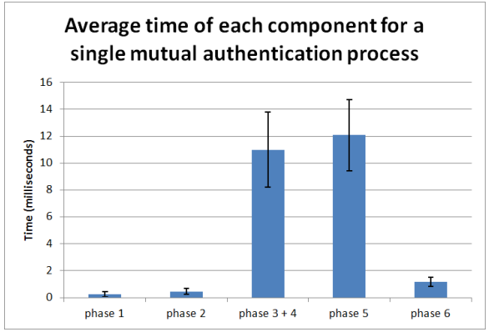

Table 1 illustrates the total time for the mutual authentication execution and the percentage in regard to the total time. In phase 1 and 2 and 6, since there is no asymmetric cryptography the time they take are minimal. It is in the phase 3 + 4 and phase 5 that the largest time-consuming phases can be found, since it is where the heaviest asymmetric operations are made, such as asymmetric encryption and digital signature. Those times can be disregarded when compared to the total time including the round trip time (of about 48 milliseconds using a localhost Message Node). 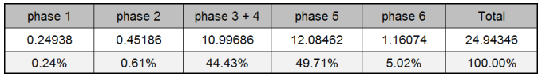

To evaluate possible extreme usage scenarios for this protocol, the time required to perform multiple the mutual authentication processes simultaneously was evaluated, as depicted in Figure 3. From the values obtained it is possible to observe that the values grow linearly and do not introduce a bottleneck to the reTHINK framework.

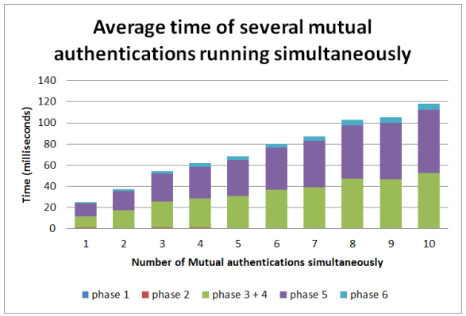

Figure 3 – Search times using hashtables

The above evaluation does not contemplate the round trip time. Since a public Message Node is required, its time must also be taken into account. To evaluate the impact of this node in the reTHINK framework a Message Node was defined to run in a localhost environment. Table 2 illustrates the total time of the mutual authentication execution including the round trip time imposed by the messages exchanged itself.

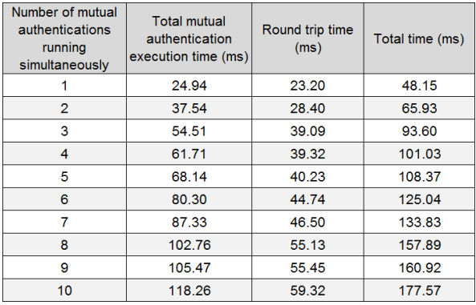

Table 2 - Time of the mutual authentication several times an its round trip time

From this analysis, it is possible to conclude that the mutual authentication, in an ideal communication network, presents values almost unnoticeable to the common user (<200 milliseconds). Even in rare scenarios when 10 mutual authentication processes are executed. Since the execution time of the protocol is independent from the round trip time, the biggest bottleneck of this mutual authentication is in the communication time itself, where the communication latency can introduce a significant time to the conclusion of the mutual authentication process.

#### Secure communications

The ID Module is also responsible for providing secure communications in the messages exchanged between Hyperties, performing the encryption, decryption and integrity verification of those messages. To perform the evaluations of the messages exchanged over the secure communication several tests were created that tried to replicate the sending of messages in different scenarios, from one Web Browser running an instance of the reTHINK application to another Web Browser also running instances of reTHINK, replicating the communication between two users. Both of reTHINK instances have a Hyperty running, representing a real case of two Hyperties communicating between them. The tests were performed by sending messages with different sizes, multiple messages simultaneously, and with different Message Nodes, one running in the test machine and the other running in the Altice Labs servers.

For each sent message the following operations were measured: * Runtime Core A: Time it takes for the Alice’s Runtime Core to process the message created by a Hyperty and send it, excluding the time taken by the IdM. * Runtime Core B: Time it takes for the Bob’s Runtime Core to receive the message, process it and delivery it to the Hyperty destination, excluding the time taken by the IdM. * IdM A: Time Alice’s IdM takes to encrypt and authenticate the message. * IdM B: Time Bob’s IdM takes to decrypt and to validate the received message. * Round trip time: Travel time of the message, including the passage through the Message Node.

The performed evaluations consider the transmissions of several messages ranging from 16 Bytes to 8192 Bytes. It was not possible to send messages with more than 8192 Bytes of information due to message size limitations of the Domain Registry. Figure 4 depicts the obtained results, excluding the round trip time of the messages. It is possible to observe that both IdM A and B suffer a rather small increment to the time required to process the messages with the increase of the message size. The obtained values suggest, that the IdM does not introduce a bottleneck or a considerable decrease in performance, taking into consideration the total time taken from both Runtime Core’s A and B to process the messages.

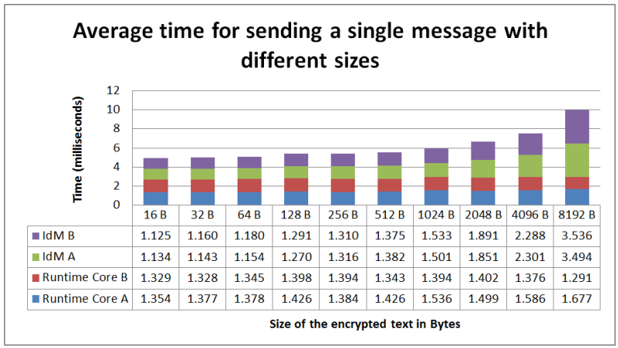

Figure 4 - Time of each component for different sizes

To test the responsiveness of the IdM to several message transmission requests at the same time, two tests were performed that send multiples messages simultaneously. One test ranging from 1 up to 10 messages sequentially and another test testing multiples of 10 messages up to 50 messages. Each message contains a 32 Bytes value to be handled by the IdM, simulating a conversation with the exchange of short messages between users. The results obtained for both tests are depicted in Figures 5 and 6. These Figures depicts the average time in milliseconds that each component takes to send a single message when multiple messages are sent, including the round trip time. From these results it is visible that the A and B IdM delay increases with a linear proportion, for up to 50 small messages sent simultaneously. This linear increase is due to the fact that browsers do not possess concurrency, meaning they only use a single thread to run JavaScript code. Because the IdM methods are asynchronous, it is possible for the IdM method to loses its thread processing time to another method, only regarding the processor later on to conclude the task. The time the method is interrupted is accounted in the total time the method takes.

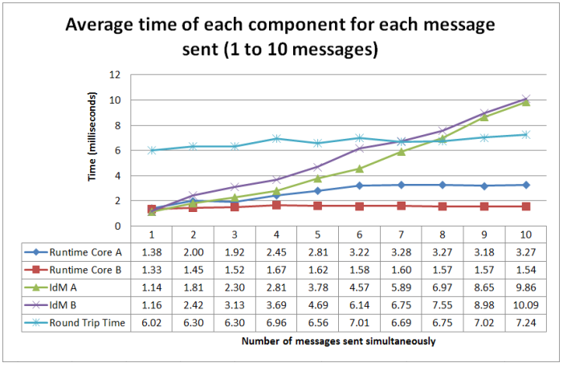

Figure 5 - Time each component takes to send multiple messages simultaneously (1 to 10 messages)

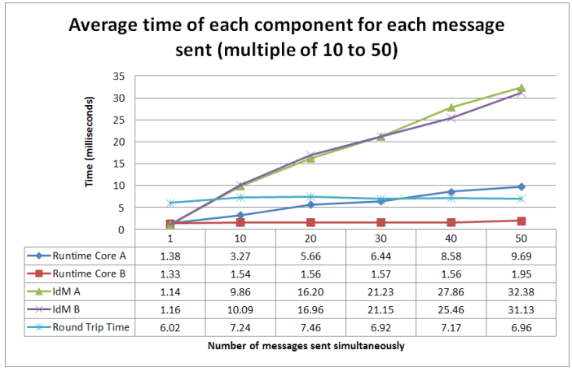

Figure 6 - Time each component takes to send multiple messages simultaneously (1 to 50 messages)

When sending multiple messages simultaneously there is a difference between the latency and the throughput, being the latency in this case the total time to send a single message takes and the throughput the total time to send all the messages. So, the obtained results are depicted in Table 3, showing the individual time for each component, the total time for each message, the latency and the total time of all messages. For this test a localhost Message Node was used, leading to similar round trip times, independently of the number of messages sent. From the results it is possible to observe that the latency increases with the increase of the messages sent simultaneously, resulting in a sub linear increase. Despite this increase with number of messages sent simultaneously, the total delay is relatively low, even for multiple messages.

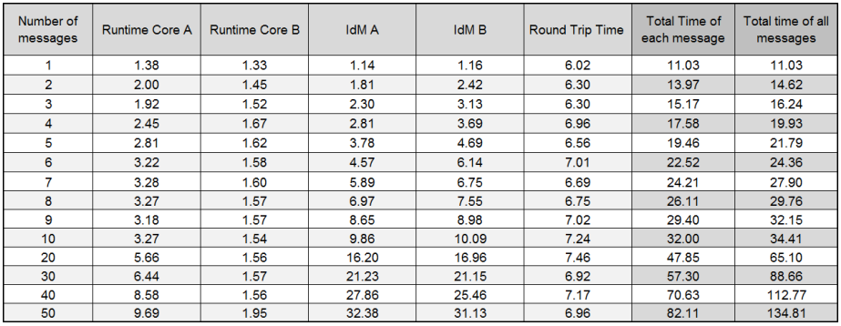

Table 3 - Total time each message takes to send, individually and all together, using the localhost Message Node (Time in milliseconds)

To evaluate the impact of the Message Node, obtained the same tests were performed using a public Message Node located in the Altice Labs servers. The values are depicted in Table 4. These values suggest that the times for both Runtime Cores and A and B IdMs remains similar independently of the Message Node used, where the biggest difference is in the round trip time, where in this last test it expectedly takes more time.

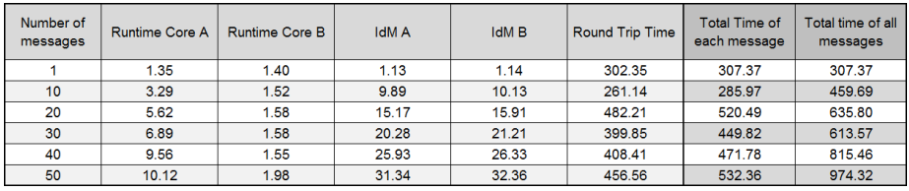

Table 4 - Total time each message takes to send, individually and all together, using the Altice Labs Message Node (Time in milliseconds)

From these results it is possible to conclude that the biggest bottleneck in the transmission of messages is the network latency, and that the performance of the IdM is only slightly affected when sending multiple messages at the same time.

Making a deeper analysis of the IdM times, the IdM times were decomposed on the following aspects: initial vector (IV) generation, encryption using AES, message authentication and encoding, for the IdM A and the opposite, for the IdM B. The values depicted in Figure 7 suggest that when sending multiple messages simultaneously the values that tend to increase are related to the encryption and hash computation. The IV generation and the encode/decode steps are barely noticeable. It is also possible to observe that both A and B IdM take approximately the same to process a message, for the same number of messages sent simultaneously.

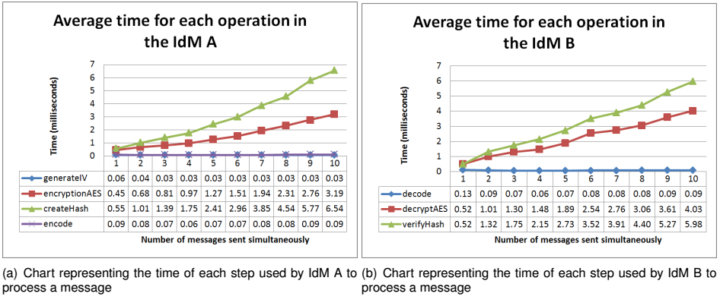

Figure 7 - Methods times used for A and B IdM’s

From the obtained results for the secure communication using messages, it is possible to conclude that the IdM methods do not increase exponentially, not even in the most extreme cases. This allows to conclude that the system is able to perform with adequate metrics, independently of the number of messages exchanged or the size of the messages. The biggest factor in the performance is the network latency.

### Future work

Future integration can consist in the adding of the negotiation between peers, to allow IdP restriction and security level to a conversation. This feature is described in [Corre et al. paper](https://link.springer.com/chapter/10.1007%2F978-3-319-60131-1_27) and is implemented for demonstration purpose, but not integrated in the core runtime.

## Cross-Domain Discovery evaluation

### Short description

This section describes the usage of components involved in the IMaDS discovery and registry framework [1][2]. Using the IMaDS framework, users can connect to other users' devices using a immutable GUID. The framework uses three components, being Discovery, Global Registry, and Domain Registry, while the ReThink runtime provides a GUI component to store and manage contacts in an addressbook application

### Functional tests procedures

The Addressbook is a web based application included in the ReThink runtime that allows users to create and maintain one's identity. The Addressbook is reachable in the browser at localhost as part of the admin interface of the ReThink runtime. Its main screen shows a list of contacts and means to query for and add users:

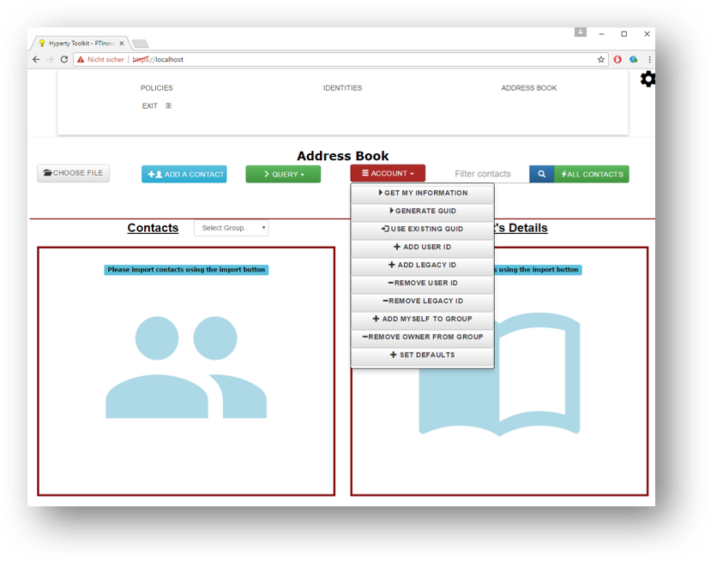

Addressbook Create GUID

At first use, a new GUID needs to be created and registered in the Global Registry service. This is automated via the option "generate GUID" in the "Account"-menu. The process registers a new GUID and publishes it in in the Global Registry service along with information specified in the registration process.

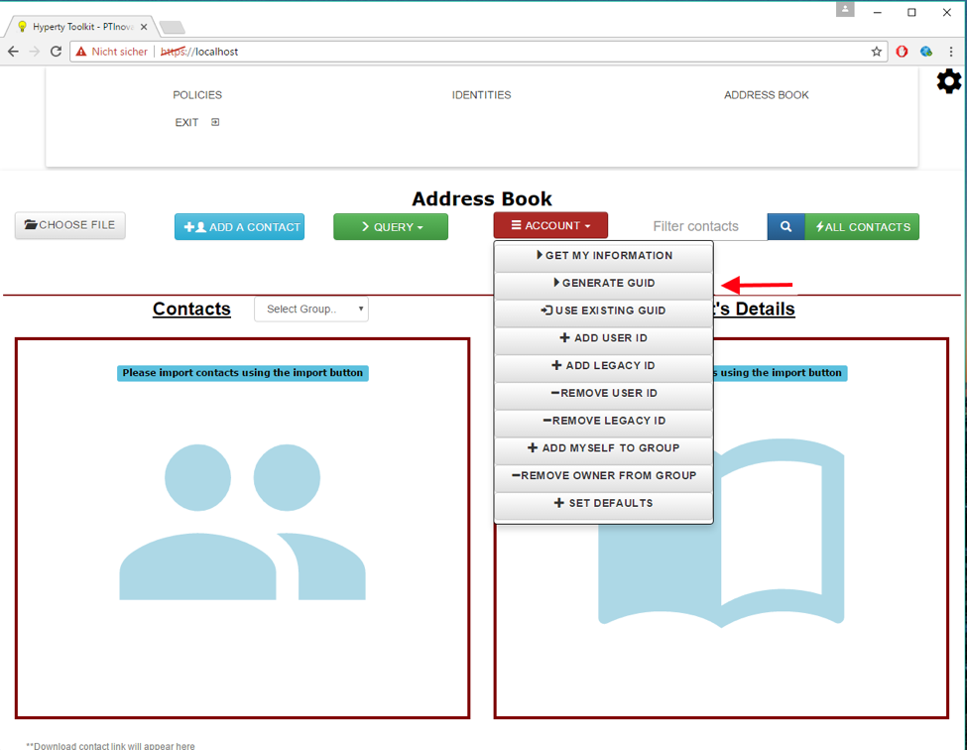

Addressbook Info

To view and edit one's contact details, users can use the "get my information" function that displays a dialog with all details of the user's account. Changes can be made directly in the dialog and the changed account details can be directly sent to the Global Registry: 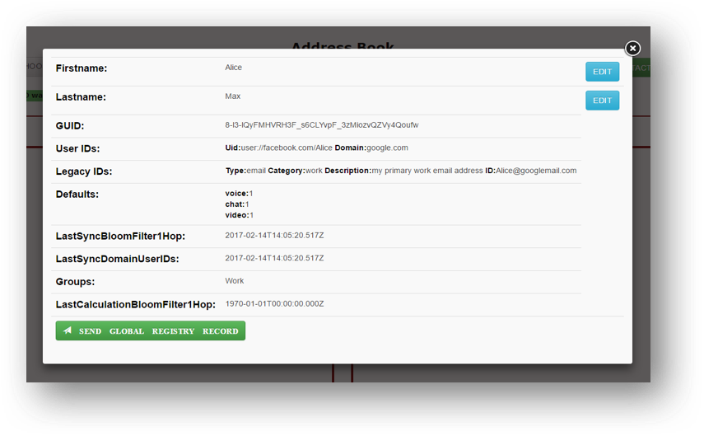

When selecting contacts in the Addressbook, available information for the selected contact is shown. This includes the username and ids: 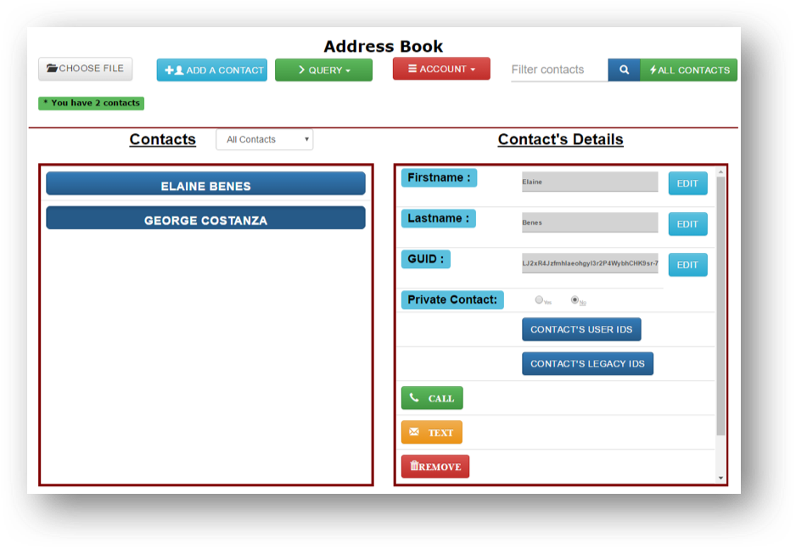

The Addressbook further allows to search for users either by a known GUID or arbitrary contact details:

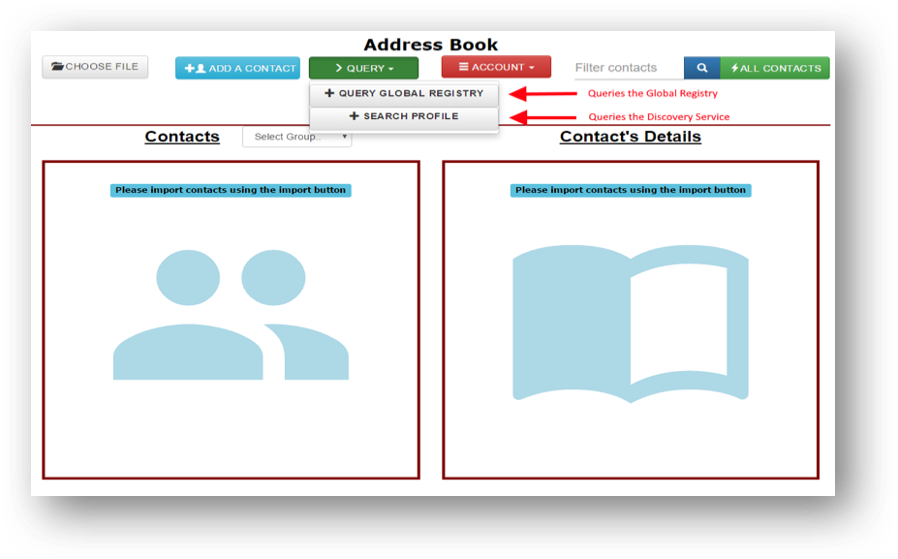

Addressbook Query

The DISCOVERY SERVICE further provides a standalone web interface to enable users and other services to search for users. People are used to use search engines like google when they want to find information about a certain topic. In the same way, they can search for persons or also devices in reTHINK. They formulate a search query like “Michael Mueller T-Labs” or “reTHINK Project” in order to find one or more so called profiles of a person or a device. Although this service is easy to use like a classic search engine, there are fundamental differences.

Source of query results: Search results are profiles that are written by the user that wants to be found. Results are not crawled or scanned in the Internet. Every user that wants to be found or that wants his devices to be found, can create one or many profiles within the discovery service. These profiles stay fully under user control.

Policy-based visibility: Every profile can be configured with a certain visibility. So the owner of a profile can configure which user or which group of users can see his profile.

Interfaces

Web-GUI: The reTHINK discovery has a Web-Interface for users that want to use reTHINK discovery with their browser, like they are used to from a classic search-engine. Furthermore the web-GUI enables to create and manage profile accounts.

 ' 1) Plain web search: The user can go to the reTHINK Discovery Website and search for users or devices. The search results are so called profiles. They have a headline and some text for description. They might have hashtags describing certain topics, communities, locations etc.. Profiles can also contain communication endpoints like e-mail address, phone number, websites, facebook- or linkedin profile URLs.

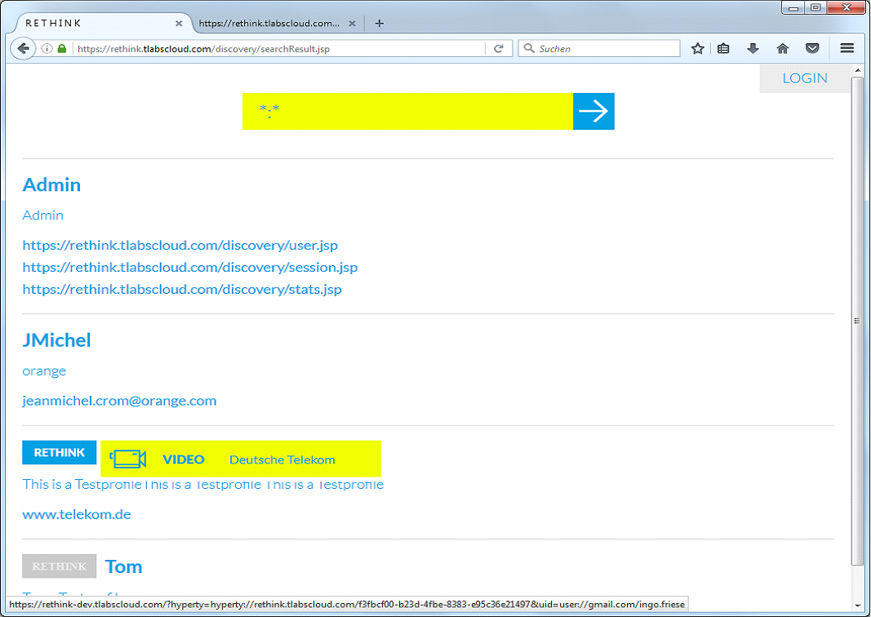

Discovery GUI search results

1. Create his own account: Every user has the possibility to create his own account with the reTHINK discovery service.



Discovery GUI profile registration mask

REST-API

The discovery service offers also a REST-API for search queries, that can be used from other services or applications. The interface can be "pinged" by e.g GET https://rethink.tlabscloud.com/discovery/rest/discover To search eg. for "Hans Telekom" call GET https://rethink.tlabscloud.com/discovery/rest/discover/lookup?searchquery=Hans+Telekom The answer is a JSON Object like for Example:

{  
"instanceID":"telekom1",  
"responseCode":201,  
"searchString":"Hans+Schmitt",  
"results": [  
{  
"resultNo":0,  
"instanceID":"telekom1",  
"hashtags":"T-Labs Telekom",  
"description":"Hans Testprofile text text text",  
"rethinkID":"REAyDT-tYQI2u1km9LgYj05zb1hLmy__XlIN5B1LWUQ",  
"headline":"Hans",  
"contacts":"Hans.Schmitt@telekom.de",  
"hasrethinkID":"true",  
"hyperties": [  
{  
"url":"hyperty=hyperty%3A%2F%2Frethink-dev.tlabscloud.com%2Fd2aad579-a213-4400-9e24-af2b23dbaed8",  
"userID":"uid=user:\\gmail.com\hans.schmitt",  
 "media":"VIDEO",  
 "provider":"Deutsche Telekom"  
},  
{  
"url":"hyperty=hyperty%3A%2F%2Frethink-dev.tlabscloud.com%2Fb71cd853-f657-4b6a-919b-07916bd3d50e",  
 "userID":"uid=user:\\gmail.com\hans.schmitt",  
 "media":"VIDEO",  
"provider":"Deutsche Telekom"  
}  
]  
 } ] }

The result contains, beside the content, also the instanceID. This instanceID is used to distinguish between different Discovery service instances. Furthermore, the endpoint of all hyperties that are currently running are shown, including supported media type and the regarded service provider as well as the used identity aka. userID.

In case the GUID is not known, the Discovery service of the ReThink framework can be queried. Here, all found contacts matching the search query are returned and can be added directly to the contact list:

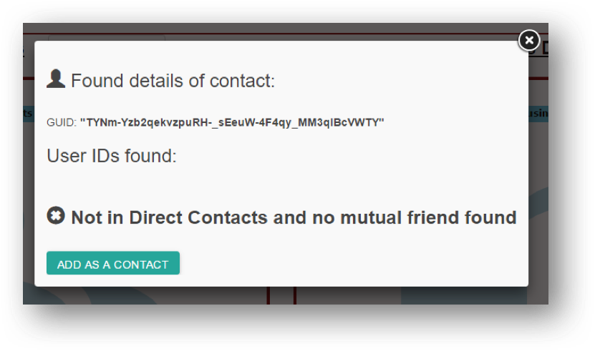

Discovery Result

In case the GUID of the contact is known, the Addressbook application directly contacts the Global Registry service. Information retrieved from the Registry service is displayed in a dialog. The contact can then be directly added to the contact list:



Addressbook Result

The Global Registy provids an association between each user identity (GUID) and the service provides with which he is registered. This is a relationship that changes infrequently. However, the same does not hold true for the information regarding the devices being used by the user to access each service provider's services. As devices change networks and are turned on and off, reachability information must be updated frequently. As such, each Service Provider run its own instance of a Domain Registry, where a mapping between each user and the services (hyperties) being used in each of the user's devices is kept. The runtime of each device is responsible for keeping this information up to date. The interaction with the Domain Registries is transparently performed by the Runtime on each device. The user is not aware and does not have to performe any action.

While the example described above covers manual discovery and handling of user identifiers, resolving is usually carried out automatically. Here, a user specifies a GUID to contact, e.g. selected from the Addressbook application, which he wants to connect to, e.g. call. The IMaDS framework then automatically resolves a GUID to the user's UserIDs and further to this user's active Hyperty instances (using the suitable Domain Registry). Following this process, a connection is automatically initialized between two users.

A typical usage scenario of the IMaDS services comprise a user Alice, who wants to connect to another user Bob, who is registered in one or more service domains. If required, Alice would query the Discovery component to search for Bob using facts that describe Bob. By resolving Bob’s GUID via the Global Registry, she receives a list of service domains Bob is registered with. As each UserID in the returned dataset also comprises information about the respective service provider’s Domain Registry, Alice can now query the Domain Registry for Bob’s communication endpoint and establish a connection.

### Non-functional evaluation

The runtime communicates with the Discovery Service, Global Registry and Domain Registry using the Discovery Lib, a runtime library that provides a single API for accessing the 3 services. The Discovery library allows the discovery of remote Hyperties or Data Objects by using different criteria. To evaluate this component, the most complex query available was used, which discovers Hyperties or Data Objects by profile data. This query translates the profile data into GUIDs by querying the Discovery Service. Then, for each found GUID, it executs a query to the Global Registry to get all the user IDs and domains associated. Finally, for each user ID and (Service Provider) domain pair, a query to the corresponding Domain Registry is executed, to get the registered Hyperties or Data Objects.

The goal of these tests is evaluate the performance of the combined IMaDS from the point of view of the user, by querying all three, in succession, from the runtime.

The methodology used to evaluate the Discovery library was to develop a web application that loads an Hyperty programmed to use the discovery service using profile data. For the web application to work properly and discover the Hyperties associated to the profile data, we had to create an account in the Discovery Service with a GUID registered in the Global Registry. A Service Provider domain and an user ID were associated to that GUID and an hyperty registered in the associated Domain Registry. Then, we run the tests, collecting four metrics in each execution:

* Time necessary to complete a query to the Discovery Service;
* Time necessary to complete a query to the Global Registry;
* Time necessary to complete a query to the Domain Registry;
* Total time spend in the discovery by profile data: sum of the previous three steps.

The tests were repeated one hundred times. The client was run on a MacBook Pro, using the Chrome Browser, connected to INESC-ID's network. The Domain Registry was a part of Altice Labs test bed. The Discovery Service is the one provided by T-Labs. The Global Registry is the one shared by all testbeds and it was interfaced via Altice Labs testbed.

In order to test the performance, we varied the number of concurrent requests, using 1, 2, 5, and 10. As this is run from a single runtime, concurrent requests are not expected to be frequent and 10 concurrent requests is a very unlikely event. Below is a chart for each metric. Results are presents as a cumulative distribution function (CDF), with a line for each number of concurrent requests (n).

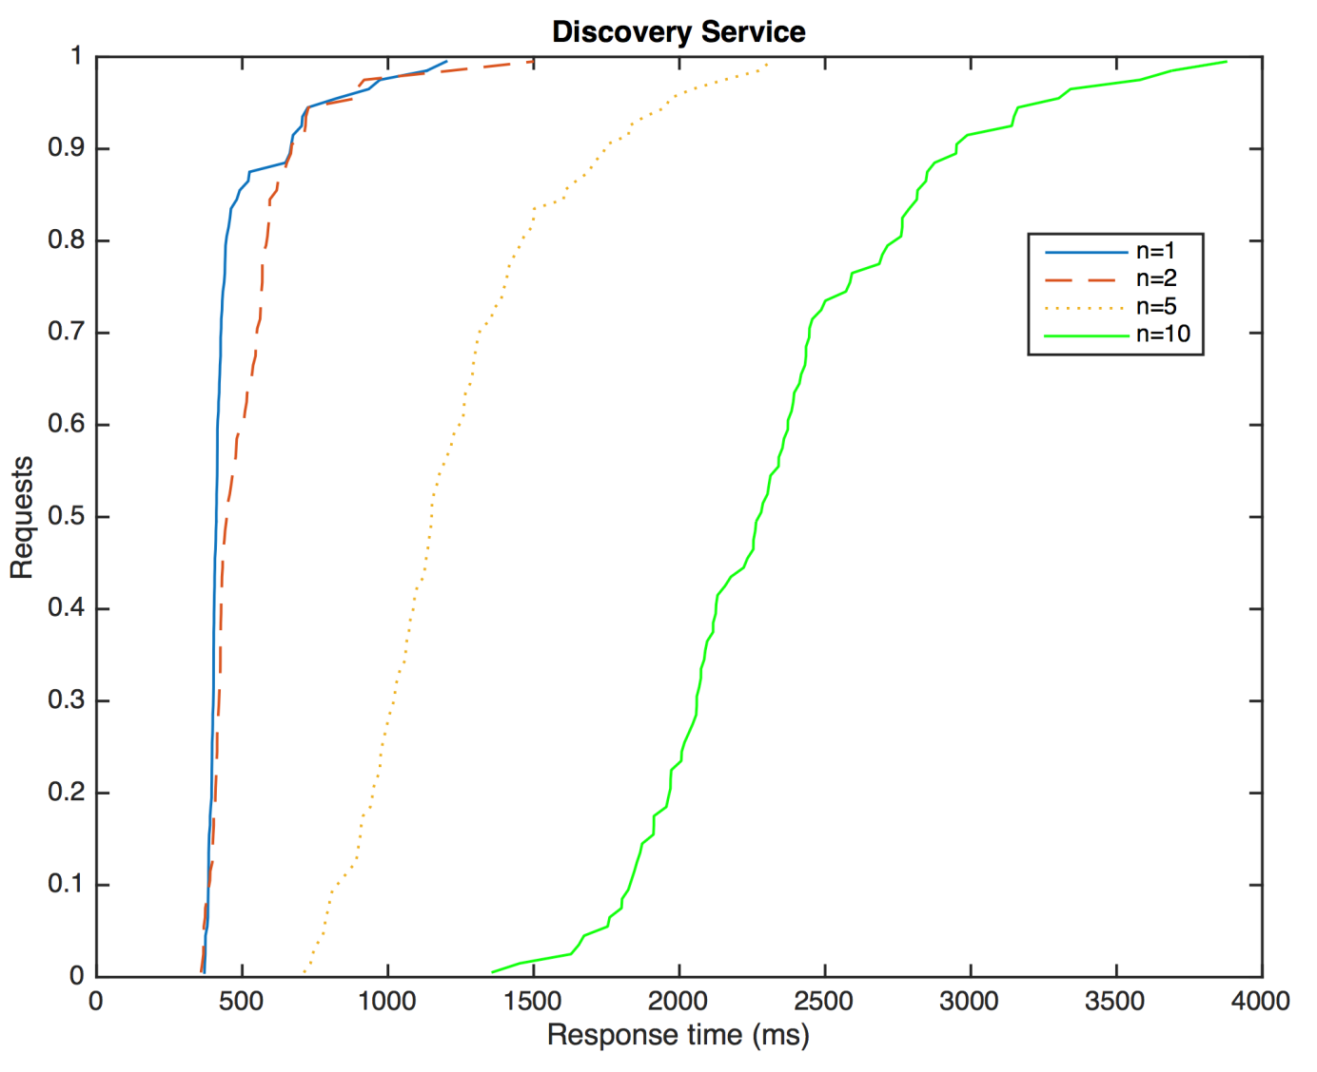

Discovery Service

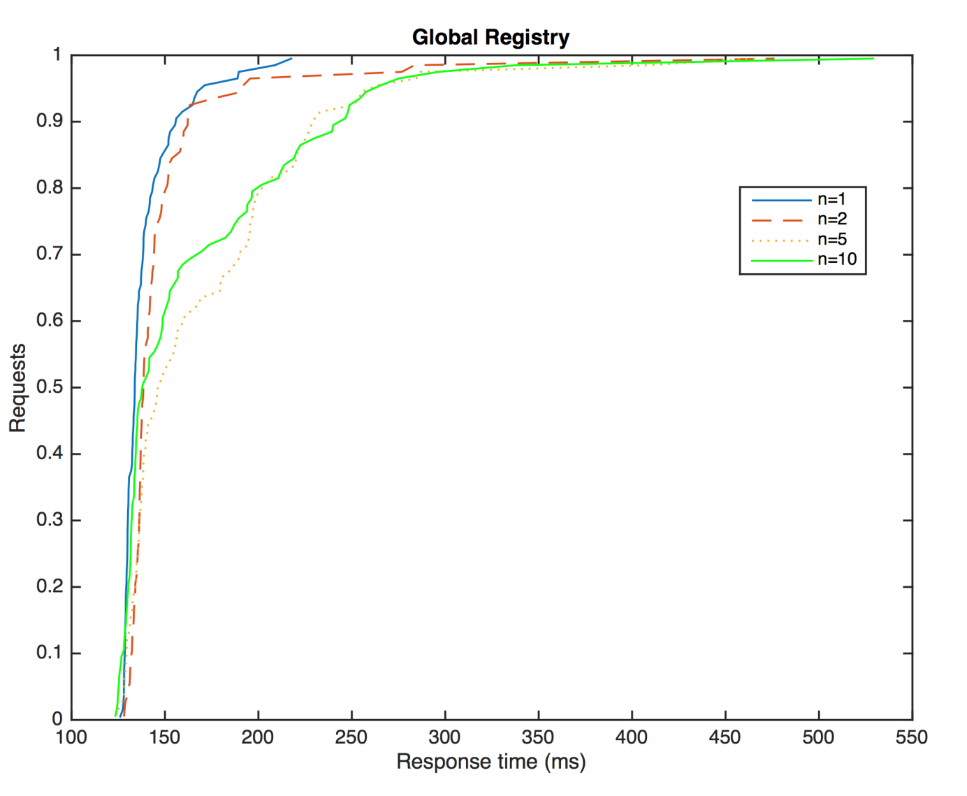

Global Registry

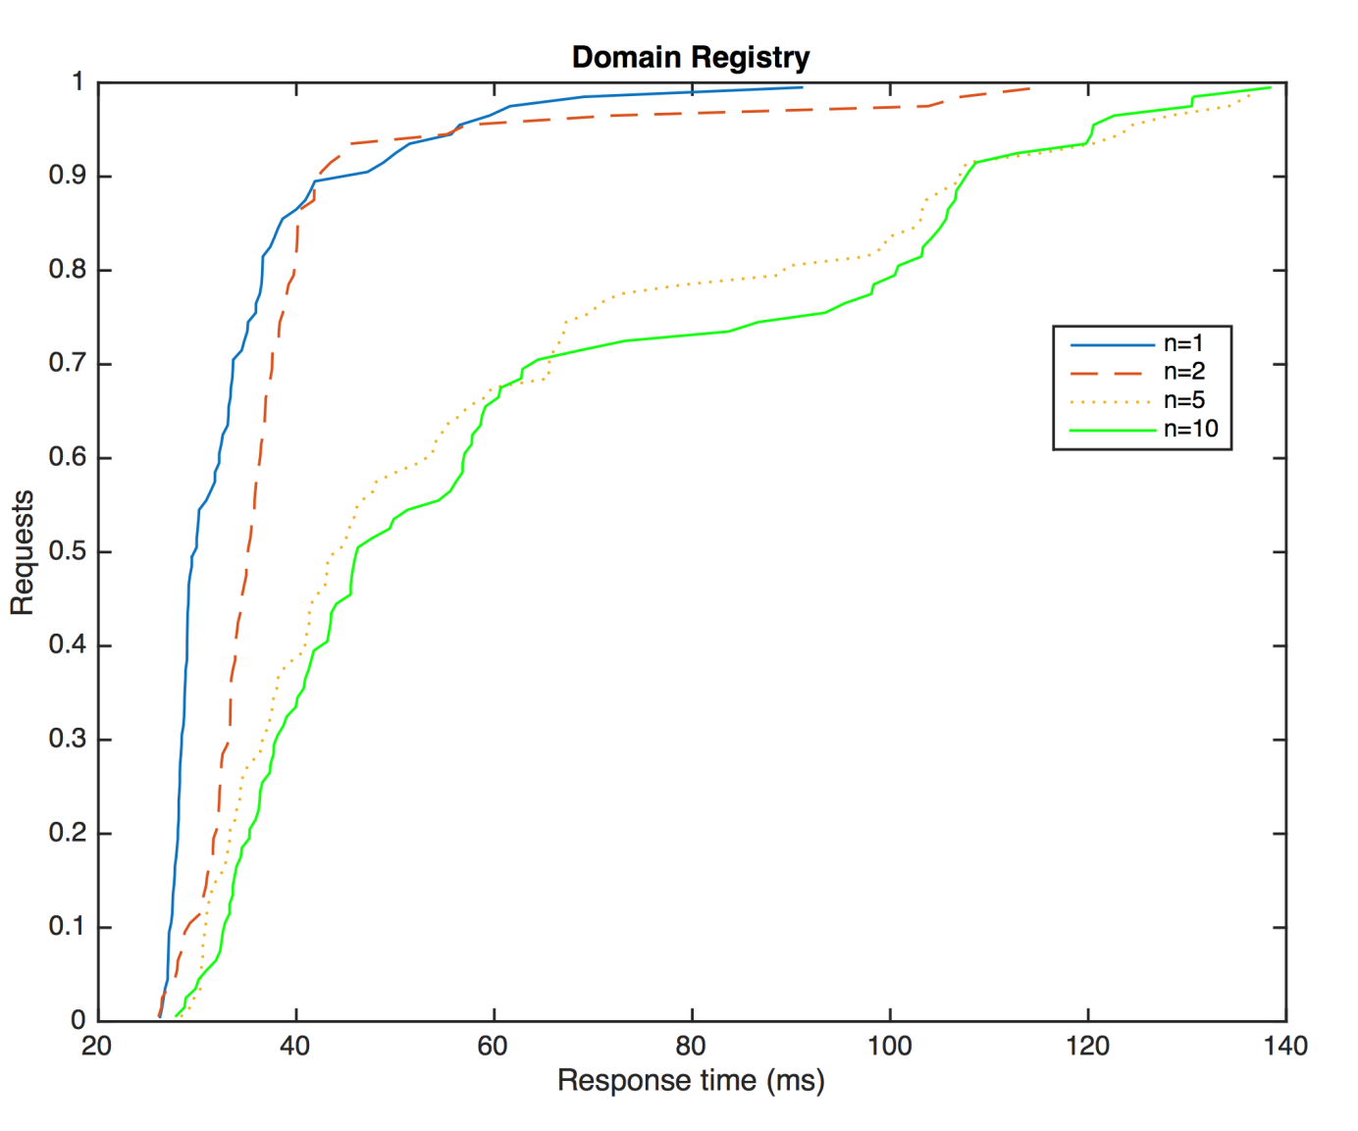

Domain Registry

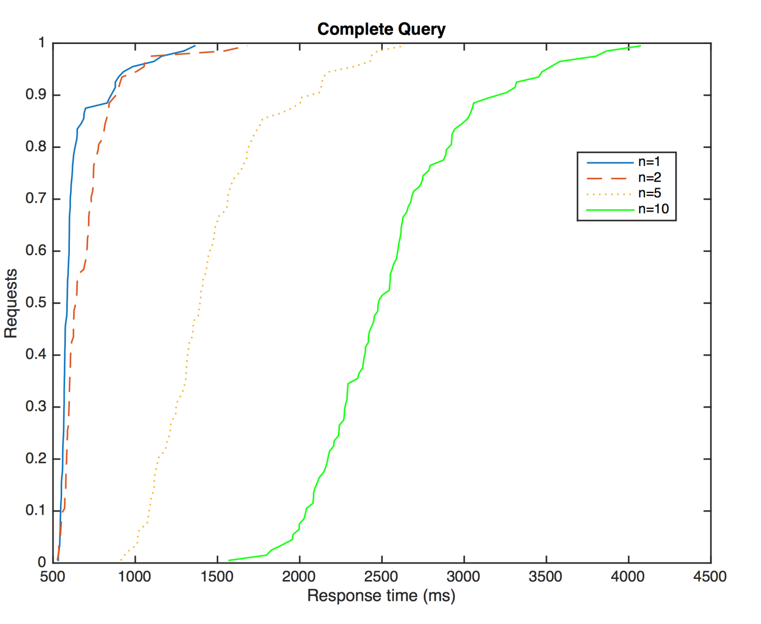

Complete Query

As expected, the higher the number of concurrent requests, the longer the reply time. We can also observe that the Domain Registry provides the fastest response. This was expected as this is the component that has to handle the highest number of queries and update requests. As such, it was designed to be highly performant. The Global Registry's response time is slightly higher as expected. This is due to the fact that the Global Registry has to contact several peers of the DHT in order to provide the reply. However, as the number of peers grows, the response time is expected to only grow logarithmically. The Discovery time takes the longest to respond and is the greatest contributor to the overall query time. This is partly due to the fact of this server being the most distant.

We can also observe that for all the services, the 80% fastest queries lay within a small time band, showing a very consistent response time. A greater variability is observable in the 10% slowest queries.

## Policy Framework Evaluation

*To de done: An overview of the framework and the rational for having two engines taking into account that PoliTHINK is also deployed in the MN*

### PoliTHINK Policy Engine Evaluation

We present the evaluation of the Policy Engine system developed by INESC-ID, henceforth referred to as PoliTHINK. We start by describing the methodology (section 1). Afterwords, we present the main evaluation results regarding the memory usage measurements (section 2), the measurements for the loading times of policies from both non-persistent memory and persistent memory (section 3), and the results of evaluation time of policies (section 4).

#### Methodology

Before presenting the obtained results of PoliTHINK evaluation, we will first present the methodology used in the execution of the tests. The time it takes to process a policy was separated in two stages: first, the loading time, second, the evaluation time. The tests to evaluate these variables will be performed for an increasing complexity of policies specified on our Policy Specification Language and also on XACML, the OASIS1 standard for policy specification. To test the loading time of XACML policies, we used an XML parser provided by JavaScript. To test the evaluation time of XACML policies, we built a specific program to read the XML DOM tree in order to extract the information necessary for the verification of the conditions represented in the policy. To improve the reliability of the tests, each experience was performed 11100 times, distributed by 11 runs of 1010 repetitions each. From the 11 runs, the first one was ignored, and for each run, the first 10 repetitions were also ignored. This way it was possible to discard the warm up periods and equalize the obtained results, further improving their reliability.

The complexity of a policy varies, on the one hand, with the number of rules, and on the other hand, with the size of the condition in a rule. The evaluation of each metric will be done for two groups of policies. The first group is characterized by policies composed of 1, 10, 100 and 1000 rules, each holding a simple condition to be examined. The second group is characterized by policies composed of one single rule, with an advanced condition that combines the result of 1, 10, 100 and 1000 simple conditions through logical operators. When the reTHINK application is started, the Policy Engine is not populated with the policies that users or service providers may have specified in previous sessions. To populate it, these policies are loaded from the persistent memory and stored in a local hash table, which is used to retrieve policies for message evaluation in that session. The processing time of the two ways of loading policies will be evaluated, as well as the processing time of policy evaluation. These tests were carried out in the two environments where the Policy Engine is integrated in: the Core Runtime and the Vertx Messaging Node. The tests were performed in a machine with the Intel Core i3-2367M CPU @ 1.40GHz, 4 GB of RAM, running on 64-bit Ubuntu 14.04 LTS.

1: OASIS (Organization for the Advancement of Structured Information Standards) is a global organization that works on the development and adoption of standards for security, Internet of Things, and other areas.

#### Memory Usage

To evaluate the memory consumption, we take into account the fact that the Policy Engine can be integrated into two different environments: the Core Runtime and the Vertx Messaging Node. In both environments, policies can be stored both persistently and not persistently. The persistent way of storing policies in the Core Runtime is done through the Persistence Manager, which uses the Local Storage. It is a storage type that provides a means to store data with no expiration date within the user’s browser. The Vertx Messaging Node policies are stored in a file, which is loaded when the first message is sent to the Policy Engine for validation. To understand the impact of loading policies from the persistent memory when the system is booted, we must quantify how many bytes their representation requires. Figure 1 (below) presents the number of bytes occupied by policies with 1, 10, 100 and 1000 simple conditions and by policies with 1 rule composed of 1 advanced condition that combines 1, 10, 100 and 1000 simple conditions. In Figure 1 (a), it is presented the number of bytes used by the Persistence Manager to store each policy; Figure 1 (b) presents the measurements obtained for the policies stored in JSON/XML files. For better readability, Figure 1 (c) illustrates the measurements presented in Figure 1 (a) in a chart, and 1 (b) illustrates the measurements presented in Figure 1 (d).

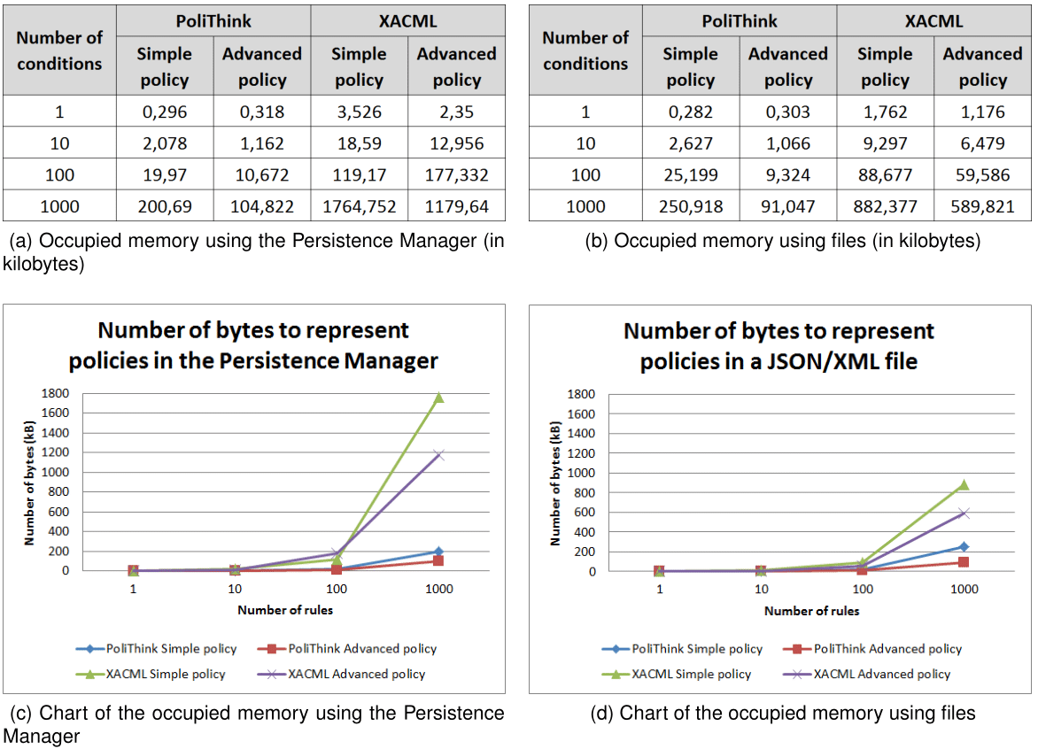

Figure 1: Persistent memory usage for policy representation

Taking into account the results obtained for PoliTHINK and for XACML in both platforms, we observe that our solution is always more efficient than XACML in terms of memory usage. On average, a policy represented in PoliTHINK is 7,6 times more concise than XACML to specify the same behavior. Also, we can conclude that the number of bytes used to represent policies is always higher when using the Persistence Manager, as depicted in Figure 1. This is justified by the encoding used in the different environments. On the one hand, the Local Storage used by the Persistence Manager stores the policy as a JavaScript string, which uses UTF-16 encoding, i.e., each character is represented by 16-bit blocks. On the other hand, the default encoding of the Vertx Messaging Node is UTF-8, i.e., each character is represented by 8-bit blocks. For the most verbose policies, namely XACML, the measurements made for the file are approximately half of what was measured for the Local Storage, which clearly reflects the impact of the encoding on each platform. Adding to these observations, it should also be noted that representing the same conditions on a simple policy and on an advanced policy implies a big difference when it comes to the number of bytes needed. While a simple policy with X conditions requires the specification of X rules with fixed fields repeated X times, advanced policies only require that these fields are represented once for the rule holding the advanced condition. For this reason, the discrepancy between the occupied memory for simple and advanced policies increases rapidly for 1, 10, 100 and 1000 conditions.

#### Policy Loading Time

One of the requirements of PoliTHINK is that it provides an efficient solution in terms of the necessary time for loading and evaluating policies. Similarly to the previous section, this section presents the measurements obtained for the loading time of simple and advanced policies with an increasing number of rules and conditions. Next, we will present the time measurements obtained when loading policies from persistent memory and from the local hash table, starting with the former.

##### Loading Time from Persistent Memory

The policies loading time from persistent memory is measured differently in both environments where the Policy Engine is integrated. For the Core Runtime, policies are stored using the Persistence Manager; for the Vertx Messaging Node, policies are stored in a text file. To measure the loading time in the Core Runtime, a timer is set using a library that generates the microseconds before the policy is loaded from the Persistence Manager, and a second timer is set right after that request is fulfilled. Loading a policy with a given key from the Persistence Manager consists of requesting the Local Storage to retrieve the value that corresponds to the policy key, which is then parsed to JSON format. Subtracting the two timers gives the time it takes for the policy to be loaded from the Persistence Manager. To measure the loading time in the Vertx Messaging Node, a timer is set before reading the file, which consists on instantiating a FileInputStream and a BufferedReader given the path to the JSON/XML file holding the policy, and then reading the file line by line, concatenating the contents in a string. The measurements obtained for the policies loading time are presented in Figure 2 (below), where Figure 2 (a) shows the loading time of policies when using the Persistence Manager, and Figure 2 (b) presents the measurements obtained for the same policies but when they are loaded from JSON/XML files. Figure 2 (c) illustrates the measurements presented in Figure 2 (a), and 2 (b) illustrates the measurements presented in Figure 2 (d).

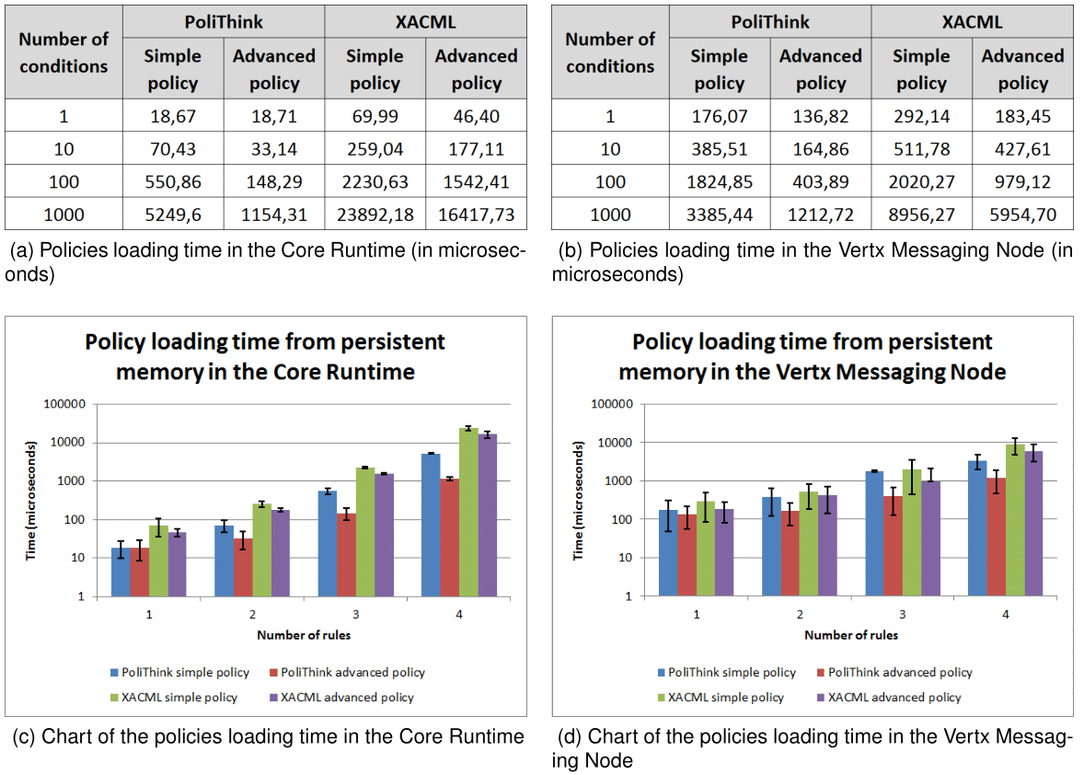

Figure 2: Policies Loading Time from Persistent Memory

Taking into account the results obtained for PoliTHINK and for XACML in both platforms, we observe that our solution is always more efficient than XACML in terms of loading time from persistent memory. The policy loading time is closely linked with the corresponding memory usage, i.e., as the policies' complexity implies a higher number of bytes to represent them, the more time it is needed to load them. This relationship is illustrated in Figure 3 (below), where Figure 3 (a) illustrates the memory usage for policies in the Core Runtime and 3 (b) illustrates the policy loading time in the same environment. In this figure it is possible to clearly observe the trend of the policies loading time from persistent memory, which follows the trend of memory usage in the Persistence Manager.

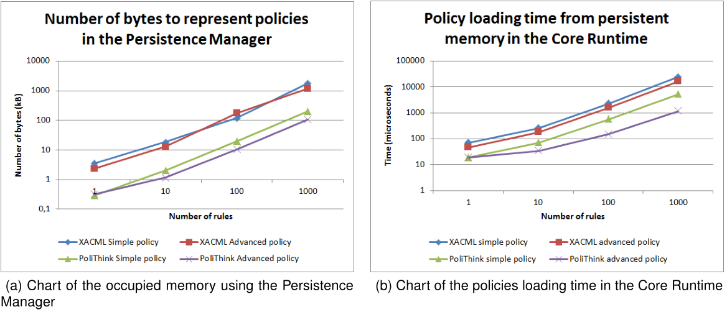

Figure 3: Memory Usage and Policies Loading Time Comparison

When the policies are loaded from the persistent memory to the Policy Engine, they are stored in a local hash table. This hash table is then accessed for each message if there is an active user policy (in the Core Runtime), or if there is an applicable service. Next, we present the measurements obtained when loading the policies from the local hash table.

##### Loading Time from Local Hash Table

A hash table is a data structure that can map keys to values through a hash function in constant time. To avoid the overhead introduced by loading the policies from the persistent memory for each message that requires policy evaluation, the Policy Engine uses a hash table to store the policies that correspond to a given policy key. Therefore, when a message is intercepted by the Policy Engine, the policy to apply is retrieved from the hash table instead of from the persistent memory, which greatly improves the loading time. To examine the performance of loading the policies from the hash table, a test similar to the one performed in the previous section was carried out: a timer was set before accessing the hash table, and a second timer was set after reading the policy that corresponds to a given key. Subtracting the two timers gives the time it takes for the policy to be loaded from the non-persistent memory. The measurements obtained for this test are presented in Figure 4 (below), where Figure 4 (a) shows the loading time of policies in the Core Runtime, and Figure 4 (b) shows the loading time of policies in the Vertx Messaging Node. The charts presented in Figure 4 (c) and (d) correspond to the values provided in Figures 4 (a) and (b), respectively.

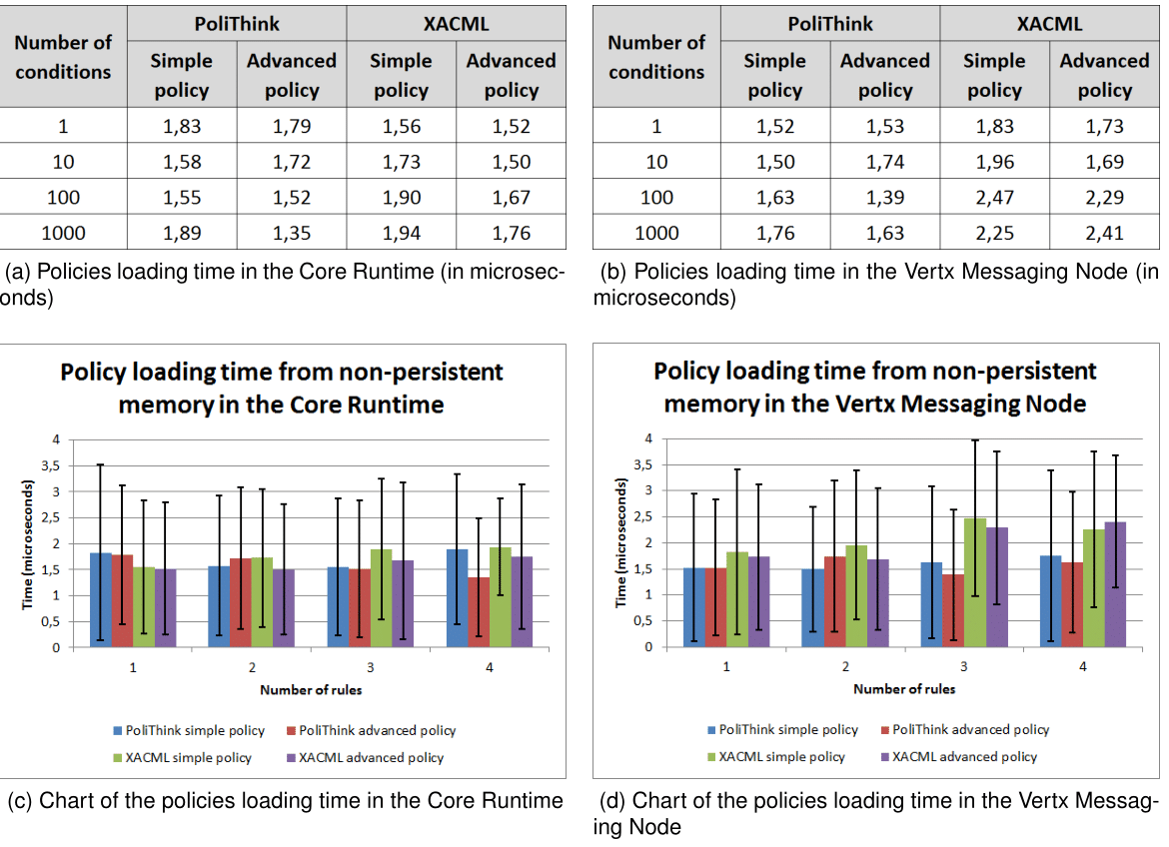

Figure 4: Policies Loading Time from Non-persistent Memory

Taking the presented measurements into account, we observe that loading policies from the hash table is considerably faster than loading policies from the persistent memory. We also observe that the load time is independent of the stored amount of information and also independent of the platform. On average, loading a policy from the hash table takes approximately 1.75 microseconds. This value corresponds to approximately 10 times less what was obtained for the best case of the persistent memory loading evaluation - which corresponds to the PoliTHINK simple policy with 1 rule. To restrict the overhead introduced by the loading of policies to a minimum, each policy is loaded only once from the persistent memory when the session starts, and until the end of that session they are loaded from the hash table. After loading a policy, it is necessary to evaluate it in order to generate an authorization decision. Next, we present the time measurements obtained for the evaluation of policies.

#### Policy Evaluation Time

A policy is composed of a set of rules, which by their turn are composed of 1 or more conditions, simple or advanced. The evaluation of a policy consists of evaluating each rule on the array of rules; the evaluation of a rule consists of verifying the condition applicability and returning the specified authorization decision if the condition applies. Consequently, the evaluation time of a policy is expected to be increasingly higher when the number of conditions to evaluate also increases. To measure the impact of policy evaluation on both the Core Runtime and the Vertx Messaging Node, a timer was set before starting the evaluation of a policy, and a second timer is set right after the evaluation completes. Subtracting the timers gives the time it takes for a policy to be evaluated. The measurements obtained for the evaluation of the test policies are presented in Figure 5, where Figure 5 (a) shows the evaluation time of policies in the Core Runtime, and Figure 5 (b) shows the evaluation time of policies in the Vertx Messaging Node.

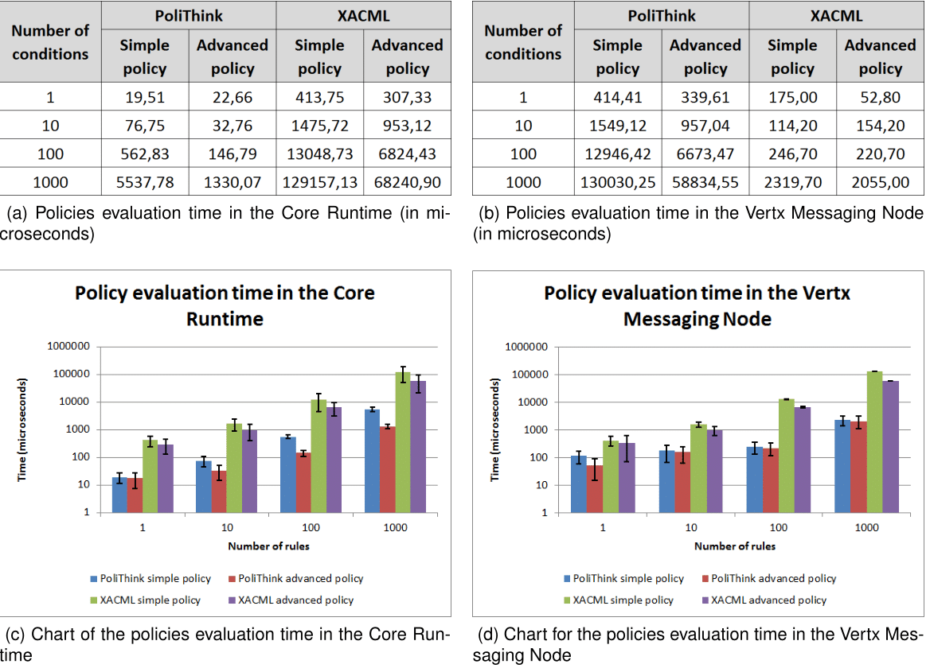

Figure 5: Policies Evaluation Time

Taking into account the results for PoliTHINK and XACML in both platforms, we observe that our solution is always more efficient than XACML in terms of policy evaluation time. Such difference exists due to the means of extracting the information using each language. On the one hand, policies represented in the PoliTHINK Policy Specification Language are objects, and the policy properties are accessed directly. On the other hand, extracting the information from a policy represented in XACML requires traversing the node tree, which is computationally more expensive. Adding to this observation, and as expected, we observe that increasing the number of conditions to be evaluated results on a higher evaluation time. Also, we observe that the policy evaluation time in Vertx Messaging Node is, on average, 1.8 times higher that the policy evaluation in the Core Runtime. Since the Vertx Messaging Node uses Nashorn2 to embed JavaScript code in Java applications, this outcome would be expected: to execute the JavaScript code of the Policy Engine, Nashorn compiles it into Java bytecodes and runs them on the JVM (Java Virtual Machine) itself. Consequently, the overhead introduced by this process was reflected in the policy evaluation time.

2: Nashorn is a JavaScript engine developed by Oracle.

#### Summary

We presented the evaluation of the implemented solution. For the two types of policies, i.e., that are composed of simple or advanced conditions, we studied the behavior of the solution by observing the time it takes to load and evaluate policies while increasing the policies' complexity. Our implementation revealed itself as an efficient solution for the reTHINK framework when compared to the XACML policy specification language, both in terms of memory usage and processing time.

### JACPoL Policy Engine Assessment

#### Introduction

**Policy Engine.** The policy engine follows PEP/PDP architecture, and is currently implemented in the [Node.js-based messaging node](https://github.com/reTHINK-project/dev-msg-node-nodejs) [1] of reThink project. However, by simply invoking the interface of PEP, it is possible to migrate the policy engine to other components of the reTHINK framework. Fig. 1 below indicates the overall architecture of the policy engine.

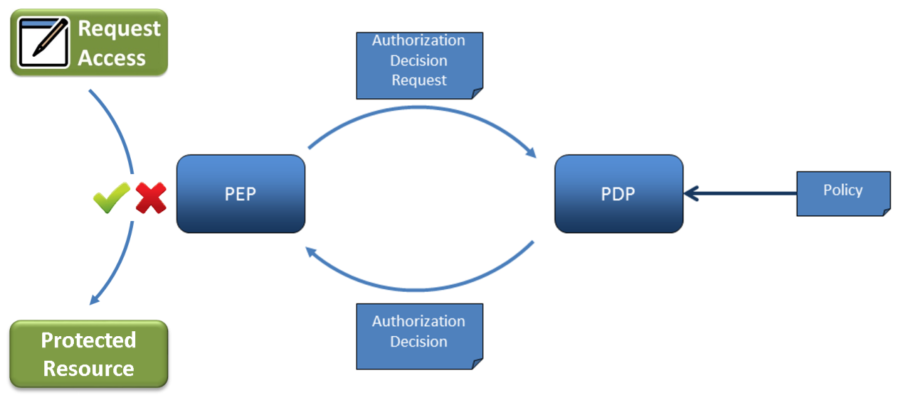

Fig. 1 - Policy Engine Architecture

The Policy Enforcement Point (PEP) is the component in charge of intercepting communication messages and protecting targeted resources by requesting an authorization decision from a Policy Decision Point (PDP) and enforcing that decision. The PDP sits at the very core of the policy engine architecture. It implements the policy description language and evaluation logic. Its purpose is to evaluate authorization requests coming from the PEP against the policies loaded from the Policy Retrieval Point (PRP). The PDP then returns a decision – either of Permit, Deny, or Not Applicable.

Fig. 2 shows the sequence diagram indicating communication pattern between components of the policy engine.

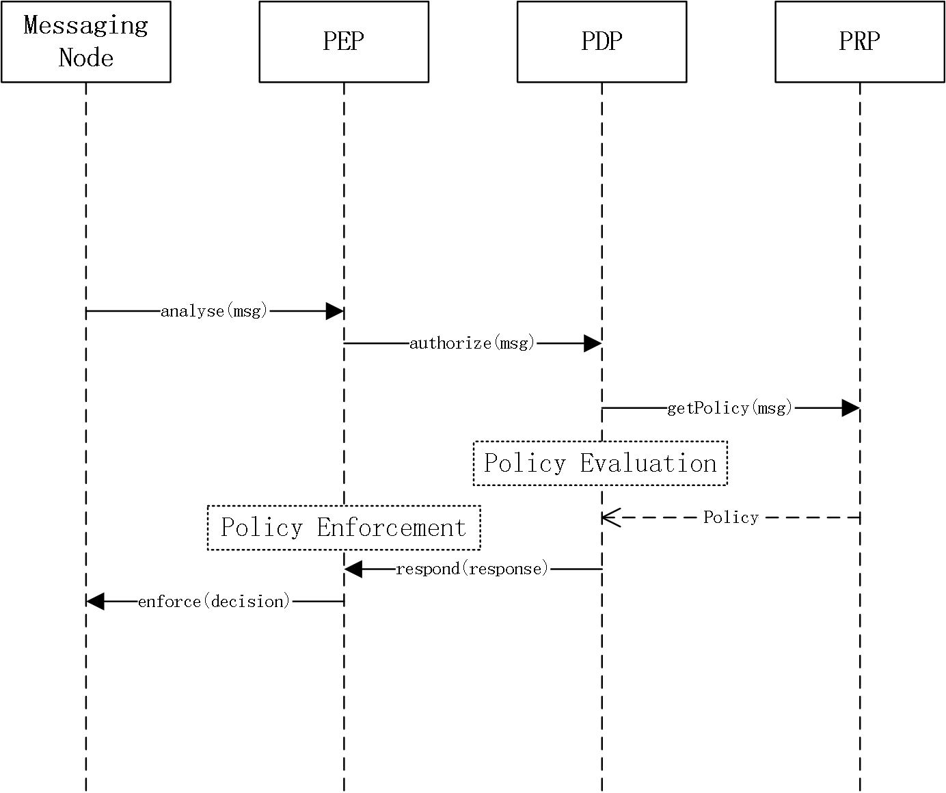

Fig. 2 - Sequence Diagram

For more details concerning the policy engine design and implementation please refer to the README file [here](https://github.com/reTHINK-project/dev-msg-node-nodejs/tree/master/src/main/components/policyEngine) [2] in the policy engine folder of the Node.js MN source code repo.

**JACPoL Policy Language.** JACPoL is a simple but expressive JSON-based language to specify policies. It is specifically designed for turning the needs of access control into meaningful policies that can govern whether and where a request should be blocked, filter which elements of the returned resource it can contain, and constrain the values that can be set for properties. The reTHINK policies are expressed using JACPoL that is tailored to the requirements of reTHINK framework. Policies following this language use a rich vocabulary that gives the ability to configure end user or service provider configurations in an expressive and flexible way.

JACPoL contains three structural elements, namely Policy Set, Policy, and Rule. The fields of each element and the relationships between them are presented in Fig. 3 as below.

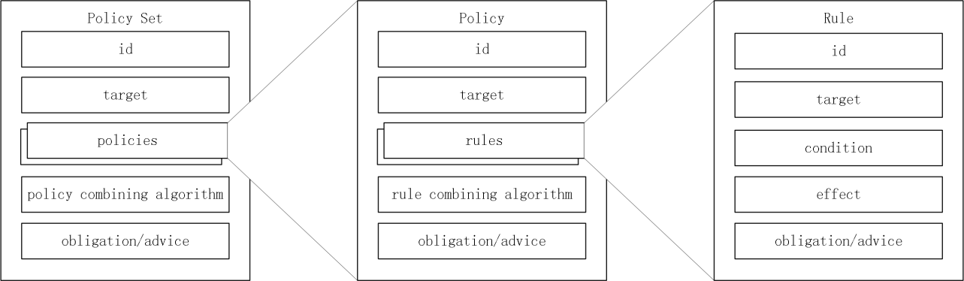

Fig. 3 - JACPoL Structure

* A **rule** element defines the target elements to which the rule is applied and details conditions to apply the rule and has three components such as target, effect, and condition. A target element specifies the resources, subjects, actions and the environment to which the rule is applied. A condition element shows the conditions to apply the rule and an effect is the consequence of the rule as either permit or deny.
* A **policy** is the set of rules which are combined with some algorithms. These algorithms are called rule-combining algorithms. For instance "Permit Override" algorithm allows the policy to evaluate to "Permit" if any rule in the policy evaluates to "Permit". A policy also contains target elements which show the subjects, resources, actions, environment that policy is applied.
* A **policy set** consists of Policies combined with policy-combined algorithm. It has also target like a Policy.

Fig. 4 is an example rule: for messages that are of registration msgType and read actType, if the requested resource is user://gmail.com/chiang.zju and the requester is he.johen@gmail.com, then deny.

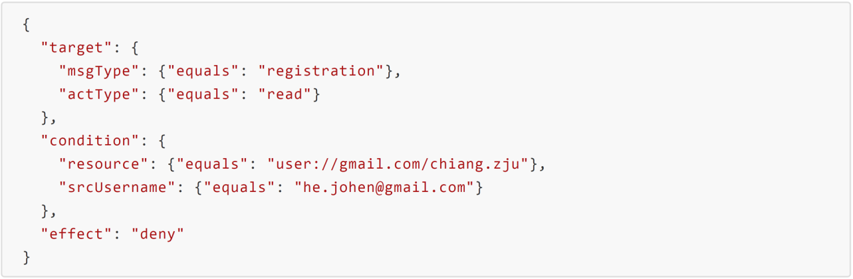

Fig. 4 - An Example Rule

JACPoL provides a simple, flexible, scalable, and expressive attribute-based access control capability, and at the same time supports obligations or advice to enable a set of network management and security features. The detailed syntax and semantics of JACPoL can be found [here](https://github.com/reTHINK-project/dev-msg-node-nodejs/tree/master/src/main/components/policyEngine/prp/policy) [3].

#### Methodology Overview

This section introduces methodology and setup for the evaluation of the policy engine. The evaluation is separated into three parts: first is the conformance evaluation to assess the effectiveness of the policy engine with respect to the requirements of reTHINK framework; second is the performance evaluation to test the policy evaluation language in terms of a set of criteria such as processing delay, etc; third is the comparison evaluation, where we comprehensively compare the policy engine with the one for the runtime developed by INESC. For conformance evaluation, we choose the Connector hyperty for demonstration, analyze in details about the signaling messages and phases based on communication sequence diagram. As a result, we have identified for this use case a set of policy control points (PCPs) available for the deployment of different policies. The subsequent section would provide a concrete view of the policies that could be effectively deployed based on these PCPs. For performance evaluation, we assess the policy language in comparison with the standardized XACML policy language. We conduct repeated tests in order to get reliable results that reflect real performance. For comparison evaluation, we compare key features of the two policy engines in order to clarify their differences in terms of their design and implementation.

#### Conformance Evaluation

The connector hyperty is one of the hyperties that are available on the reTHINK testbed. It provides services like user search and WebRTC call. When running on the user device runtime, the hyperty represents for the user as a live instance providing communication services within the reTHINK framework.

##### Message Node Functionalities and Policing Requirements

The Node.js based Messaging Node is one of the reference implementations of the CSP Messaging services in the reTHINK Architecture. The role of Messaging Nodes in the reTHINK Architecture is described in detail in [Hyperty Messaging Framework](https://github.com/reTHINK-project/specs/blob/master/messaging-framework/readme.md). Overall, as part of CSP backend services, it interacts with other rethink CSP backend components like the CSP domain registry, CSP catalogue.

The message node is responsible for the message delivery at domain level, which is based on a simple message router functionality that performs a lookup for listeners registered to receive the message. The message is posted to all found listeners, which can be other routers/message nodes or the final recipient end-point. Thus, the reThink messaging framework is comprised by a network of routers/message nodes where each router/message node only knows adjacent registered routers/message nodes or end-points. Meanwhile, listeners are programmatically registered and unregistered by routing management functionalities, which take their decisions according to a higher level view of the routing network.

Message nodes are responsible for the interaction of runtimes that might belong to different administrative domains by offering protocol stubs to these external runtimes. The domain operators need a mechanism to control these domain interactions and to potentially block or limit certain combinations of message exchange. In order to achieve this, a MN must provide a hook in the message flow that allows applying policy-based decisions to the routing. These policies must be manageable by the domain Policy Manager. Therefore a Policy Engine provides Policy Decision and Policy Enforcement functionalities at Domain level for incoming and outgoing messages in cooperation with authentication and authorization provided by Identity Management functionalities. It also provides authorization / access control to the Message BUS.

Overall, the policy engine supports a message node to accomplish the following operations:

* Policy-based inter/intra domain routing.
* Policy-based functioning and access control of the message node components and support services (including address allocation and subscription management).
* Policy-based functioning (part of) and access control of reTHINK backend services (including Domain Registry, Global Registry and Identity Management support services).

##### Policy Control Points and Conformable Policing Examples

In this section we analyze the connector hyperty use case step by step from the initiation of the call. We assume that the runtime has been downloaded from the right catalogue according to the configuration of the testbed (environment variables), and the Protostub and then the hyperty have been also loaded from the catalogue.

**Phase 1. Hyperty registration**

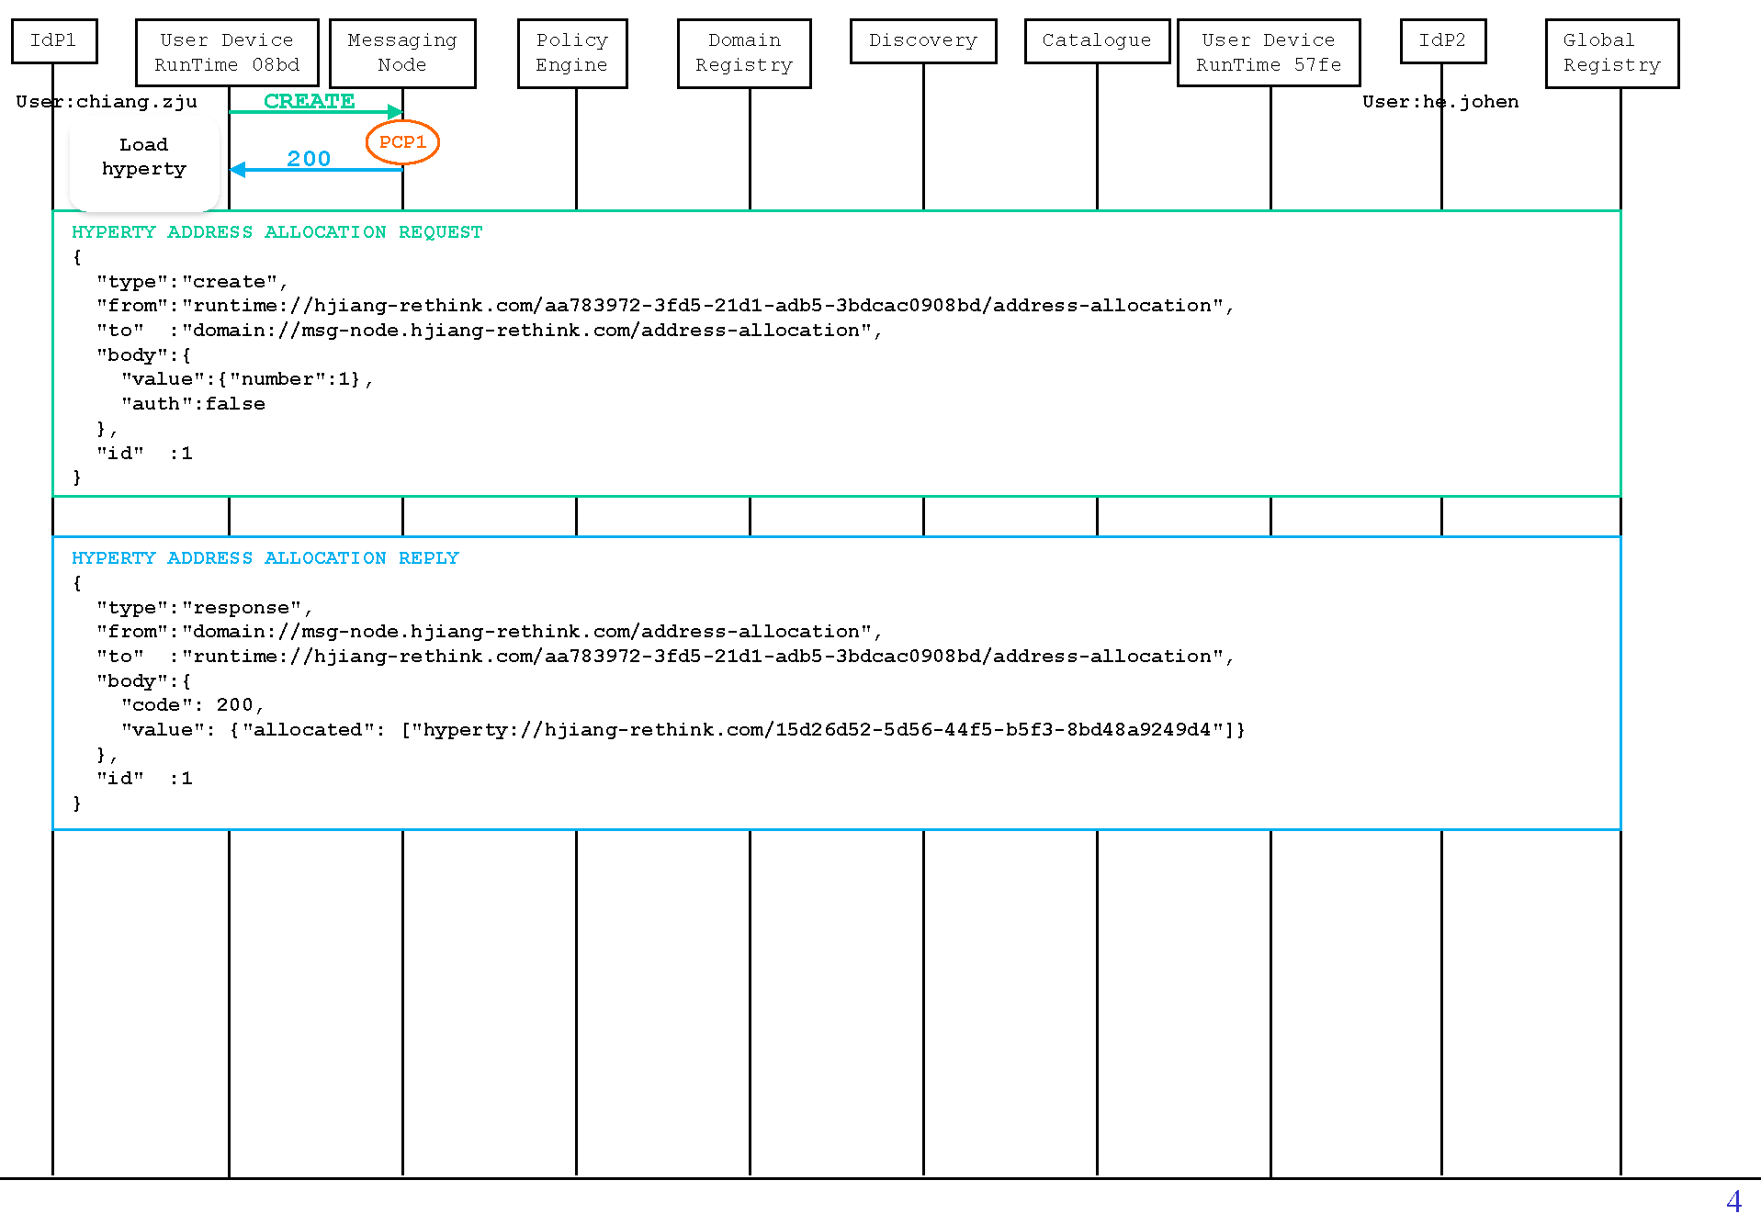

callflows

The first observed message is sent from the runtime to the address allocation manager of the messaging node to request for an address for the just loaded Connector hyperty. Thus the first PCP can be identified for the policy-based control (deny/permit) of this procedure on the message node. At this point, the policy for example can limit the number of requested addresses as expressed below for PCP 1.

* Example 1: for messages of *addressAllocation* msgType and *create* actType, if the requested number of addresses is more than 1, then deny.

{  
 "target": {  
 "msgType": {"equals": "addressAllocation"},  
 "actType": {"equals": "create"}  
 },  
 "condition": {  
 "valueNumber": {"moreThan": 1}  
 },  
 "effect": "deny"  
}

In addition, we can also use policies to limit the maximum number of address allocation requests from the same runtime within a period.

* Example 2: for messages of *adddressAllocation* msgType and *create* actType, if the *runtime* has reached the allowed maximum number of requests (50) within a minute, then deny.

{  
 "target": {  
 "msgType": {"equals": "addressAllocation"},  
 "actType": {"equals": "create"}  
 },  
 "condition": {  
 "addrAllastMin": {"moreThan": 50}  
 },  
 "effect": "deny"  
}

As there is returned value in the body of the response message, we can thus also define policies at this point to control the returned value.

* Example 3: for messages of *addressAllocation* msgType and *response* actType, if the allocated number of addresses is more than 1, then permit, but limit the number of allocated addresses to 1.

{  
 "target": {  
 "msgType": {"equals": "addressAllocation"},  
 "actType": {"equals": "response"}  
 },  
 "condition": {  
 "valueAllocate": {"moreThan": 1}  
 },  
 "effect": "permit",  
 "obligations": {"limitByNumberOfEntries": {"valueAllocated": 1}}  
}

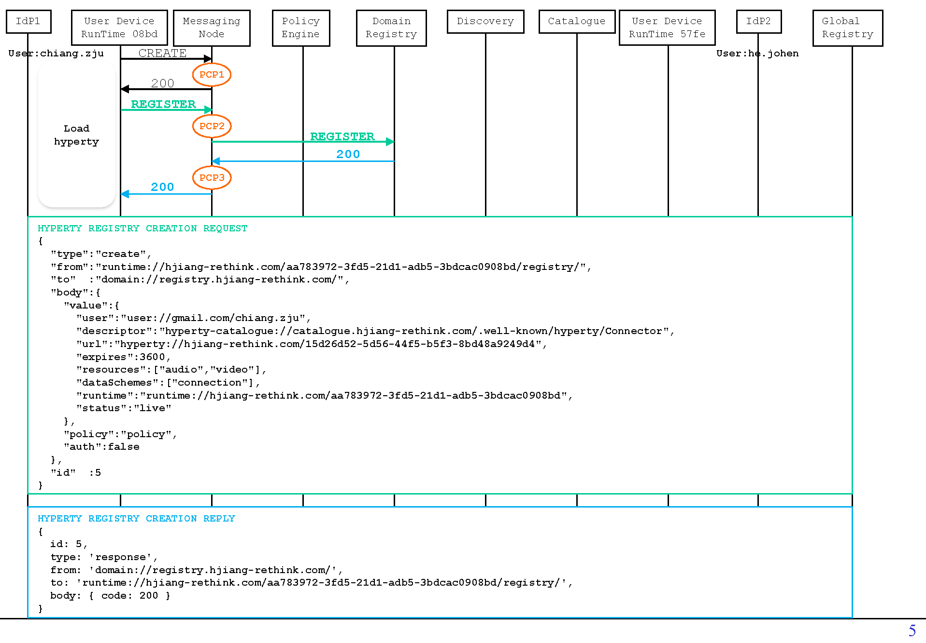

callflows

The next message is to register the new hyperty to the domain registry with all the necessary information such as its address, user url, runtime url, etc.. Some policies can be to examine the content of the registry entry, or the validity of the requested service for the given user. **Please note** that the functionality-specific policies are better to be deployed on the policy engine of the corresponding reTHINK backend component instead of the message node. For example, a policy as below should be normally deployed on the policy engine of the domain registry:

* Example 4: for messages that are of *registration* msgType and *create* actType, if the user has reached the predefined maximum number of hyperties that it can register (100 for example), or the *expires* value is larger than 3600, then deny.

{  
 "target": {  
 "msgType": {"equals": "registration"},  
 "actType": {"equals": "create"}  
 },  
 "condition": [  
 {"userRegistries": {"moreThan": 100}},  
 {"valueExpires": {"moreThan": 3600}}  
 ],  
 "effect": "deny"  
}

**However**, it is possible that some part of the policies (e.g., generic policy-based routing and access control) related to reThink backend services could be deployed on the edge (message node) to release these central servers from numerous invalid requests. For example, back to this use case, an apparently invalid registry request can be dropped directly by the message node at PCP 2 instead of being forwarded to the domain registry:

* Example 5: for messages that are of *registration* msgType and *create* actType, if the *value* field does not exists, then deny.

{  
 "target": {  
 "msgType": {"equals": "registration"},  
 "actType": {"equals": "create"}  
 },  
 "condition": {"bodyValue": {"exists": false}},  
 "effect": "deny"  
}

In addition, there might be needs to limit a user to use only a set of hyperties that are defined in the service agreement.

* Example 6: for messages that are of *registration* msgType and *create* actType, if the source user tries to register a hyperty that is not Connector, DTWebRTC, or GroupChat, then permit.

{  
 "target": {  
 "msgType": {"equals": "registration"},  
 "actType": {"equals": "create"}  
 },  
 "condition": {"valueDescriptor": {"not": {"like":["*/Connector","*/DTWebRTC","*/GroupChat"]}}},  
 "effect": "permit"  
}

For PCP 3, as the response message does not contain any other value except for the returned code, there is no point in blocking or modifying the message. Therefore, we did not see any meaningful policy which could be deployed at this point.

Then, another user also tries to register the same hyperty at another device following the same procedure.

**Phase 2. Intra-domain User Discovery**

After that, the two users should have their hyperties loaded and ready. Now we assume that the user *chiang.zju* tries to call the other user *he.johen*.

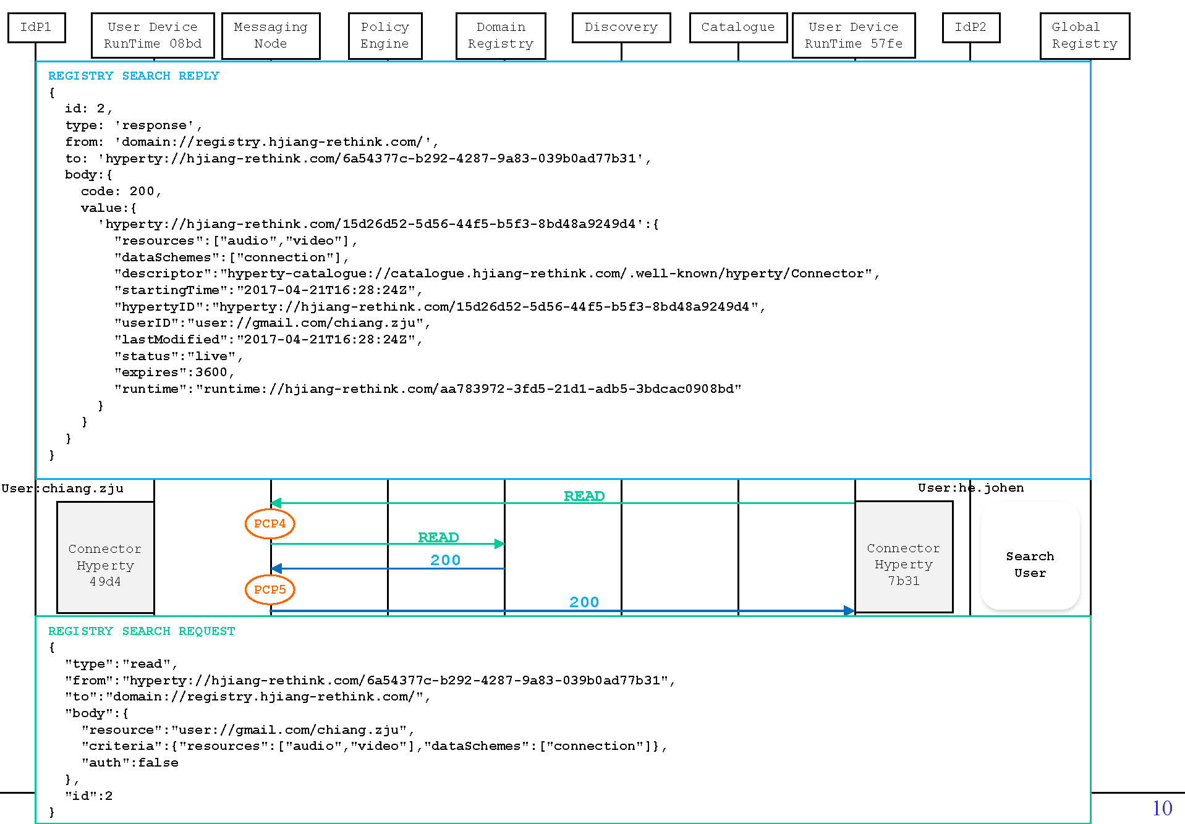

First, as we can see the figure above, the caller would send a request of read type to the domain registry to search for the available hyperties of the callee with specific criteria. In return, the domain registry replies with a list of hyperties of the callee that satisfies the criteria. As there might be cases that sometimes the callee wants to configure itself invisible to all others for a specific period of time, we can thus have some policies as examples below for PCP 4:

* Example 7: for messages that are of *registration* msgType and *read* actType, if the targeted *resource* is user *user://gmail.com/chiang.zju* and if it is weekends or between 9 PM and 6 AM of weekdays, then deny.

{  
 "target": {  
 "msgType": {"equals": "registration"},  
 "actType": {"equals": "read"}  
 },  
 "condition": {  
 "resource": {"equals": "user://gmail.com/chiang.zju"},  
 "anyOf": [  
 {  
 "time": {"between": "21:00:00 06:00:00"},  
 "weekday": {"not": {"in": ["saturday","sunday"]}}  
 },  
 {  
 "weekday": {"in": ["saturday","sunday"]}  
 }  
 ]  
 },  
 "effect": "deny"  
}

Or if the caller is blacklisted by the callee:

* Example 8: for messages that are of *registration* msgType and *read* actType, if the targeted *resource* is user *user://gmail.com/chiang.zju* and the source user is *he.johen@gmail.com*, then deny.

{  
 "target": {  
 "msgType": {"equals": "registration"},  
 "actType": {"equals": "read"}  
 },  
 "condition": {  
 "resource": {"equals": "user://gmail.com/chiang.zju"},  
 "srcUsername": {"equals": "he.johen@gmail.com"}  
 },  
 "effect": "deny"  
}

At PCP 5, the policy engine could intercept the returned message which contains a list of hyperties of the callee from domain registry. The policy examples described above could also be implemented at this point:

* Example 9: for messages that are of *registration* msgType and *response* actType, if the *valueUser* is *user://gmail.com/chiang.zju* and the *dstUsername* is *he.johen@gmail.com*, then deny.

{  
 "target": {  
 "msgType": {"equals": "registration"},  
 "actType": {"equals": "response"}  
 },  
 "condition": {  
 "valueUser": {"equals": "user://gmail.com/chiang.zju"},  
 "dstUsername": {"equals": "he.johen@gmail.com"}  
 },  
 "effect": "deny"  
}

Additionally, we can also deploy other policies with more sophisticated manipulation based on the content of the returned value. For example, the callee may only want some of its hyperties, or a specific hyperty visible to the caller.

* Example 10: for messages that are of *registration* msgType and *response* actType, if the *valueUser* is *user://gmail.com/chiang.zju* and the *dstUsername* is *he.johen@gmail.com*, then permit, but only keep the Connector hyperty in the returned list.

{  
 "target": {  
 "msgType": {"equals": "registration"},  
 "actType": {"equals": "response"}  
 },  
 "condition": {  
 "valueUser": {"equals": "user://gmail.com/chiang.zju"},  
 "dstUsername": {"equals": "he.johen@gmail.com"}  
 },  
 "effect": "permit",  
 "obligations": {"limitByConditionOfEntries": {"bodyValue": {"descriptor": {"like": "*/Connector"}}}}  
}

Until now we have provided sufficient examples on how the reTHINK PDL is implemented to realize different policing requirements for reTHINK.

#### Performance Evaluation

We have evaluated the performance of our policy evaluation language by comparing it with a common policy language XACML. We examine their vertical and horizontal scalabilities respectively in terms of the number of nesting layers (depth) and the number of sibling rules (scale).

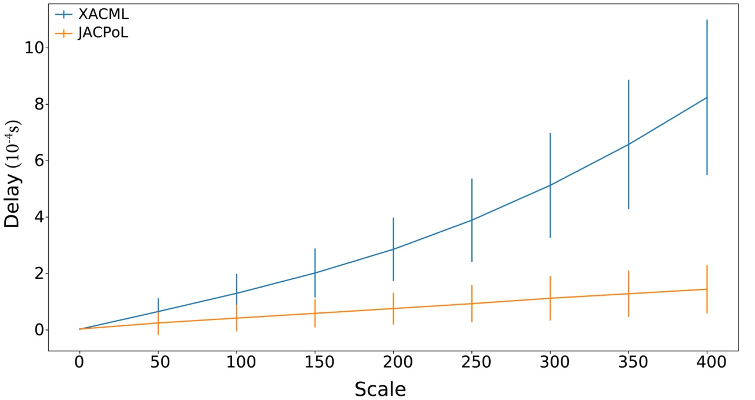

Fig. 5 - Effect of the number of sibling rules

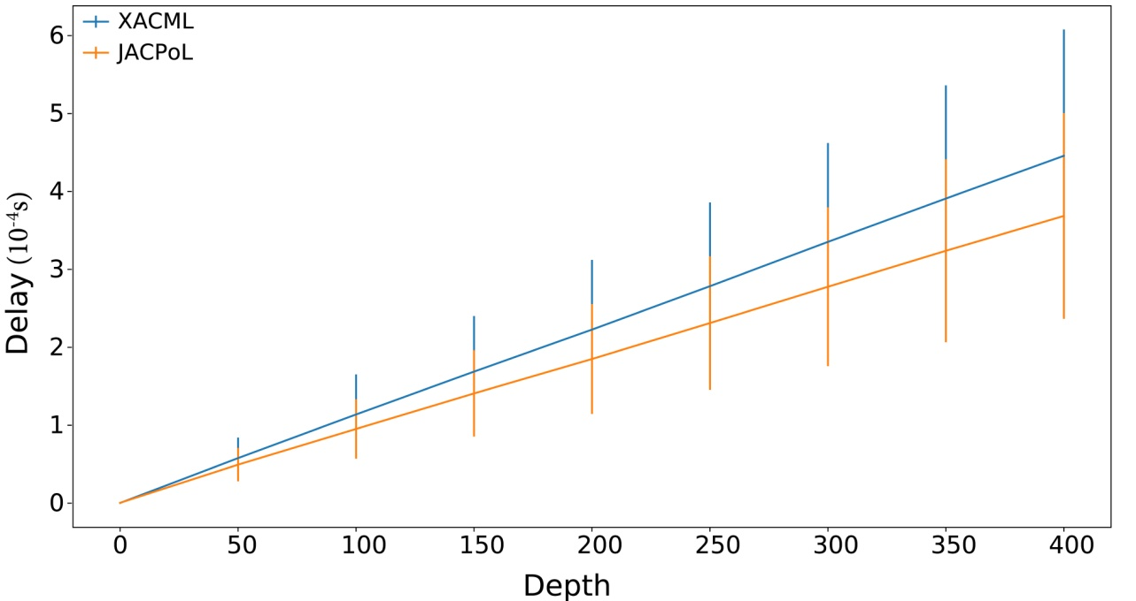

Fig. 6 - Effect of the number of nesting layers

Each test was repeated 1000 times conducted on a Windows 10 PC with 16G memory and a 2.6GHz Intel core i7-6700HQ processor. From the results we can see that JACPoL is more efficient and scalable and evaluated with less latency than XACML thanks to its JSON syntax and well-defined semantics.

#### Conclusions and recommendations

As we can see from above, the policy engine fulfils access control requirements of reTHINK and at the same time provides good performance results.

In practical application, policies are not a list of independent rules, as it would bring difficulties and inefficiency to policy indexing and management, and a bad design would even introduce conflicts between different rules. On the other hand, a good design of policies, would not only improve the performance of policy engine, but also ease the management work of policies for the administrator. In this section, we provide some guidelines that could be followed when designing policies based on reTHINK PDL.

**- Clarify Policing Needs**

First and foremost, clarify what policies are needed and what to achieve with these policies, with a clear list of all the rules that is planned to be deployed.

**- Classify Policies & Rules**

Generally speaking, rules with similar *targets* (for similar purposes) are put in the same policy, and similar policies are put in the same policy set. When managing policies, it is important to classify carefully different rules and policies in order to form a well structured and layered policy set. Policies could be classified in many ways depending on your policy needs. For instance, in previous examples, most of rules use *msgType* and *actType* in order to index right policies for targeted messages. In such case, we can accordingly construct policies and policy sets based on these two attributes in the *target* fields of rules:

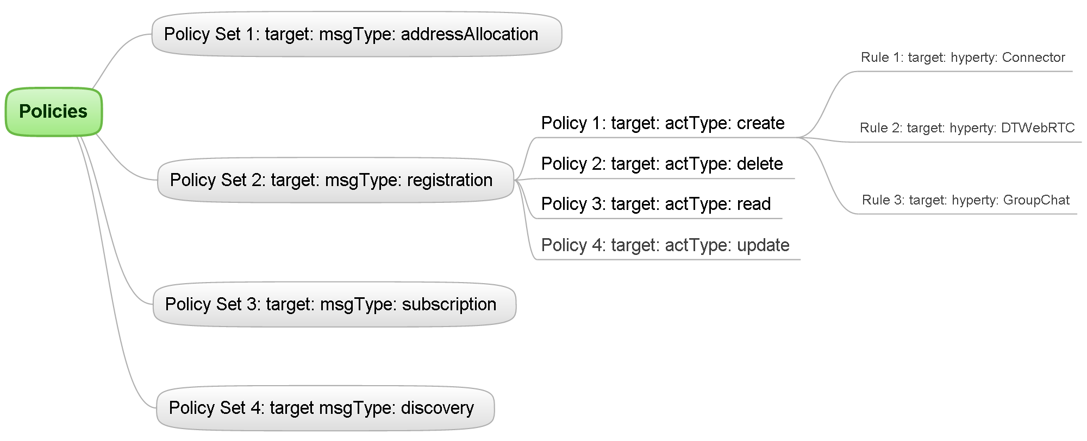

**- Properly Utilize Logical Operators**

Actually as you might already noticed, in the examples above, there are policies which have similar (same) *target* fields. In these cases, rules which have the same *target* field can be possibly combined into one rule with their *condition* fields connected by logical operators (*AND*, *OR*, *NOT*). For example a combination could be done for the two rules as below:

* Rule 1:

{  
 "target": {"msgType": {"equals": "addressAllocation"}},  
 "condition": {"time": {"between": "23:00:00 01:00:00"}},  
 "effect": "deny"  
}

* Rule 2:

{  
 "target": {"msgType": {"equals": "addressAllocation"}},  
 "condition": {"addrAllastMin": {"moreThan": 50}},  
 "effect": "deny"  
}

* Combined Rule:

{  
 "target": {"msgType": {"equals": "addressAllocation"}},  
 "condition": [  
 {"addrAllastMin": {"moreThan": 50}},  
 {"time": {"between": "23:00:00 01:00:00"}}  
 ],  
 "effect": "deny"  
}

Such kind of combination can reduce policy index and process time for a message, and also globally make policies simpler and shorter. Therefore, a proper utilization of logical operators in *target* and *condition* fields is important when designing policies.

### Comparison Evaluation

In this section, PoliTHINK and JACPoL Policy Engines are compared. We summarize the comparison in the table as below:

|  |  |  |
| --- | --- | --- |
|  | [PoliTHINK](https://github.com/reTHINK-project/dev-runtime-core/tree/develop/src/policy) | [JACPoL](https://github.com/reTHINK-project/dev-msg-node-nodejs/tree/master/src/main/components/policyEngine) |
| Programming Language | Javascript | Javascript |
| Environment | Runtime Core and Messaging Node | Messaging Node |
| Administrative Domain | End User and CSP | CSP |
| Policy Management | Locally Defined | Remotely Maintained |
| Policy Language Syntax | JSON | JSON |
| Architecture | PDP/PEP | PDP/PEP/PRP/PIP |
| Access Control Scheme | ABAC | ABAC |
| User Interface | Yes | No |
| Complex Rule | Partly Support | Support |
| Obligation | Support | Support |
| Context Awareness | Yes | Yes |
| Policy Readability | Medium | High |
| Policy Expressiveness | Medium | High |
| Policy Index | Partly Support | Support |

As we can see, the two policy engines have the following features in common:

* Both are developed in Javascript.
* Both policy languages follow JSON syntax.
* Both employ ABAC access control scheme.
* Both support obligation and are context sensible.
* Both adopt PEP/PDP architecture.

On the other hand, they have following differences:

* The PoliTHINK was designed to be used in the runtime browser for the end user and in the backend Message Node for the CSP, while the JACPoL is limited to be used in the backend component for the CSP.
* The PoliTHINK policies are managed locally through a user web interface, while the JACPoL policies are maintained remotely in a repository.
* In addition to PDP, PEP components, the JACPoL policy engine has additional modules such as PIP and PRP.
* The JACPoL policy engine does not have a web UI.
* The PoliTHINK policy engine does not fully support complex rule or policy index, which would be illustrated further in the subsequent paragraphs.
* At last, although both use JSON syntax, the JACPoL policy language semantics is more expressive and readable than the PoliTHINK policy language.

In the following text we compare policy specification languages of the two policy engines. Please refer to here for more information about [the runtime policy language](https://github.com/reTHINK-project/specs/blob/master/policy-management/runtime/policy-specification-language.md) [5] and here for [the CSP policy language](https://github.com/reTHINK-project/dev-msg-node-nodejs/tree/master/src/main/components/policyEngine/prp/policy) [3].

**Readability.** Given the rule as below for example, we can see that for the same rule, the JACPoL policy language is more readable than the PoliTHINK policy.

**Fig. 7 - A runtime rule example (upper) and a CSP rule example (lower) to verify working hours.**

**Expressiveness.** From the above example we can see both policy language can express complex condition using logical operators (AND, OR, NOT) to combine constraints on multiple attributes. However, in addition to that, the CSP policy language also support the following semantics that the runtime policy language does not support:

{"sumOf x y": {"not": {"anyOf": [  
 {"between": "j k"},   
 {"equals": "z"}]}}}

in which the string "sumOf x y" is an *attribute condition*. The keyword *sumOf* defines a function to compute the sum of attributes *x* and *y*, which is to be evaluated by the subsequent *condition expression*. Please note that a parameter like *j, k* or *z* can also possibly be another attribute instead of an explicit value. In this sense, we can see that the CSP policy language can do more flexible examination on the attributes using various operations.

**Scalability.** Both policy languages support rule index using a *target* field to verify the applicability of a given rule. However, the PoliTHINK policy language does not include this concept for policy index, which may cause it less scalable and not efficient.

# Architecture Assessment

The assessment of the architecture is based on the requirements provided in the deliverable D2.1 Framework Architecture Definition [1]. Two main categories were provided non functional requirements and functional requirements. The non-functional requirements include requirements of platform performance, stability and maintainability etc. Functional requirements include requirements of user features, data structure and support functions.

For the first assessment we’ll keep only requirements tagged “Must” and “Should”.

A column givin assessment of the requirement is added and filled with a value among

* OK: the requirement is considered met.
* ND: not demonstrated: means that the requirements has not been completely met or has not been assessed
* KO: the requirement is not met.

After each row, a text is given to analyse the result.

## General architecture requirements

|  |  |  |  |  |  |
| --- | --- | --- | --- | --- | --- |
| **Id** |  |  | **Name** | **Description** | **Assessment** |
| **NF1** | M |  | Loose coupling | The reTHINK defined framework aims more agility in service development by reducing the dependencies possible between modules (loosely coupled architecture) | OK |

The framework has been designed in a microservice architecture where most of the components are designed independently, with different technologies and deployed on independent nodes thanks to Docker images. Thus, the Message Node has 3 different implementations (Java, Javascript and Matrix), the registry and the catalogue functions are separated from the Message Node, etc.

|  |  |  |  |  |  |
| --- | --- | --- | --- | --- | --- |
| **NF2** | M |  | Scalability | The reTHINK defined framework should be easily scalable (Fabrics in each layer offer scalable mechanisms for the registration, look-up and discovery of hyperties as well as communication between them). | OK |

The principles of microservices architecture design perfectly fits to the scalability requirements. A lot of tests have been conduced and results are available in this document.

|  |  |  |  |  |
| --- | --- | --- | --- | --- |
| **NF3** | M | Architecture design | The main architecture is based on Web principles: service oriented, session management, stateless APIs. | OK |

see NF1, microservices, sandboxes, etc.

|  |  |  |  |  |
| --- | --- | --- | --- | --- |
| **NF4** | S | Usability for developers | Different types of stakeholders are targeted by the project, and among them Developers. Ease of development means that APIs are simple and common protocols are re-used. | ND |

Feedback received from developpers is sometimes mitigated due to the constant evolution of the framework which is not yet stable.

|  |  |  |  |  |
| --- | --- | --- | --- | --- |
| **NF6** | M | Terminal independence | The design should avoid any restrictions on terminal compatibility or new terminal embedded software | OK |

The Hyperty Runtime is independant from OS and browsers

|  |  |  |  |  |
| --- | --- | --- | --- | --- |
| **NF7** | M | Browser and apps compatibility | The reTHINK framework should not dictate unnecessary features or any visible display, in order to facilitate other applications fully and non-invasively. It should aspire to the highest compatibility possible to internet services as implemented in most browsers. | OK |

The Hyperty Runtime has been tested in at least Firefox and Chrome browser.

|  |  |  |  |  |
| --- | --- | --- | --- | --- |
| **NF 10** | S | Service Mobility | Architecture should support "liquid applications", i.e. application deployments that follow the mobile user on the fly / service execution close to the consumer | OK |

Hyperty concept follows edge computing principles and the service is deployed as much as possible on user device.

|  |  |  |  |  |
| --- | --- | --- | --- | --- |
| **Id** |  | **Name** | **Description** |  |
| **F20** | S | Standard APIs | The communication service provider should be able to define APIs that determine how software is accessed, but what input parameters are required and what output results are returned should be standardized by reTHINK. Such APIs do not need globally unique URLs each, but the address of the whole platform is provided for those that have subscribed to the service. This enables the CSP to develop its own platform without constraints. | OK |

The API and data design is provided in the deliverable D2.2 [2].

|  |  |  |  |  |
| --- | --- | --- | --- | --- |
| **F29** | M | enable endpoints to be mobile | Endpoint hyperties should be able to function even when the endpoints are mobile, i.e. IP address is linked to the endpoint URL dynamically | OK |

Hyperties address and associated Data Object addresses, are virtual addresses that are independent from network addresses. In this way, the change of network addresses has no impact on the delivery of Hyperties business capabilities.

|  |  |  |  |  |
| --- | --- | --- | --- | --- |
| **F32** | M | Dynamic Network Side Service provisioning | It must be possible to have network side services (e.g. telephony gateway, media processing like media recording or audio and video bridges for multiparty) dynamically discovered, selected and provided before or during the Conversation. | OK |

This was demonstrated for example with IMS interoperability scenario.

|  |  |  |  |  |
| --- | --- | --- | --- | --- |
| **F41** | M | End-user Service Usage data | It must be possible that End-users authorizes Service Providers to collect service usage data to build the end-user Profile | KO |

This scenario was not implemented due to time issue.

|  |  |  |  |  |
| --- | --- | --- | --- | --- |
| **F42** | M | End-user Service Usage data ownership | It must be possible that End-user profile is managed and owned by the end-user including: -to change profile (create, update, delete); -to export it to other service provider | OK |

The identity management is based on GUID and Identity providers and allows the user to manage his/her own private information.

## Interoperability

|  |  |  |  |  |
| --- | --- | --- | --- | --- |
| **F3** | S | Interoperability between identity providers | Two or more end users registered in a different IdP should be able to communicate with the same communication service provider (CSP) | OK |

Current framework works with Google and Microsoft IdP. Two more IdPs have been provided thought not integrated yet.

|  |  |  |  |  |
| --- | --- | --- | --- | --- |
| **F4** | S | Interoperability between service providers/domains | Two or more end users registered in a different IdP and a different communication service provider (CSP) should be able to communicate | OK |

The architecture allows interoperability with Protocol on the fly. Interoperability between different domains using different Message Nodes and protocols (Vertx, Matrix and NodeJs) has been demonstrated.

|  |  |  |  |  |
| --- | --- | --- | --- | --- |
| **F28** | M | Discovery of Communication Peers | Cross domain Context or Keyword-based discovery of communication peers | OK |

Global Discovery and the Discovery service are accessible online <https://rethink.tlabscloud.com/discovery/> .

|  |  |  |  |  |
| --- | --- | --- | --- | --- |
| **F30** | M | Inter-domain H2H Communication usage experience | In Inter-domain H2H Communication it must be possible that each end-user has the usage experience set by its Service Provider | OK |

See F4.

## Security and Identity Management

|  |  |  |  |  |
| --- | --- | --- | --- | --- |
| **F1** | S | Authenticated anonymity | A user should be able to authenticate itself to its IdP but remain anonymous for other participants in the conversation. Other participants would only know that the user is authenticated by its IdP. The user can choose to disclose its identity at will. | KO |

The architecture designed allows anonymity and identity selection. The ID module needs refactoring to allow this feature.

|  |  |  |  |  |
| --- | --- | --- | --- | --- |
| **F2** | S | Explicit trust level on identity | A user should be able to get explicit trust level or measure about other’s participant identity. | OK |

Trust level is designed throught trust module and WebRTC IdPProxy assertion. This has been designed and implemented, althought not integrated in the Hyperty framework ID Module. It is demonstrated and accessible online at: <https://acor-webrtc.rethink2.orange-labs.fr/>

|  |  |  |  |  |
| --- | --- | --- | --- | --- |
| **F5** | M | Service Subscription with external Identity | End-users must be able to subscribe new services by using Identities from external Identity Providers. It should be possible that the Identity Provider is set by the end-user even if there is no previous trustful relationship established with the Service Provider | OK |

The identity to log in a service is provided by external identity providers, even if a service provider does have its own identity management.

|  |  |  |  |  |
| --- | --- | --- | --- | --- |
| **F6** | M | Authentication with external Identity | End-user must be able to authenticate and register with a Service Provider using an Identity from a separated Identity Service Provider. | OK |

See F5.

|  |  |  |  |  |
| --- | --- | --- | --- | --- |
| **F13** | S | Terminating a session | Termination may occur by user action, app action or network event (e.g. congestion). Capping actions are regarded as app actions. The app should be notified before executing session termination. | OK/ND |

Termination by user or App action is supported. Termination from network event (e.g. congestion) is currently not implemented by any existing Hyperty but it should be possible.

|  |  |  |  |  |
| --- | --- | --- | --- | --- |
| **F23** | M | Access control for remote peers | Some form of access control can be set up by each user, controlling, e.g., who can access the data his/her device is offering. | OK |

Explicitly authorisation performed by users is currently supported by Context Producer Hyperties that receives subscription and read requests from remote Hyperties, and policy access control has been implemented in phase 2.

|  |  |  |  |  |
| --- | --- | --- | --- | --- |
| **F25** | M | M2M Ad-hoc Connection initiated by new device that registers in a trustful domain | As soon as the device is turned on and connected to the network, it must be able to automatically register in the front-end platform domain (gateway), discovers and connect with other devices or subscribe to certain events from other devices. Devices can be provided by different manufactures. | ND |

To be implemented in phase 2.

|  |  |  |  |  |
| --- | --- | --- | --- | --- |
| **F26** | M | M2M Ad-hoc Connection initiated by existing device when new device registers in a trustful domain | As soon as the device is turned on and connected to the network, it must be able to automatically register in the front-end platform domain (gateway). Other existing devices must be able to be notified about the new registered device and connects to new device to request data, publish data or to subscribe to certain events/data. Devices can be provided by different manufactures. | ND |

To be implemented in phase 2.

|  |  |  |  |  |
| --- | --- | --- | --- | --- |
| **F27** | M | Trustful Inter-domain M2M Ad-hoc Connections | According to its Access Control policies, a Device must be able to be discovered and automatically accept requests to connect from other devices registered in a different but trustful domain. | ND |

To be implemented in phase 2.

|  |  |  |  |  |
| --- | --- | --- | --- | --- |
| **F31** | S | Ad-hoc Trustful H2H Connection (with no setup signalling) | Trustful Humans should be able to directly talk and share images or other digital resources (photos) between each other with no need to perform the usual call setup procedure (invite, ring, accept). | ND |

To be implemented in phase 2.

## QoS Management

|  |  |  |  |  |
| --- | --- | --- | --- | --- |
| **F9** | C | Network QoS Management | The network QoS could be provided if requested.  This functionality should be loosely coupled and optional. | OK |

Network QoS management has been designed and tested, though not included in current framework.

|  |  |  |  |  |
| --- | --- | --- | --- | --- |
| **F10** | S | Negotiated QoS | It should be possible for the CSP to negotiate the delivery path which assures a level of service across several delivering parties (NSP). | KO |

See F11

|  |  |  |  |  |
| --- | --- | --- | --- | --- |
| **F11** | S | Security Level | It should be possible for the CSP to negotiate the delivery path which assures a level of security across several delivering parties (NSP). | KO |

This feature hasn’t been implemented and won’t be in phase 2 due to re-orientation of work concerning QoS

|  |  |  |  |  |
| --- | --- | --- | --- | --- |
| **F12** | S | User QoS management | By users' option or their communication web apps, sessions may be determined as 'best effort', so no QoS and no selectable security levels are guaranteed, but P2P free sessions can be delivered. Where users subscribe to QoS service, their CSP should be able to negotiate levels of QoS and security with the destination CSP, before commencing to transport media. | OK |

A QoS Broker has been implemented so the service can deliver QoS or not regarding policies enforced.

## Multipary, Realtime services

|  |  |  |  |  |
| --- | --- | --- | --- | --- |
| **F7** | S | Establishment of a real time communication | The end user should be able to establish a real time, voice, video, or data (texting) communication channel with one or more other parties | OK/ND |

This is enabled through connector Hyperty. Multi party connection will be demonstrated in phase 2.

|  |  |  |  |  |
| --- | --- | --- | --- | --- |
| **F8** | S | Exchange of data between two (or more) peers | The end user should be able to exchange data with one or more other peers (parties) | OK |

Demonstrated in business application.

|  |  |  |  |  |
| --- | --- | --- | --- | --- |
| **F14** | S | User Availability for incoming calls | It should be possible to ascertain when destination users are available or not and return notifications to the initiating user. | OK |

The architecture allows delivering this information in the domain registry. A presence Hyperty has been implemented.

|  |  |  |  |  |
| --- | --- | --- | --- | --- |
| **F15** | M | Choosing which endpoint per user | Incoming calls need to establish which endpoint is available, since each one is addressable separately by a unique global URL. Re-directing to another endpoint may be performed by the recipient web app. | OK |

|  |  |  |  |  |
| --- | --- | --- | --- | --- |
| **F16** | M | Alerting users for incoming calls | It is the responsibility of the users' chosen web apps to alert them to incoming call. | OK |

This is implemented at the application level.

|  |  |  |  |  |
| --- | --- | --- | --- | --- |
| **F17** | M | Choosing the mode/media for the session by arbitration | The mode and media for the communication is negotiated between the parties at session initiation time. This depends on the chosen recipient endpoint device and may influence the choice of that device, when the user is available on several of them. | OK |

Communication relies on WebRTC mechanism that manages this arbitration.

|  |  |  |  |  |
| --- | --- | --- | --- | --- |
| **F18** | M | Calling web app | The software that initiates web-based communications is regarded as web app, even if it has a client or stack in the endpoint. The user may utilize several such web apps, ad-hoc or habitually. | OK |

|  |  |  |  |  |
| --- | --- | --- | --- | --- |
| **F19** | M | Recipient web app | Called parties need not activate the same web app as the called party, but the recipient web app must be compatible with the originating CSP's APIs, i.e. the reTHINK standard APIs. | OK |

See F4.

|  |  |  |  |  |
| --- | --- | --- | --- | --- |
| **F22** | S | Emergency service | It is envisaged that there may be regulatory free services, such as SOS calling. | KO |

Not implemented in any of the service scenarios, and due to time issue.

|  |  |  |  |  |
| --- | --- | --- | --- | --- |
| **F34** | M | Multiparty H2H Communication | It must be possible to have Multiparty conversations where different resources can be shared among participants including audio, video, chat, files, etc. One or more participants may play the organisation role having permissions to control the conversation including to mute/unmute and kick-out other participants from the conversation | OK |

Available in business application.

|  |  |  |  |  |
| --- | --- | --- | --- | --- |
| **F35** | M | Communication history | All communications and associated metadata (including participants Ids, main activities, time, etc.) must be stored and accessible to authorised users according to certain authorisation policies | KO |

Not implemented in any of the service scenarios, and due to time issue.

|  |  |  |  |  |
| --- | --- | --- | --- | --- |
| **F33** | S | Network side service registration and context | As soon as a Network side service (see above) is deployed and activated it must be able to register in its domain with its context in order to be discoverable by end-users. Network side Service context should include: - availability status - connectivity description e.g. IP addresses and ports - service resource profile e.g. available storage, CPU, in/out - service resource load e.g. storage, CPU, in/out  Context change should be published e.g. service resource load, when certain policy conditions are satisfied. | OK |

This is taken into account in the domain registry.

|  |  |  |  |  |
| --- | --- | --- | --- | --- |
| **F36** | S | Ad-hoc Collaborative Assistant Services | It should be possible to enrich H2H Conversations with specialised assistant features that are provided by different Service Providers e.g. services to assist business negotiations among participants, purchase orders, professional training, job interviews, software development, professional design, project architecture. It should be possible that each Conversation participant has their one user experience set by its own assistant service provider | ND |

May be implemented in phase 2

|  |  |  |  |  |
| --- | --- | --- | --- | --- |
| **F37** | S | Assistant Services modes | It should be possible to have Assistant services attached to the conversation in different modes including: - Assistant Services are involved in the Conversation from the very beginning - Assistant Service is only used by one Participant e.g. Job Interview assistant is only used by the Interviewer participant - Assistant Service is provided by one of the Participants to all other participants e.g. professional training assistant is provided by the teacher Participant | ND |

May be implemented in phase 2

|  |  |  |  |  |
| --- | --- | --- | --- | --- |
| **F38** | M | Context publish | The condition to publish end-user context can be ruled by policies including:  -Every time an end-user registers or unregisters from its domain. - when the Context change satisfies one or more conditions e.g. when network connectivity degrades below a certain level. Authorised end-users or services will be notified about the new published Context. | OK |

Hyperty Context Producers are able to publish context data and authorised users are notified about any change in the context. Context publish is ruled by policies but and the Hyperty Producer.

|  |  |  |  |  |
| --- | --- | --- | --- | --- |
| **F39** | M | Aggregation of Context sources | Depending on the Context Service provided, Context data is the aggregation of data from different sources, including: - availability status explicitly set by Bob - connectivity status derived from events received from the network - connectivity description e.g. IP Address and ports - device profile e.g. available resources including media (mic, cam), data sources (sensors) and associated codecs. - activity status derived from data collected from sensors - localisation collected from sensors - environmental data (e.g. temperature, light, noise) derived from data collected from sensors | OK |

This is currently done by the Smart Contextual Assistance App.

|  |  |  |  |  |
| --- | --- | --- | --- | --- |
| **F40** | S | Context Access | End-users or services should be able to ask for authorisation to subscribe or to get access to a certain end-user context. Authorisation requests must be managed by authorisation policies that may require explicit authorisation by the end-user. | OK |

Hyperty Context Consumers are able to request to authorisation to subscribe and read context data.

## Deployment/exploitation

In general, significant effort has still to be done in order to simplify deployment procedures.

|  |  |  |  |  |
| --- | --- | --- | --- | --- |
| **NF5** | S | Framework management | The architecture may have several areas of management that belong to different stakeholders. Autonomy of management is paramount. Stakeholders (not users) may want to integrate the management with current systems, e.g. HSS and CRM. |  |

To be assessed in phase 2.

|  |  |  |  |  |
| --- | --- | --- | --- | --- |
| **NF9** | M | Secured Communication | Communication between entities must be trusted and secure | OK |

All Communications are encrypted. On the other side, the Hyperty Runtime followed a security by design, where Hyperties and Protocol Stubs from different domains are executed in isolated sandboxes.

|  |  |  |  |  |
| --- | --- | --- | --- | --- |
| **NF 11** | M | Coexistence of multiple architectures | reTHINK must not be another closed domain (silo). It is intended to be coexisting and connecting multiple architectures. | OK |

Not only it has been implemented with different technologies, deployed on different testbeds, but it has also been demonstrated that we can interoperate with legacy systems (Slack and IMS are implemented).

# References

1. Deliverable D2.1, “Framework Architecture Definition”, 31-07-2015.
2. Deliverable D2.2, “Data Models and Interface Specification of the Framework ”, 30-08-2015
3. Deliverable D3.1, “Hyperty-Runtime-and-Hyperty-Messaging-Node-Specification”, 30-09-2015.
4. Deliverable D4.1, “Management and Security features specifications”, 30-09-2015.
5. Deliverable D3.2, “Hyperty Runtime and Hyperty Message Node Phase 1”, 29-02-2016.
6. Deliverable D4.2, “Implementation of Governance and identity management components for phase 1”, 29-02-2016.
7. Deliverable D5.1, “Service Scenarios Specification”, 29-12-2015.
8. Deliverable D5.2, “Initial Hyperties and Service Scenarios implementation”, 29-06-2016.
9. Deliverable D6.1, “Initial Hyperties and Service Scenarios implementation”, 29-06-2016.
10. Karma testing tool, https://karma-runner.github.io/1.0/index.html; last accessed June 2016.
11. Registration Message specification, <https://github.com/reTHINK-project/dev-service-framework/blob/master/docs/specs/messages/registration-messages.md>; last accessed June 2016.
12. Hello World Hyperty, <https://github.com/reTHINK-project/dev-hyperty/tree/master/src/hello-world>; last accessed June 2016.
13. Messages Specification: <https://github.com/reTHINK-project/dev-service-framework/tree/master/docs/specs/messages>; last accessed June 2016.
14. Autobench GitHub Repository. Available online: <https://github.com/menavaur/Autobench>; last accessed June 2016.
15. Httperf GitHub Repository. Available online: <https://github.com/httperf/httperf>; last accessed June 2016.
16. Httperf Man Page. Available online: <http://www.labs.hpe.com/research/linux/httperf/httperf-man-0.9.ps>; last accessed June 2016.
17. WebRTC Security architecture, <https://tools.ietf.org/html/draft-ietf-rtcweb-security-arch-12>; last accessed June 2016.
18. [Domain Registry user manual](https://github.com/reTHINK-project/dev-registry-domain/blob/master/docs/DomainRegistryUserManual.md), <https://github.com/reTHINK-project/dev-registry-domain/blob/master/docs/DomainRegistryUserManual.md>; last accessed June 2016.
19. [HAProxy](http://www.haproxy.org/) GitHub Repository. Available online: http://www.haproxy.org/; last accessed June 2016.
20. Apache Cassandra site. Available online: http://cassandra.apache.org/; last accessed June 2016.
21. agmoyano/OpenIDConnect GitHub Repository. Available online: <https://github.com/agmoyano/OpenIDConnect>; last accessed June 2016.
22. PhPOIDC Bitbucket Repository. Available online: <https://bitbucket.org/PEOFIAMP/phpoidc> ; last accessed June 2016.
23. Message Node detailed tests results
    1. Vertx Tests

The Vertx MN was deployed as docker container on the test machine according to the instructions at the Vertx MN github page.

* + 1. Vertx conformance tests

**1. Stub Connection and Disconnection**

|  |  |  |  |
| --- | --- | --- | --- |
| **No.** | **Test** | **Result** | **Comments** |
| 1.1 | connect / disconnect | **OK** |  |

**2. Hyperty address allocation messages**

| **No.** | **Test** | **Result** | **Comments** |
| --- | --- | --- | --- |
| 2.1 | allocate single hyperty address | **OK** |  |
| 2.2 | de-allocate single hyperty address | **OK** |  |
| 2.3 | allocate block of hyperty addresses | **OK** |  |
| 2.4 | de-allocate block of hyperty addresses | **OK** |  |
| 2.5 | allocate block of hyperty addresses with allocationKey | **OK** |  |
| 2.6 | de-allocate block of hyperty addresses by allocationKey | **OK** |  |

**3. Object address allocation messages**

| **No.** | **Test** | **Result** | **Comments** |
| --- | --- | --- | --- |
| 3.1 | Allocate single object address | **OK** |  |
| 3.2 | de-allocate single object address | **OK** |  |
| 3.3 | allocate block of object addresses | **OK** |  |
| 3.4 | de-allocate block of object addresses | **OK** |  |
| 3.5 | allocate block of object addresses with allocationKey | **OK** |  |
| 3.6 | de-allocate block of object addresses by allocationKey | **OK** |  |

**4. Subscription and publish messages**

| **No.** | **Test** | **Result** | **Comments** |
| --- | --- | --- | --- |
| 4.1 | Allocate object address | **OK** |  |
| 4.2 | subscribe for object address with body.source | **OK** |  |
| 4.3 | subscribe for object address without body.source | **OK** |  |
| 4.4 | publish attribute update and receive update on both subscribers | **OK** |  |
| 4.5 | unsubscribe both subscribers | **OK** |  |
| 4.6 | publish second attribute update and don’t update on both subscribers | **OK** |  |

**5. Hyperty registration messages**

| **No.** | **Test** | **Result** | **Comments** |
| --- | --- | --- | --- |
| 5.1 | Test setup: registration of an allocated hyperty address for a given userid | **OK** |  |
| 5.2 | Search a hyperty by given userid | **OK** |  |
| 5.3 | Search a hyperty address by given userid and scheme | **OK** |  |
| 5.4 | Search a hyperty by given userid and resource-types | **OK** |  |
| 5.5 | Search a hyperty by given userid, scheme and resource-types | **OK** |  |
| 5.6 | Search and retrieve hyperty-data by a given hyperty address | **OK** |  |
| 5.7 | Search for a non existing registry object/hyperty → expect correct error message | **OK** |  |
| 5.8 | Test correct handling of keep-alive messages for an active registration | **OK** |  |
| 5.9 | Subscription for update events, when the status of the registered object changes | **OK** |  |
| 5.10 | Test delivery and receiving of status update events | **FAIL** | Expected behavior,  Not implemented by RegistryConnector |
| 5.11 | unregistration of a hyperty address | **OK** |  |

* + 1. Vertx performance tests

**1. Allocate /de-allocate Hyperty addresses**

NOTE: Since the de-allocation of hyperty addresses was not implemented yet by the Vertx MN, the de-allocation tests have been commented out for now to let the overall test-suite proceed.

|  |  |  |  |  |  |  |  |  |
| --- | --- | --- | --- | --- | --- | --- | --- | --- |
| **No** | **Test** | **No. of addresses per iteration** | **With alloc. Key ?** | **Duration in milli-seconds for different no. of iterations** | | | **Comment** | |
| **100** | **1k** | **10k** | |  |
| 1.1 | Allocate | 1 |  | 258 | 1917 | 16338 | |  |
| 1.2 | De-allocate | 1 |  | 220 | 1473 | 12983 | |  |
| 1.3 | Allocate | 3 |  | 299 | 2830 | 15990 | |  |
| 1.4 | De-allocate | 3 |  | 170 | 2394 | 13380 | |  |
| 1.5 | Allocate | 3 | x | 219 | 1688 | 16389 | |  |
| 1.6 | De-allocate | 3 | x | 179 | 1428 | 13097 | |  |

**2. Allocate /de-allocate Object addresses**

|  |  |  |  |  |  |  |  |  |
| --- | --- | --- | --- | --- | --- | --- | --- | --- |
| **No** | **Test** | **No. of addresses per iteration** | **With alloc. Key ?** | **Duration in milli-seconds for different no. of iterations** | | | **Comment** | |
| **100** | **1k** | **10k** | |  |
| 2.1 | Allocate | 1 |  | 163 | 1595 | 16055 | |  |
| 2.2 | De-allocate | 1 |  | 149 | 135 | 13314 | |  |
| 2.3 | Allocate | 3 |  | 166 | 1606 | 16370 | |  |
| 2.4 | De-allocate | 3 |  | 148 | 1403 | 13342 | |  |
| 2.5 | Allocate | 3 | x | 167 | 1648 | 16187 | |  |
| 2.6 | De-allocate | 3 | x | 172 | 1302 | 13118 | |  |

**3. Hyperty messaging**

|  |  |  |  |  |  |  |
| --- | --- | --- | --- | --- | --- | --- |
| **No** | **Test** | **Duration in milli-seconds for different no. of iterations** | | | **Comment** | |
| **100** | **1000** | **10000** | |  |
| 3.1 | 100 Byte payload | 216 | 1683 | 14932 | |  |
| 3.2 | 1kByte payload | 225 | 1788 | 14533 | |  |
| 3.3 | 10kByte payload | 310 | 2232 | 19213 | |  |

**4. Subscription and Object update publication**

**NOTE:**

The tested VertX MN did not always forward the published events to all subscribed listeners. Especially in the runs with 200 listeners variying numbers of subscribers (2 to 9) did not receive the event. Since the completeness was a test criteria, the whole test failed in such a case.

The results for this test were constrained by the limited Websocket resources in browser. This is the reason why the runs with 1000 iterations where expected to fail.

|  |  |  |  |  |  |  |
| --- | --- | --- | --- | --- | --- | --- |
| **No** | **Test** | **Duration in milli-seconds for different no. of subscribers** | | | **Comment** | |
| **100** | **200** | **1000** | |  |
| 4.1 | 100 Byte payload | 352 | **FAIL** | **FAIL** | | 5 Lost Events in 200 iterations run;  Failure with 1000 iterations expected due to Limited Websocket resources in browser |
| 4.2 | 1kByte payload | 434 | **FAIL** | **FAIL** | | 2-5 Lost Events in 200 iterations run;  Failure with 1000 iterations expected due to Limited Websocket resources in browser |
| 4.3 | 10kByte payload | 391 | **FAIL** | **FAIL** | | 3-5 Lost Events in 200 iterations run;  Failure with 1000 iterations expected due to Limited Websocket resources in browser |

* 1. NoMatrix Tests

The NoMatrix MN was deployed and configured as a docker container according to the descriptions at <https://github.com/reTHINK-project/dev-msg-node-nomatrix>.

* + 1. NoMatrix conformance tests

**1. Stub Connection and Disconnection**

|  |  |  |  |
| --- | --- | --- | --- |
| **No.** | **Test** | **Result** | **Comments** |
| 1.1 | connect / disconnect | **OK** |  |

**2. Hyperty address allocation messages**

| **No.** | **Test** | **Result** | **Comments** |
| --- | --- | --- | --- |
| 2.1 | allocate single hyperty address | **OK** |  |
| 2.2 | de-allocate single hyperty address | **OK** |  |
| 2.3 | allocate block of hyperty addresses | **OK** |  |
| 2.4 | de-allocate block of hyperty addresses | **OK** |  |
| 2.5 | allocate block of hyperty addresses with allocationKey | **OK** |  |
| 2.6 | de-allocate block of hyperty addresses by allocationKey | **OK** |  |

**3. Object address allocation messages**

| **No.** | **Test** | **Result** | **Comments** |
| --- | --- | --- | --- |
| 3.1 | Allocate single object address | **OK** |  |
| 3.2 | de-allocate single object address | **OK** |  |
| 3.3 | allocate block of object addresses | **OK** |  |
| 3.4 | de-allocate block of object addresses | **OK** |  |
| 3.5 | allocate block of object addresses with allocationKey | **OK** |  |
| 3.6 | de-allocate block of object addresses by allocationKey | **OK** |  |

**4. Subscription and publish messages**

| **No.** | **Test** | **Result** | **Comments** |
| --- | --- | --- | --- |
| 4.1 | Allocate object address | **OK** |  |
| 4.2 | subscribe for object address with body.source | **OK** |  |
| 4.3 | subscribe for object address without body.source | **OK** |  |
| 4.4 | publish attribute update and receive update on both subscribers | **OK** |  |
| 4.5 | unsubscribe both subscribers | **OK** |  |
| 4.6 | publish second attribute update and don’t update on both subscribers | **OK** |  |

**5. Hyperty registration messages**

| **No.** | **Test** | **Result** | **Comments** |
| --- | --- | --- | --- |
| 5.1 | Test setup: registration of an allocated hyperty address for a given userid | **OK** |  |
| 5.2 | Search a hyperty by given userid | **OK** |  |
| 5.3 | Search a hyperty address by given userid and scheme | **OK** |  |
| 5.4 | Search a hyperty by given userid and resource-types | **OK** |  |
| 5.5 | Search a hyperty by given userid, scheme and resource-types | **OK** |  |
| 5.6 | Search and retrieve hyperty-data by a given hyperty address | **OK** |  |
| 5.7 | Search for a non existing registry object/hyperty → expect correct error message | **OK** |  |
| 5.8 | Test correct handling of keep-alive messages for an active registration | **OK** |  |
| 5.9 | Subscription for update events, when the status of the registered object changes | **OK** |  |
| 5.10 | Test delivery and receiving of status update events | **FAIL** | Expected behavior,  Not implemented in RegistryConnector |
| 5.11 | unregistration of a hyperty address | **OK** |  |

* + 1. NoMatrix performance tests

**1. Allocate /de-allocate Hyperty addresses**

|  |  |  |  |  |  |  |  |  |
| --- | --- | --- | --- | --- | --- | --- | --- | --- |
| **No** | **Test** | **No. of addresses per iteration** | **With alloc. Key ?** | **Duration in milli-seconds for different no. of iterations** | | | **Comment** | |
| **100** | **1k** | **10k** | |  |
| 1.1 | Allocate | 1 |  | 175 | 1572 | 15847 | |  |
| 1.2 | De-allocate | 1 |  | 152 | 1292 | 12646 | |  |
| 1.3 | Allocate | 3 |  | 181 | 160 | 15835 | |  |
| 1.4 | De-allocate | 3 |  | 155 | 1368 | 13348 | |  |
| 1.5 | Allocate | 3 | x | 158 | 1586 | 15711 | |  |
| 1.6 | De-allocate | 3 | x | 150 | 1349 | 13454 | |  |

**2. Allocate /de-allocate Object addresses**

|  |  |  |  |  |  |  |  |  |
| --- | --- | --- | --- | --- | --- | --- | --- | --- |
| **No** | **Test** | **No. of addresses per iteration** | **With alloc. Key ?** | **Duration in milli-seconds for different no. of iterations** | | | **Comment** | |
| **100** | **1k** | **10k** | |  |
| 2.1 | Allocate | 1 |  | 139 | 1552 | 15077 | |  |
| 2.2 | De-allocate | 1 |  | 126 | 1246 | 12487 | |  |
| 2.3 | Allocate | 3 |  | 168 | 1520 | 14918 | |  |
| 2.4 | De-allocate | 3 |  | 131 | 1352 | 13561 | |  |
| 2.5 | Allocate | 3 | x | 153 | 1498 | 15149 | |  |
| 2.6 | De-allocate | 3 | x | 146 | 1322 | 13492 | |  |

**3. Hyperty messaging**

|  |  |  |  |  |  |  |
| --- | --- | --- | --- | --- | --- | --- |
| **No** | **Test** | **Duration in milli-seconds for different no. of iterations** | | | **Comment** | |
| **100** | **1000** | **10000** | |  |
| 3.1 | 100 Byte payload | 129 | 1307 | 12731 | |  |
| 3.2 | 1kByte payload | 129 | 1340 | 13158 | |  |
| 3.3 | 10kByte payload | 172 | 1642 | 16431 | |  |

**4. Subscription and Object update publication**

|  |  |  |  |  |  |  |
| --- | --- | --- | --- | --- | --- | --- |
| **No** | **Test** | **Duration in milli-seconds for different no. of subscribers** | | | **Comment** | |
| **100** | **200** | **1000** | |  |
| 4.1 | 100 Byte payload | 193 | 358 | **FAIL** | | Expected behavior;  Limited Websocket resources in browser |
| 4.2 | 1kByte payload | 188 | 384 | **FAIL** | | See above |
| 4.3 | 10kByte payload | 197 | 374 | **FAIL** | | See above |

* 1. NodeJS Tests

The NodeJS MN was deployed and configured as a docker container according to the descriptions at <https://github.com/reTHINK-project/dev-msg-node-nodejs>. As described there also a required “redis” docker has been installed and setup for these tests.

* + 1. Nodejs conformance tests

**1. Stub Connection and Disconnection**

|  |  |  |  |
| --- | --- | --- | --- |
| **No.** | **Test** | **Result** | **Comments** |
| 1.1 | connect / disconnect | **OK** |  |

**2. Hyperty address allocation messages**

| **No.** | **Test** | **Result** | **Comments** |
| --- | --- | --- | --- |
| 2.1 | allocate single hyperty address | **OK** |  |
| 2.2 | de-allocate single hyperty address | **OK** |  |
| 2.3 | allocate block of hyperty addresses | **OK** |  |
| 2.4 | de-allocate block of hyperty addresses | **OK** |  |
| 2.5 | allocate block of hyperty addresses with allocationKey | **OK** |  |
| 2.6 | de-allocate block of hyperty addresses by allocationKey | **OK** |  |

**3. Object address allocation messages**

| **No.** | **Test** | **Result** | **Comments** |
| --- | --- | --- | --- |
| 3.1 | Allocate single object address | **OK** |  |
| 3.2 | de-allocate single object address | **OK** |  |
| 3.3 | allocate block of object addresses | **OK** |  |
| 3.4 | de-allocate block of object addresses | **OK** |  |
| 3.5 | allocate block of object addresses with allocationKey | **OK** |  |
| 3.6 | de-allocate block of object addresses by allocationKey | **OK** |  |

**4. Subscription and publish messages**

| **No.** | **Test** | **Result** | **Comments** |
| --- | --- | --- | --- |
| 4.1 | Allocate object address | **OK** |  |
| 4.2 | subscribe for object address with body.source | **OK** |  |
| 4.3 | subscribe for object address without body.source | **OK** |  |
| 4.4 | publish attribute update and receive update on both subscribers | **OK** |  |
| 4.5 | unsubscribe both subscribers | **OK** |  |
| 4.6 | publish second attribute update and don’t update on both subscribers | **OK** |  |

**5. Hyperty registration messages**

| **No.** | **Test** | **Result** | **Comments** |
| --- | --- | --- | --- |
| 5.1 | Test setup: registration of an allocated hyperty address for a given userid | **OK** |  |
| 5.2 | Search a hyperty by given userid | **OK** |  |
| 5.3 | Search a hyperty address by given userid and scheme | **OK** |  |
| 5.4 | Search a hyperty by given userid and resource-types | **OK** |  |
| 5.5 | Search a hyperty by given userid, scheme and resource-types | **OK** |  |
| 5.6 | Search and retrieve hyperty-data by a given hyperty address | **OK** |  |
| 5.7 | Search for a non existing registry object/hyperty → expect correct error message | **OK** |  |
| 5.8 | Test correct handling of keep-alive messages for an active registration | **OK** |  |
| 5.9 | Subscription for update events, when the status of the registered object changes | **OK** |  |
| 5.10 | Test delivery and receiving of status update events | **FAIL** | Expected behavior,  Not implemented in RegistryConnector |
| 5.11 | unregistration of a hyperty address | **OK** |  |

* + 1. Nodejs performance tests

**1. Allocate /de-allocate Hyperty addresses**

|  |  |  |  |  |  |  |  |  |
| --- | --- | --- | --- | --- | --- | --- | --- | --- |
| **No** | **Test** | **No. of addresses per iteration** | **With alloc. Key ?** | **Duration in milli-seconds for different no. of iterations** | | | **Comment** | |
| **100** | **1k** | **10k** | |  |
| 1.1 | Allocate | 1 |  | 259 | 1851 | 18551 | |  |
| 1.2 | De-allocate | 1 |  | 153 | 2218 | 14415 | |  |
| 1.3 | Allocate | 3 |  | 194 | 2547 | 18802 | |  |
| 1.4 | De-allocate | 3 |  | 170 | 2169 | 15074 | |  |
| 1.5 | Allocate | 3 | x | 188 | 2569 | 18709 | |  |
| 1.6 | De-allocate | 3 | x | 170 | 2154 | 14496 | |  |

**2. Allocate /de-allocate Object addresses**

|  |  |  |  |  |  |  |  |  |
| --- | --- | --- | --- | --- | --- | --- | --- | --- |
| **No** | **Test** | **No. of addresses per iteration** | **With alloc. Key ?** | **Duration in milli-seconds for different no. of iterations** | | | **Comment** | |
| **100** | **1k** | **10k** | |  |
| 2.1 | Allocate | 1 |  | 242 | 1752 | 16915 | |  |
| 2.2 | De-allocate | 1 |  | 154 | 1392 | 14156 | |  |
| 2.3 | Allocate | 3 |  | 193 | 1715 | 16908 | |  |
| 2.4 | De-allocate | 3 |  | 161 | 1379 | 13611 | |  |
| 2.5 | Allocate | 3 | x | 188 | 1754 | 16672 | |  |
| 2.6 | De-allocate | 3 | x | 154 | 1391 | 13286 | |  |

**3. Hyperty messaging**

|  |  |  |  |  |  |  |
| --- | --- | --- | --- | --- | --- | --- |
| **No** | **Test** | **Duration in milli-seconds for different no. of iterations** | | | **Comment** | |
| **100** | **1000** | **10000** | |  |
| 3.1 | 100 Byte payload | 270 | 1557 | 14493 | |  |
| 3.2 | 1kByte payload | 185 | 1616 | 15853 | |  |
| 3.3 | 10kByte payload | 267 | 2227 | 22393 | |  |

**4. Subscription and Object update publication**

|  |  |  |  |  |  |  |
| --- | --- | --- | --- | --- | --- | --- |
| **No** | **Test** | **Duration in milli-seconds for different no. of subscribers** | | | **Comment** | |
| **100** | **200** | **1000** | |  |
| 4.1 | 100 Byte payload | 282 | 569 | **FAIL** | | Expected behavior;  Limited Websocket resources in browser |
| 4.2 | 1kByte payload | 398 | 581 | **FAIL** | | See above |
| 4.3 | 10kByte payload | 498 | 791 | **FAIL** | | See above |